ROAD CLOSURE IN BELTON
Mon 10th to Fri 21st December 2018

Due to road works along Littleworth Lane there will be no access to the village for the Centrebus Services 47 & 747. Rutland County Council will provide a FREE shuttle bus service at the times below to provide access to Uppingham and Bus Services:

MONDAY TO FRIDAY
Belton (dep) | 0705 | 0911 | 1116 | 1312
Uppingham (arr) | 0713 | 0918 | 1121 | 1317
Uppingham (dep) | 0715 |  |  | 1325 | 1625
Belton (arr) | 0723 |  |  | 1333 | 1634

SATURDAY
Belton (dep) | 1012 | 1012
Uppingham (arr) | 1017 | 1217
Uppingham (dep) |  |  | 1425
Belton (arr) |  |  | 1433

For transport assistance outside of these times you may be able to book local taxi operators or be eligible to use Voluntary Action Rutland (01572 724705)
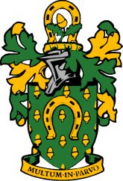

Rutland County Council

