

Uppingham Town Council

Health and Safety Policy

2013

Uppingham Town Council

It is our policy to provide, so far as is reasonably practicable :-

- A workplace and work activities that will be safe for our employees, visitors and others who may be affected by what we do.

- Safe plant, equipment and systems of work.

- Safe use, handling and storage of articles and substances.

- Instruction and training for and consultation with our employees.

- A safe working environment.

- Adequate facilities and welfare arrangements.

- Sufficient resources to implement the policy and the assignment of responsibilities.

Employees are reminded that they have a duty to take reasonable steps for their health and safety and other people who may be affected and to co-operate with arrangements in all matters relating to health and safety.

This policy will be kept up-to-date and reviewed annually.

Signed

Position

Date

Health And Safety Organisational Chart

Councillors

Town Clerk
Caretaker
Premises Officer
Litter Picker
Officer Staff

RESPONSIBILITIES

Town Councillors

The Councillors have the ultimate responsibility for the health and safety of Uppingham Town Council but designates the Town Clerk to undertake the day to day management.

The Council has nominated the Clerk to have special responsibility for health and safety.

The Council will ensure that :-

- they provide a lead in developing a positive health and safety culture throughout the organisation.

- all its decisions reflect its health and safety intentions.

- adequate resources are made available for the implementation of health and safety.

- they will promote the active participation of workers in improving health and safety performance.

- they will review the health and safety performance of the Council on an annual basis.

Town Clerk

The Clerk is the designated person with overall responsibility for health and safety within the Council. She will ensure that :-

- our Health and Safety Policy is implemented, monitored, developed, communicated effectively, reviewed and amended as required

- suitable and sufficient funds, people, materials and equipment are provided to meet all health and safety requirements

- adequate insurance cover is provided and renewed

- competent persons are appointed to provide health and safety assistance and advice

- an adequate system of maintenance exists and operates to keep premises, plant and work equipment in a safe condition

- statutory examinations are planned, completed and recorded

- there is regular communication and consultation with staff on health and safety issues

- an effective training programme is established to ensure staff are competent to carry out their work in a safe manner

- accidents, ill health and 'near miss' incidents at work are recorded, investigated and reported

- safety issues raised are thoroughly investigated and, when necessary, further effective controls implemented and communicated to staff

- contractors engaged are reputable, can demonstrate a good health and safety record and are made aware of relevant local health and safety rules and procedures

- effective contingency plans are in place with a designated competent person in charge of the planning and control measures for situations involving imminent danger

- health and safety objectives are set and their achievement is measured and reported in the annual report.

- areas in the control of Uppingham Town Council are inspected and maintained in a safe condition

Premises Officer

The Premises Officer has responsibility for ensuring the open areas, cemeteries and play area are free of hazards.

The Premises Officer will :-

- Undertaken weekly documented inspections of the play areas

- Undertake regular inspections of the cemetery checking paths, litter bins and seating

- Visually check headstones for stability

- Inspect other open spaces and buildings and document findings

- Report any concerns to the Town Clerk

Caretaker

The Caretaker will ensure that in their areas of control :-

- Regularly inspect the Town Hall for hazards and report finding to the Town Clerk

- Undertake fire checks as defined in the Fire Log Book and complete the documentation.

- Avoid any improvisations of any form which could create an unnecessary risk to their personal safety and the safety of others

Employees

All employees must:

take reasonable care of their own safety

take reasonable care of the safety of others affected by their actions

- observe the safety rules

- comply with the Health and Safety policy

- conform to all written or verbal instructions given to them to ensure their personal safety and the safety of others

- dress sensibly and safely for their particular working environment or occupation

- conduct themselves in an orderly manner in the work place and refrain from any antics or pranks

- use all safety equipment and/or protective clothing as directed

- avoid any improvisations of any form which could create an unnecessary risk to their personal safety and the safety of others

- maintain all equipment in good condition and report defects to their supervisor

- report all accidents to the Town Clerk whether an injury is sustained or not

- attend as requested any health and safety training course

- observe all laid down procedures for processes, materials and substances used

- observe the fire evacuation procedure and the position of all fire equipment and fire exit routes.

Arrangements

1.1 | Accident Investigation  It is our policy to investigate.  - All accidents resulting in any reportable injury or losses of any assets.  - Accidents, however minor.  - All near-misses.  The investigation will involve taking witness statements, photographing evidence where appropriate and obtaining any other evidence of an incident.  From this information the Town Clerk will decide whether further action is necessary to prevent a re-occurrence or to comply with legislation
1.2 | Accident Reporting  It is our policy to report all serious injuries, industrial diseases and dangerous occurrences.  We will report all notifiable accidents to the enforcing authority.  The Accident Book must be fully completed for all injuries incurred at work, however minor.
1.3 | Alcohol and Drug Abuse  No alcohol can be consumed on the premises unless specifically authorised by the Town Clerk or member of the Council.  Anyone found taking alcohol or drugs on the premises without permission is guilty of gross misconduct, and will be disciplined accordingly
1.4 | Asbestos  The Policy of Uppingham Town Council is to :-  - Produce and maintain an Asbestos Register that is available to all staff, contractors and property users.  - Promote awareness of the hazards associated with asbestos.  - Produce a Management Policy and Procedures Plan.  - Periodically review the plan to ensure that any areas of asbestos requiring it, are sealed, encapsulated, inspected, monitored, labelled or removed.  - Ensure the Council’s Policy conforms to Regulation 4 of the Control of Asbestos at Work Regulations 2006.
1.5 | Consultation  Staff meetings will be held regularly. Any items discussed will be noted and where appropriate, actioned.
1.7 | Consultation and Training  The Council is committed to providing employees with adequate information, instruction and training. External assistance will be used to provide professional health and safety training if required.  - We will ensure that all newly appointed or promoted staff receive an efficient induction into their jobs.  - We will provide training to increase the productivity and performance of existing staff, ensuring that they are updated in line with new legislative requirements, techniques and technology.  - Training needs will be reviewed at least once a year.  - Records of training will be kept for all employees.
1.8 | Contractors  All contractors working on our premises are required to comply with appropriate rules and regulations governing their work activities.  We will ensure that, prior to engaging any contractor, they are competent and that work is carried out safely.
1.9 | COSHH  We recognise that some substances have the potential to cause ill health and we will introduce measures to identify any such substances our employees use or are exposed to in the course of their work.  Where practical alternatives exist, we will not use harmful substances.  Substances that we must use will be assessed and control measures introduced to prevent risk.  No product should be brought onto the premise or used by an employee until it has been assessed and deemed safe.
1.10 | Display Screen Equipment  It is our policy to provide a safe and comfortable working environment and we will put in place arrangements and procedures for the assessment of risks from the use of DSE.  A user, defined as a person using display screen equipment for a large proportion of their working day, is entitled to free eyesight tests and this will be discussed with the individuals concerned. It is unlikely that any member of Uppingham Town Council staff is a “User” as defined by the DSE Regulations however, every effort will be made to ensure those working with computers are comfortable.
1.11 | Driving At Work  Driving is not an integral part of the Council activities and there are no Council owned vehicles.  Those employees using their own vehicles for attending Council activities should ensure their vehicle is roadworthy and they themselves are fit and capable of driving with the appropriate licence.  The Council expects those driving for work to be physically fit, healthy and wear the appropriate vision aids as prescribed by their optician.  It is the responsibility of the individual to comply with the requirements of DVLA with regards to the licence and the Highway Code.

1.13 | Electricity At Work  All electrical systems on our premises will be inspected to ensure there is no danger.  All portable appliances will be given a thorough electrical test by a competent person at fixed intervals, which reflect the potential risks associated with the class of appliance.  The fixed wiring installation supplying electrical sockets, lighting or other wired in equipment will be inspected by a competent electrician at least every five years.
1.14 | Fire Safety  We will put in place arrangements for the assessment of risks from fire and appropriate control measures to minimise the risks identified. These measures will include the following arrangements, procedures and controls.  - Regular inspection of the premises for fire safety.  - Fire extinguishers will be placed at clearly signed fire points.  - Emergency exit routes will be kept clear at all times.  - We will train in the use of extinguishers, procedures for fire drills and evacuation.  - Records of training and drills will be kept.  We will  - Provide adequate numbers of fire extinguishers on the premises.  - Ensure that the fire extinguishers are subject to regular maintenance.  - Formulate emergency evacuation procedures.  - Practice the evacuation procedures at least twice a year.
1.15 | First Aid  We recognise our legal duty to make sufficient provision for first aid to employees.  We will make appropriate arrangements to ensure that there are an adequate number of trained first aiders.  In the event of anything other than minor injuries, medical assistance must be sought.

1.16 | Lone Working  Uppingham Town Council will ensure, so far as is reasonably practicable, that employees who are required to work alone or unsupervised for significant periods of time are protected from risks to their health and safety.  The Council will determine, by risk assessment, those activities where work can actually be done safely by one unaccompanied person. This will include the identification of hazards from means of access and/or egress, machinery, goods, substances, etc.  Particular consideration will be given to:  - the remoteness or isolation of workplaces  - any problems of communication  - the possibility of interference, such as violence or criminal activity from other persons  - the nature of injury or damage to health  Information and Training  Employees will be given all necessary information, instruction, training and supervision to enable them to recognise the hazards and appreciate the risks involved with working alone.  Employees will be required to follow the safe working procedures devised including:  - when working alone, e.g. in an isolated area a member of the Council is aware of your location and expected time frame necessary to complete the task  - check that work being done has been subject to risk assessment and check the assessment yourself – some work may have been identified as requiring the assistance of a second person or simply prohibited from being a lone working activity  - if possible and arranged beforehand, keep in regular contact with someone else, e.g. use a mobile phone to call  - If there is no mobile phone connectivity then ensure you arrange for an alternative method of checking in i.e. visiting the office, walkie talkie, other  - do not put yourself at risk; if you do not feel safe discuss the situation with the Town Clerk  Certain tasks will not be carried out whilst working alone and these include working at height i.e. from ladders, heavy lifting activities. Further arrangements will be put in place for these activities.
1.17 | Manual Handling  We will undertake risk assessments in respect of all manual handling operations identified as having a significant risk and will strive to reduce these risks as far as possible.  Training in lifting techniques will be provided for staff involved in all operations identified as having a significant risk.
1.18 | Noise  The Council does not consider that the noise levels in its work activities exceed the lower action level as defined in the Noise at Work Regulations
1.20 | Personal Protective Equipment (PPE)  PPE will be provided where our risk assessments show that a risk cannot otherwise be avoided.  It will only be used where it is not reasonably practicable to modify the activity, the process, or the method of work to prevent risk.  PPE will be maintained and replaced as necessary to ensure its effectiveness. Employees must report loss or obvious defects in PPE as soon as practicable.
1.21 | Pregnant Females  The Council recognises that all work involving pregnant women and nursing mothers will need to take into account their physical and psychological capacity.  Employees are reminded that they have a duty to advise the Town Clerk as soon as they know they are pregnant.

1.22 | Risk Assessment  We will carry out suitable and sufficient assessments of the risks to the health and safety of our employees and to others who might be affected by our work activities.
1.24 | Smoking At Work  Smoking is not permitted anywhere within the Council buildings or on Council premises
1.25 | Stress Management  The Council recognises that stress is an increasing factor in our daily lives.  We will endeavour to increase general awareness of stress and ways to combat workplace stress.  We will take action to prevent workplace stressors and monitor and evaluate stress indicators in our employees.  Where an employee feels under stress he/she should make the Town Clerk aware of the situation.
1.26 | The Indoor Environment  It is our policy to provide a working environment that is safe and comfortable.
1.27 | Trees & Open Spaces (including play areas & cemeteries)  The Council are responsible for numerous trees situated around the town and acknowledge its responsibility to ensure they are well maintained.  Trees are of great benefit to the Town and the overall risk to human safety is extremely low, however the Council does have a duty of care and will undertake a balanced and proportionate approach to tree safety.  - Independent Inspection – The Council on a regular basis will arrange for all trees under their control to be assessed by a suitably qualified person with expertise in tree management. The Council will react accordingly to the recommendations with regards to tree maintenance.  - Visual Inspection – Depending on the recommendations of the expert report the Council will undertake regular visual inspections at appropriate intervals. The interval will be dependent on condition, location and size of the tree.  All inspections will be documented.  Play areas are inspected for safety;  - 6 Monthly inspection by external independent person following which a report is provided  - Weekly documented visual inspection by the Council’s Premises Officer  Cemeteries will be inspected regularly for safety and tidiness. All inspections will be documented.
1.28 | Visitors and Hall Users  Our policy regarding the control of visitors on our premises is that :-  - We must be aware that any visitor is on the premises.  - Visitors are the responsibility of the Council whilst on the premises.  - Hall hirers have a responsibility for the safety of their own attendees and should be aware of the safety and evacuation information provided to them in the Hirers Pack  - Hall hirers should detail any safety concerns to the Town Clerk who will investigate and take appropriate action  All visitors must comply with any instructions given to them.
1.29 | Work Equipment  We will, so far as is reasonably practicable, ensure that all work equipment is safe and without risk.  To minimise the risk of injury from work equipment we will :-  - Carry out risk assessments of all equipment in use and all new or second hand equipment purchased.  - Ensure that all maintenance procedures are kept up-to-date.  - Provide suitable training.
1.30 | Young Persons  We will pay special regard to the needs of any young persons by risk assessing the tasks we are asking them to do and take into account their inexperience and immaturity.
2.0  2.1 |  | APPENDIX  Arrangements  - Overall and final responsibility for health and safety is that of The Councillors of Uppingham Town Council  - Day to day responsibility for ensuring the policy is put into practice is delegated to the Town Clerk  - Our nominated Competent Person is WPS Insurance Brokers  - The following employees are responsible for health and safety in their areas :-
- Employees should report any health and safety concerns to the Town Clerk

- The Town Clerk will be responsible for ensuring any risk assessments as required by Regulations are undertaken.

- Action required to reduce or control the risks will be approved by Town Clerk or where appropriate, the Council Members.

- The Town Clerk will be responsible for ensuring that employees are made aware of the findings of the risk assessments and any control measures identified.

- Any defects in plant, equipment, buildings or systems should be reported to the Town Clerk

- The Health and Safety Law Poster is displayed in the entrance hall

3.1 | Arrangements
3.1 | - Induction training for new employees is the responsibility of the Town Clerk
3.1 | - Job training will be co-ordinated by the Town Clerk  - The training plan will be reviewed at least annually  - Training records are kept in the Town Clerk’s  office  - The first aid box is kept in the Members Room
3.1 | - The Accident Book is kept in the Members Room  - All accidents should be reported to the Town Clerk  - the Town Clerk will conduct the accident investigation  - Emergency escape routes are checked weekly by the Caretaker  - Fire safety checks are carried out weekly by The Caretaker  - The fire alarm is tested weekly by The Caretaker

Manual Handling

PRINCIPLES OF GOOD HANDLING TECHNIQUE

- Planning

Plan the lift, consider where the load is to be placed, the distances involved, are there any obstructions such as closed doors? is assistance required?, can handling aids or equipment be used?
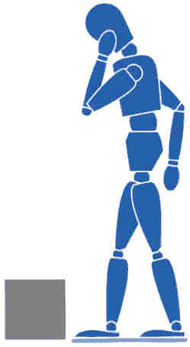

- Feet

The feet should be positioned apart (shoulder width), one foot ahead of the other in the direction of the intended movement



- Knees

Adopt a good posture for handling with the knees bent (not squat – don’t kneel), in order to gain the most effective power from the thigh muscles

- Back

The back should be straight - not necessarily vertical (15 - 20º) from vertical is alright, keeping the natural curve of the spine. It may help to tuck in the chin. If necessary, lean forward a little over the load to get a good grip and to keep the centre of gravity over the load.

- Arms

The arms should be close to the body (nearer the centre of gravity) with the shoulders level and facing the same direction as the hips.


- Hands

Ensure a firm grip on the load using the roots of the fingers and the palm of the hand. Holding the load this way is also less tiring than keeping the fingers straight.

- Head

Raise the chin out and up as the lift begins, otherwise this results in round shoulders and a curved spine.

8 Moving the load

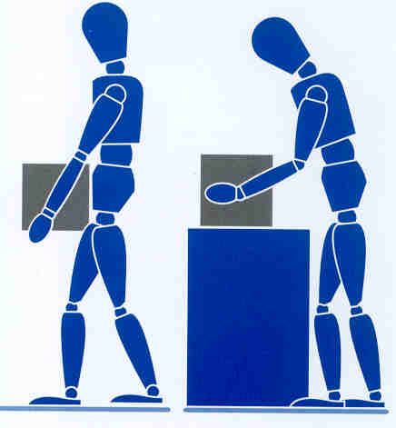
- Keep the load as close to the trunk for as long as possible, and where relevant, keep the heaviest side of the load close to the body. Slide the load towards you if required.

- Lift smoothly

- Move the feet not the trunk when turning to the side, i.e., don’t twist.

- Put the load down and then slide the load into the required position if necessary.

9 Team Handling

Handling by two or more people may make possible an operation that is beyond the capability of one person, or reduce the risk of injury to a solo handler.
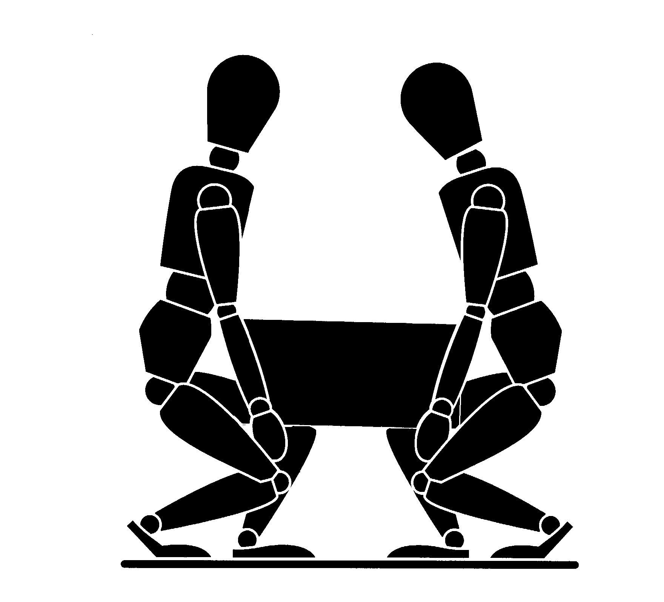

Additional difficulties may arise if team members impede each other’s vision or movement, or if the load offers insufficient good handholds. This can occur particularly with compact loads which force the handlers to work close together or where the space available for movement is limited.

When lifting loads at or near floor level is unavoidable, handling techniques which allow the use of relatively strong leg muscles rather than those of the back are preferable, provided the load is small enough to be held close to the trunk. In addition, if the task includes lifting to shoulder height, allow the handlers to change hand grip. Bear in mind, however, that such techniques impose heavy forces on the knees and hip joints which must carry both the weight of the load and the weight of the rest of the body.

The closeness of the load to the body can also be influenced by foot placement. The elimination of obstacles which need to be reached over or into will permit the handler’s feet to be placed beneath or adjacent to the load before beginning the manual handling operation.

Display Screen Equipment (DSE)/Visual Display Unit (VDU)

Some practical tips:

Getting comfortable

- Adjust your chair and VDU to find the most comfortable position for your work. As a broad guide, your forearms should be approximately horizontal and your eyes the same height as the top of the VDU.

- Make sure you have enough work space to take whatever documents or other equipment you need.

- Try different arrangements of keyboard, screen, mouse and documents to find the best arrangement for you. A document holder may help you avoid awkward neck and eye movements.

- Arrange your desk and VDU to avoid glare, or bright reflections on the screen. This will be easiest if neither you nor the screen is directly facing windows or bright lights. Adjust curtains or blinds to prevent unwanted light.

- Make sure there is space under your desk to move your legs freely. Move any obstacles such as boxes or equipment.

- Avoid excess pressure from the edge of your seat on the backs of your legs and knees. A footrest may be helpful, particularly for smaller users.

Keying In

- Adjust your keyboard to get a good keying position. A space in front of the keyboard is sometimes helpful for resting the hands and wrists when not keying.

- Try to keep your wrists straight when keying. Keep a soft touch on the keys and don’t overstretch your fingers. Good keyboard technique is important.

Using a mouse

- Position the mouse within easy reach, so it can be used with the wrist straight. Sit upright and close to the desk, so you don’t have to work with your mouse arm stretched. Move the keyboard out of the way if it is not being used.

- Support your forearm on the desk, and don’t grip the mouse too tightly.

- Rest your fingers lightly on the buttons and do not press them hard.

Reading the screen

- Adjust the brightness and contrast controls on the screen to suit lighting conditions in the room.

- Make sure the screen surface is clean.

- In setting up software, choose options giving text that is large enough to read easily on your screen, when you are sitting in a normal, comfortable working position. Select colours that are easy on the eye (avoid red text on a blue background, or vice-versa).

- Individual characters on the screen should be sharply focused and should not flicker or move. If they do, the VDU may need servicing or adjustment.

Posture and breaks

- Don’t sit in the same position for long periods. Make sure you change your posture as often as practicable. Some movement is desirable, but avoid repeated stretching to reach things you need (if this happens a lot, rearrange your workstation)

- Most jobs provide opportunities to take a break from the screen, e.g. to do filing or photocopying. Make use of them. If there are no such natural breaks in your job, your employer should plan for you to have rest breaks. Frequent short breaks are better than fewer long ones.

Ladders and Stepladders

This guidance is to help you:

- know when to use a ladder;
- decide how to go about selecting the right sort of ladder for the particular job;
- understand how to use it;
- know how to look after it; and
- take sensible safety precautions.

When is a ladder the most suitable access equipment?

As a guide, only use a ladder or stepladder:

- in one position for a maximum of 30 minutes;

- for ‘light work’ - they are not suitable for strenuous or heavy work. If a task involves you carrying more than 10 kg (a bucket of something) up the ladder or steps it will need to be justified by a detailed manual handling assessment;

- where a handhold is available on the ladder or stepladder;

- where you can maintain three points of contact (hands and feet) at the working position;

On a ladder where you cannot maintain a handhold, other than for a brief period of time, other measures will be needed to prevent a fall or reduce the consequences of one. On stepladders where a handhold is not practicable you will need to consider whether it is safe to work or not.

Is it a safe place to use a ladder or stepladder?

As a guide, only use a ladder or stepladder:

- on firm ground or spread the load (e.g. use a board);

- on clean, solid surfaces (paving slabs, floors etc). These need to be clean (no oil, moss or leaf litter) and free of loose material (sand, packaging materials etc) so the feet can grip. Shiny floor surfaces can be slippery even without contamination;

Never stand ladders or stepladders on moveable objects, such as pallets, bricks, lift trucks, tower scaffolds, vans, stacks of paper or boxes etc. If the ladder or stepladder won’t reach, you need to use a more suitable type of access equipment.

Safety in use – stepladders

On a stepladder do not:

- overload it – you and anything you are carrying should not exceed the highest load stated on the stepladder;

- use it in locations where the restraint devices cannot be fully opened. Any locking devices must also be engaged;

- use the top two steps of a stepladder, unless a suitable handrail is available on the stepladder;

- don’t use the top three steps of swing-back or double-sided stepladders, where a step forms the very top of the stepladder.

Correct – two clear rungs. Don’t work any higher up this type of stepladder. | Correct – 3 clear rungs, do not work any higher on this type of stepladder

When using stepladders, avoid work that imposes a side loading, such as side-on drilling through solid materials (e.g. bricks or concrete), by having the steps facing the work activity. Where side-on loadings cannot be avoided you should prevent the steps from tipping over, for example by tying the steps to a suitable point, or you should use a more suitable type of access equipment.

Incorrect – steps side on to work activity | Correct – steps facing work activity

Where you cannot maintain a handhold (e.g. putting a box on a shelf), the use of a stepladder will have to be justified by taking into account:

- the height of the task;
- a safe handhold still being available on the stepladder;
- whether it is light work ;
- whether it avoids side loading;
- whether it avoids overreaching
- whether your feet are fully supported; and
- whether you can tie the stepladder.

Consider tying a stepladder where possible and helpful to the task (e.g. side-on working or where two free hands are needed). Stepladders should not be used for access to another level unless they have been designed for this.

Is the ladder or stepladder safe to be used?

You must check that the ladder or stepladder is in a safe condition before using it (a daily pre-use check). As a guide, only use ladders or stepladders that:

- have no visible defects.

- have a current detailed visual inspection (look for an inspection label).

- are suitable for work use. Use Class 1 or EN 131 ladders or stepladders at work because domestic (Class 3) ones are not normally suitable for use at work;

  - have been maintained and stored in accordance with the manufacturer’s instructions.

Also, you must always use a non-conductive ladder or steps for any necessary live electrical work.

Pre-use checks

Look for obvious visual defects before using a ladder or stepladder. Check that:

- all the ladder feet are fitted;

- the feet are in good repair (not loose, missing, splitting, excessively worn, secure etc);

- the feet are clean - the feet should be in contact with the ground. Ladder feet should also be checked when moving from soft/dirty ground (e.g. dug soil, loose sand/stone, a dirty workshop) to a smooth, solid surface (e.g. paving slabs), to ensure the foot material and not the dirt (e.g. soil, embedded stones or swarf) is making contact with the ground;

- all the screws, bolts and hinges are secure;

- on a stepladder, that the “spreaders” on the ladder can be locked into place.

- There are no other obvious signs of damage such as cracks.

If you find a problem, DO NOT USE the ladder. It should be repaired (if practicable) or destroyed.

Storage

When storing ladders and stepladders, store them in a well ventilated area to prevent sagging and warping. Store straight ladders in flat racks or on wall brackets, don’t hand them from the rungs. Store step ladders in the closed, vertical position.

The information in this Guidance is based on the HSE leaflet ‘Safe use of ladders and step ladders’

