# Proposal for Gym Equipment on Tod’s Piece

For Amenities Committee 17/2/21

**Issue:**

The lack of adult Gym Equipment in Uppingham has been accentuated by the closure of USSC for the last year. There has been ‘walking’ or ‘running’ in the streets and local roads, but for many teenagers and adults having a piece of apparatus is very helpful.

Going forward this is a valid alternative for some people to the cost of joining a gym, while encouraging health and fitness outdoors.

While not everyone’s cup of tea, many parks do have these items now and I believe these would be well used if they were installed.

**Solution:**

**I would like to propose we look seriously at providing the town with suitable outdoor gym equipment**.

Research shows three local companies worth considering, but expertise is needed to ensure correct items are included.

Research of town members views/potential to use/preference for activity is needed.

**Providers:**

[www.sunshinegym.co.uk](http://www.sunshinegym.co.uk)

[www.tgogc.com](http://www.tgogc.com) The Great Outdoor Gym Co.

[www.wicksteed.co.uk/playground-equipment/sport-fitness/](http://www.wicksteed.co.uk/playground-equipment/sport-fitness/)

This is the area in West Glebe park in Corby.

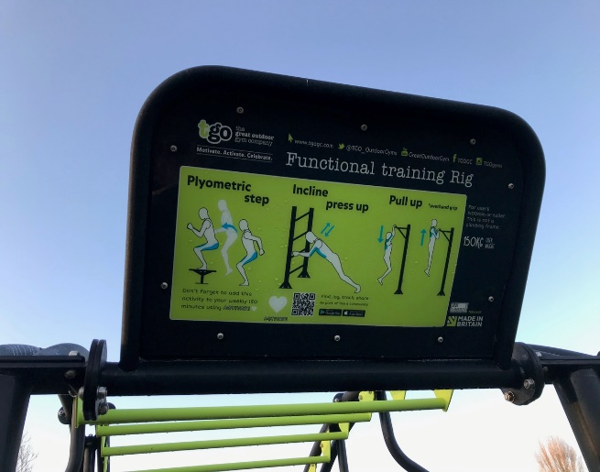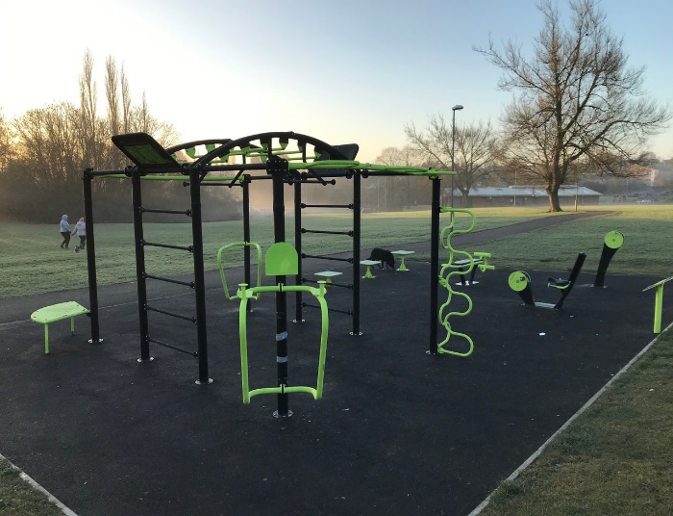

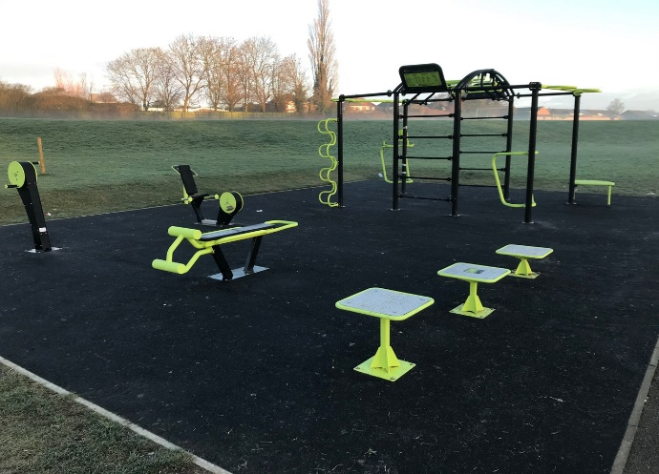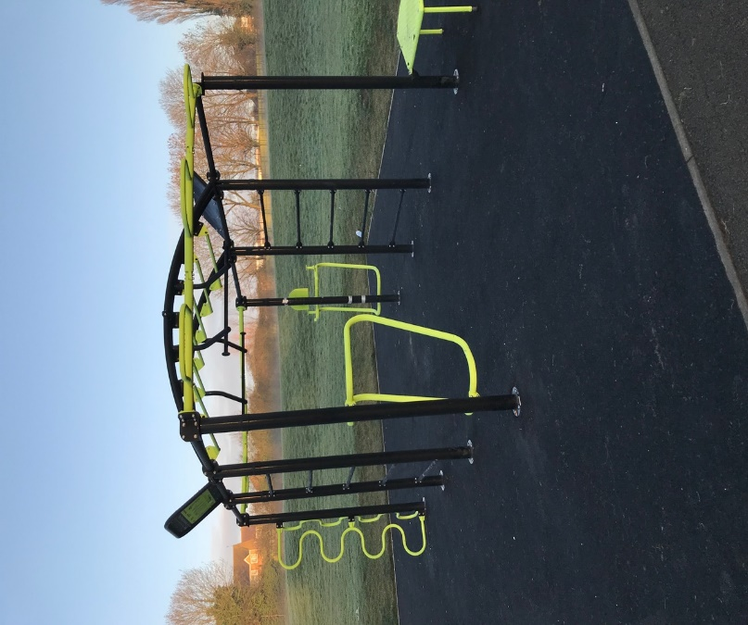

Some parks have a running track or items in a linear position, others in a group as shown.

A linear aspect on the carparking side would e possible now, without too much disruption.

**Potential cost:**

All these providers indicate £25 to 30K for 5 to 7 pieces, depending on those chosen and surface chosen.

Liz Clarke for Amenities

15.2.21