**Introduction**

The purpose of the design guidelines is to improve the quality of new build development in Rutland and South Kesteven.

The Design Guide has been funded from a special grant awarded by the Government on the basis that this would be prepared jointly between the two Councils.

Setting out the Council’s high design expectations and the steps anyone wishing to apply for planning permission should take, the guidance is also there to assist with the assessment of development proposals and to help inform anyone with an interest in design in the area.

The document covers all types of development, including large residential developments, commercial schemes and household extensions.

**Why are the guidelines so important?**

Good design matters as it frames the places in which we live, work, socialise and do business.

It covers a broad range of issues- from tackling climate change to making it easier to park your car, put the bins out or walk to school. Research has consistently demonstrated the link between design and people’s physical and mental wellbeing.

The document builds upon policies within Rutland’s Local Plan (2020), and will be a material consideration when determining planning applications.

This is the first draft of the document and we are seeking views on the style, format, usability and content of the document. As such, it is important that we find out what you think.

By involving you in this process and considering any suggestions you may have as to how the document might be improved; we hope the final version of these guidelines will be one that works for everyone.

**Please spare us a few moments to complete this Survey. Thank you.**

**Please return all completed surveys to** **localplan@rutland.gov.uk**

**PLEASE NOTE THIS CONSULTATION CLOSES ON 12 March 2021**

**Section One – Your Priorities**

**There are many elements that make up a well-designed neighbourhood. We would like to know which of these are the most important to you or the organisation you represent.**

**1. Which factors do you think are most important when considering the design of new housing developments? Please choose no more than three.**

Minimising the impact on climate change.

Ensuring new development blends into the wider landscape and has a green character designed for nature that people can enjoy.

Encouraging people to live healthy, sociable and active lifestyles. Opportunities for walking, cycling and great places to play are included in the design.

Respecting the built character and materials of the local area. Architecture to be of a high quality.

Responding to local issues and listening to local people.

Providing a range of houses for different people’s needs, budgets and circumstances.

Making places accessible, easy to move around and well connected to their surroundings.

Places that function well and are designed to reflect practical considerations (e.g. bins and parking).

**2. Is there anything else you think should be included as a priority, which hasn’t been? Please use the space below to tell us about it.**

A recognition of the need for these guidelines to be in accordance with those set out in made and emerging Neighbourhood Plans (specifically for us the Uppingham Neighbourhood Plan).

**Section Two – The Document as a whole**

**Rutland County Council’s Design Guidelines has seven chapters and is split into two parts. The first three chapters have been designed to help applicants understand and respond to the wider context in respect of their application with the remaining four chapters dedicated to various aspects of design.**

**Please click** **here** **to see a copy.**

**Before we find out what you think of each of the chapters, we would like to know what your thoughts are on the entire document.**

**3. Are the design guidelines easy to follow?**

Yes

No

Don’t know

Doesn’t apply

**4. Is the guidance easy to use?**

Yes

No

Don’t know

Doesn’t apply

**5. Do you think the layout and format of the document will help you if/when applying for planning permission?**

Yes

No

Don’t know

Doesn’t apply

**6. Do you think the layout and format of the guidelines will help if you are being asked to consider or assess a scheme?**

Yes

No

Don’t know

Doesn’t apply

**7. Does the guidance reflect any priorities you, or any organisation you represent, have?**

Yes

No

Don’t know

Doesn’t apply

Use this space for additional comments

**Uppingham Town Council is very keen to promote good design for new developments especially in line with our Neighbourhood Plan.**

**8. Do you think the content in the document …..?**

Is too detailed

Contains the right amount of detail

Is not detailed enough

**9. Please use the space below to make any suggestions which you think would improve this document:**

**We would like to see more specific guidance given for small sites of under ten dwellings. We would also wish to see text that recognises the need for local flexibility as set out in our Neighbourhood Plan.**

**Section 3 - The document in detail**

**Part One of the Design Guidelines – Chapters 1-3**

Part One of the Guide requests that development proposals are not prepared in any detail before applicants have a thorough understanding of the site and context. It also requests that development proposals respond to this local context and character. Undertaking the simple steps that have been set out in order helps ensure that new development sits comfortably within the local area. This is known as the design process.

Providing a broad overview of the special characteristics of the area, Part One of the document gives more detail on and examples of the information and diagrams that are expected at the different stages of the design process.

This is illustrated below:

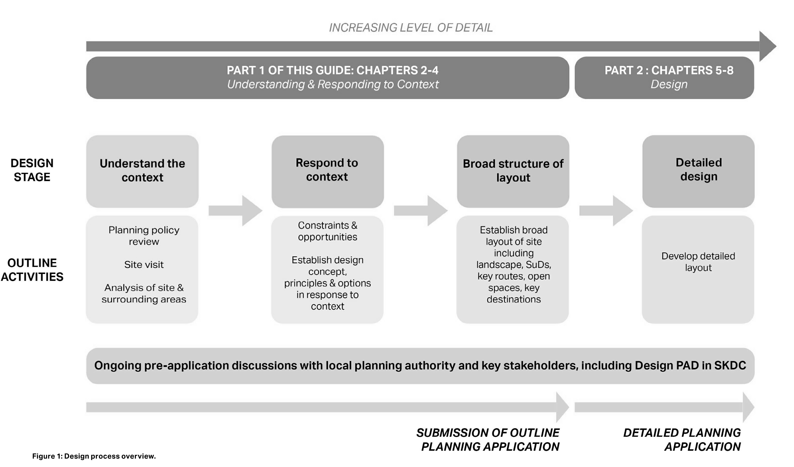**South Kesteven and Rutland’s Design Process Flowchart**

**10. Does chapter one clearly set out the steps that should be taken in order to follow the design process?**

Yes

No

Don’t know

Doesn’t apply

**11. Is the overview of Rutland and South Kesteven's special character provided in Chapter two accurate and helpful?**

Yes

No

Don’t know

Doesn’t apply

**Please use this space to comment**

**Although we think that this could be enhanced for Rutland as we feel that the Two Rutland Market towns have largely been ignored in the body of the text and detailed proposals.**

**12. Does chapter three clearly set out the type of information and diagrams required at the various stages of the design process?**

Yes

No

Don’t know

Doesn’t apply

**Please use this space to comment**

**Although again this could be enhanced by more detailed reference to the importance of made and emerging Neighbourhood Plans, especially recognising the need for some local flexibility as set out in such plans. It also needs to reference any amendments that may be proposed in Neighbourhood Plans.**

**Part 2 - Chapters 4-7**

Part 2 of the Guide focuses on specific design solutions. It summarises the national design guidance that all applicants will be expected to follow and then identifies common design issues specific to Rutland and South Kesteven for major residential schemes (greater than 10 dwellings). It then considers more detailed elements of design, householder applications/extensions, infill development and residential amenity. Finally, it covers non-residential schemes.

**13. Details of the national guidance that must be followed by applicants are found in chapter four. Does this chapter provide enough information on the national design guidance documents that must be followed?**

Yes

No

Don’t know

Doesn’t apply

**Please use this space to comment**

Click here to enter text.

**14. The fifth chapter sets out the key strategic design considerations for major residential schemes (greater than 10 dwellings). Are the key issues for major residential schemes covered in this chapter?**

Yes

No

Don’t know

Doesn’t apply

**Please use this space to comment**

**We believe that there has been a failure to recognise the potential importance of the next generation of private cars (both electric and potentially hydrogen). The RCC Local Plan calls for all new housing to have electric car charging points and we would like to see a recognition that good environmental plans are not just restricted to walking and cycling (important though they are). On the same theme we feel that there is not enough recognition of the needs of those with disabilities and mobility issues.**

**15. Detailed elements of design, such as architecture and materials, the impact it may have on residential amenity (natural light, privacy, and outlook), householder extensions and infill development are covered in chapter six. Does this chapter identify the more detailed elements of good design that are relevant to Rutland and South Kesteven?**

Yes

No

Don’t know

Doesn’t apply

**Please use this space to comment**

**Again this must be cross referenced to the Design Guidelines in Neighbourhood Plans generally and the Uppingham Neighbourhood Plan specifically. We note the comment at 1.5 (Engagement) that “the Policies in a Neighbourhood Plan have the same weight as those in the local Plan”.**

**16. Does this chapter set out clear guidance on householder extensions?**

Yes

No

Don’t know

Doesn’t apply

**Please use this space to comment**

Click here to enter text.

**17. The final chapter of the document focuses on design requirements for commercial development within Rutland and South Kesteven. It includes details on how applicants will be expected to illustrate that they have responded to the climate emergency by making their buildings more sustainable. Does this set out the key design considerations that are most relevant to commercial development in Rutland and South Kesteven?**

Yes

No

Don’t know

Doesn’t apply

**Please use this space to comment**

Click here to enter text.

**Section Four- About you**

To ensure that we have taken the views of all our stakeholders into account, we would like to know a bit more about you. The information you give us will help us to measure if the views we have gathered are representative of the communities we serve.

**18. Are you?**

A resident of Rutland

A county, district, town or parish councillor

A developer or agent

Representing an organisation (please use the space below to tell us which one)

An individual or organisation that has applied to RCC for planning permission in the last six months; or is expecting to apply in the next six months

Other (please specify)

**Uppingham Town Council**

All comments received as part of our consultation will be made publicly available. A document summarising comments received will be available to view on the Council’s website www.rutland.gov.uk/designguide later this year.

If you would like to submit a comment, you must also supply your name and address. Please note that your personal data will not be made publicly available.

**19. Please complete the following**

Name: Peter Leppard Acting Town Clerk

Organisation (if applicable): Uppingham Town Council

Address 1: Town Hall

Address 2: 49 High Street East

Town: Uppingham

County: Rutland

Post code: LE15 9PY

**Contacting you**

**20. If you would like to receive updates about this consultation or news or notifications about future consultations, please let us know how you would like us to contact you. Please tick all that apply.**

Yes, you may contact me by email

Yes, you may contact me by post

**21. If you would like us to contact you by email, please complete the section below:**

Email Address: townclerk@uppinghamtowncouncil.co.uk

You can change your contact preferences at any time by emailing the Council's Planning Policy team: localplan@rutland.gov.uk

To find out more about how we look after your information please click here

**22. If you have any questions or would like to comment on anything included in this survey, please use the space below.**

We believe that it is important to amend section 1.3 to specifically include reference to made and emerging Neighbourhood Plans.

These proposals are made jointly between RCC and South Kesteven. We would like RCC to explain the rationale (as none is given in the document).

We wish to seek clarification of whether or not it is proposed to have a separate guideline for smaller sites or if these are to be treated in the same way as domestic extensions.

Apart from these points we believe that there is much to support in these Design Guidelines and if adopted will help to strengthen our tools for ensuring that development in Uppingham takes place in line with the general wishes of our residents, provided appropriate notice is taken of the Uppingham Neighbourhood Plan.