Uppingham Neighbourhood Plan (Review) 2022/2023
Submission Version

Foreword and Introduction from The Town Mayor
One of the most important documents a town can produce is a Neighbourhood Plan. This looks forward, ensuring the town develops in the way which we have agreed, and we are not at the whim of random development and undesired change. There is no doubt it can be challenging to accept the need for increased housing, however by planning properly and looking ahead, the choice of where housing is and what the supportive infrastructure looks like, become ours. Developers are required to work with the Town Council regarding numbers, layout, design, roads and so on which without a plan can be uncontrolled.
Many hours of work by both councillors and other group representatives have led to this revision of the 2016 Neighbourhood Plan in accordance with new planning laws and the nature of the information which must now be included. I am grateful to them for the time and commitment they have given to this.
The Draft Neighbourhood Plan was published for a six-week consultation period earlier in 2023, after which changes will be considered before the refreshed Uppingham Neighbourhood Plan will be submitted to Rutland County Council in July 2023. RCC will then undertake a final consultation and appoint (in consultation with the Town Council) an independent examiner to consider comments received and check that the plan meets the Basic Conditions. After this the plan, in an agreed final form, with hopefully only minor changes, will be subject to a whole town referendum. If a simple majority (over 50% voting “Yes” that they support it) is achieved, the updated Neighbourhood Plan will have legal status and will be a material consideration in relation to planning decisions by Rutland County Council.
There is an adopted Development Plan which looks forward to 2026 and a new Local Plan has been started by Rutland County Council, although this will not be in place until at least the end of 2025. In order to ensure we do have a say in the development in Uppingham we must have a plan completed and agreed long before this. The Neighbourhood Plan covers the period until 2041 and will require revisions approximately every five years.
This new version of the Neighbourhood Plan will enable us, as a community, to ensure we maintain control over the location and scale of new development, its design and construction standards. It will also help us think carefully about how we address the effects of climate change on our town and the lives of our community. To that end, Uppingham Town Council anticipates offering a wider Climate Change Strategy within the next two years for your consideration alongside the agreed Neighbourhood Plan.
I encourage you continue to engage in the process and, critically, to take part in the Referendum. All towns must develop in order to flourish, and we all want Uppingham to continue to be a great place to live, to work, to play. This refreshed Neighbourhood Plan is a vital part of this process.
Liz Clarke

Contents
1. Plan vision
2. Plan objectives
3. Neighbourhood Area
4. Status of the refreshed Neighbourhood Plan
5. Next steps
6. Summary of planning context
7. Indicative dwelling requirement
8. The evidence base
9. Neighbourhood Plan Policies and Community Aspirations
Neighbourhood Plan Policies
General principles of development and addressing climate change
Housing Policies
Proposed new housing sites.
Other Housing Policies
Protecting the character and heritage of the town
Business and employment
Transport and active travel
Community facilities and services
Open Spaces and Environment
Implementation, Monitoring and Review
Acknowledgements
Appendix 1 – List of (with links to) Evidence Documents
Maps
Neighbourhood Area/Plan Boundary Map
Overall sites map
Policy U-HA1 Site allocation for land off Leicester Road (in front of Cricket Club)
Policy U-HA2 Site Allocation for land off Ayston Road
Policy U-HA3 Site Allocation for Land at Uppingham Gate
Policy U-HA4 Site allocation for land to the East of The Beeches
Policy U-HA5 Site allocation for land off Goldcrest/Firs Avenue
Policy TC1: Primary Retail Frontages
Policy BE1: Employment Land and Mixed Use – Uppingham Gate
Policy BE2: Mixed Use/Retail development at the junction of the A47 and Ayston Road
Policy OS1: Protect and enhance existing open spaces (Map 1,2 & 3)
Policy OS3: Proposed Local Green Spaces (Map 1)
1. Plan vision
1.1 Uppingham already benefits from a “made” Neighbourhood Plan (formal date 11th January 2016) covering the period of 2013 – 2026. This was produced in general conformity with the Rutland County Council Core Strategy adopted in July 2011. Rutland County Council are in the process of updating their Local Plan which will cover the period up to 2041, but this will take several years. Accordingly, the decision was taken by Uppingham Town Council not to delay a refresh of the Uppingham Neighbourhood Plan, in line with the Neighbourhood Planning Act 2017. The Neighbourhood Plan period is, therefore, 2022 to 2041.
1.2 The aim of the Neighbourhood Plan is to retain and enhance the traditional values of our small market town ensuring that future development in Uppingham reflects the community’s needs and aspirations, incorporating new homes, businesses, and technology where appropriate. The built environment resulting from the plan will reflect the town’s heritage and rurality and be compatible with local and national policies. Above all it should enable all sections of the community to enjoy a sustainable way of life.
1.3 Uppingham has a history of innovation and is proudly independent. It often seeks local solutions to address its needs while seeking to build and maintain connections with the wider world. The content of, and approach taken to develop this plan reflects this philosophy.

2. Plan objectives
2.1 These include:
- Continue to protect the town’s heritage appearance and modernise its infrastructure.
- Stimulate social and economic growth, while addressing the climate crisis and affirming which areas of the town should remain as open space.
- Strengthen community spirit, community health and community safety.
- Improve community life with particular regard for vulnerable, disadvantaged and
disabled people.
- Improve the sustainability of the town’s retail centre and economic zones.
- Attract public and private sector investment.
- Allocate/facilitate substantial new housing, reflecting Uppingham’s role as a service centre which is now the second largest settlement in the county and ensuring that at least 30% of new dwellings are ‘affordable’ (on sites of more than 10 dwellings) in accordance with RCC policy.
- Create new housing developments designed as ‘clusters’, incorporating green space and wildlife corridors.
- Enhance the visitor offer and attract the next generation of tourists.

3. Neighbourhood Area

3.1 The Neighbourhood Planning Area, designated by Rutland County Council on 26th November 2012, for the existing Plan is used for this review. The area, as shown on the map, includes all of Uppingham Parish and a small part of Ayston Parish which is adjacent to/South of the A47. There are no houses or businesses in this area, but as with the existing Neighbourhood Plan, Ayston Parish has been consulted on this review.
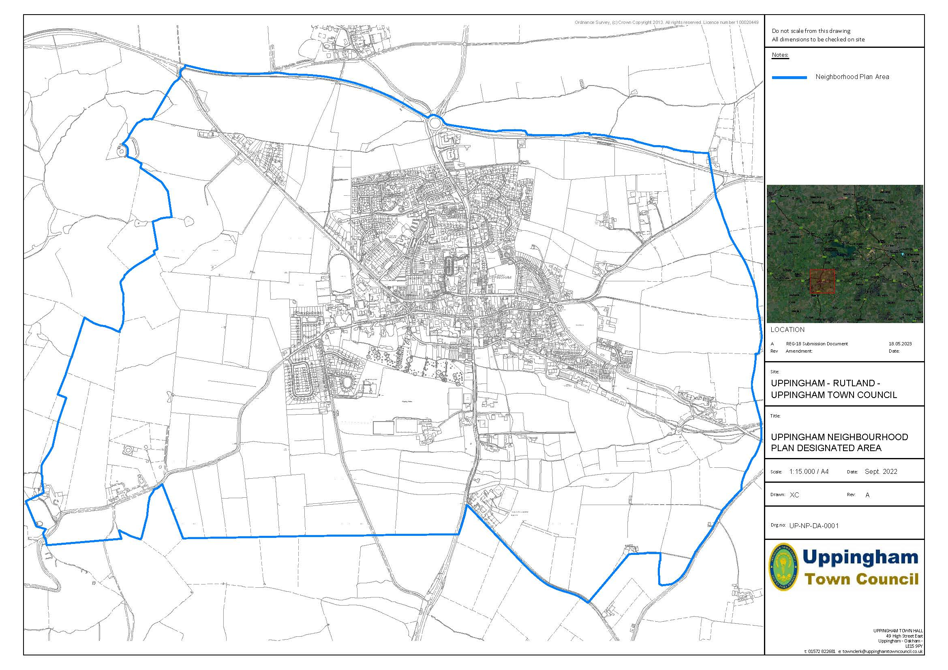

4. Status of the refreshed Neighbourhood Plan
4.1 The review of the Neighbourhood Plan is being undertaken in accordance with the Government Guidance https://www.gov.uk/guidance/neighbourhood-planning--2#updating-neighbourhood-plan Under Paragraph 106 it is considered that the review includes material modifications, including new site allocations, which change the nature of the plan and which will require examination and a referendum. Paragraph 85 (How are more substantive neighbourhood plan updates made?) also applies. The Local Planning Authority (LPA), Rutland County Council (RCC), has also concluded that the review of the current made Uppingham NP involves material modifications which changes the nature of the plan and, therefore, it will require examination and a referendum. As the Qualifying Body for the NP, Uppingham Town Council also believes that the modifications, in particular the new site allocations, are substantial and will change the nature of the plan.
4.2 In accordance with guidance, the Neighbourhood Plan Advisory Group (NPAG), appointed to oversee the review process, has followed the advice set out in Locality Toolkit (Implementation, Monitoring, and Review of Neighbourhood Plans).
- Updated details of community and stakeholder engagement.
- Updated the evidence base to reflect the most recent data and national/local policy.
- Reviewed and revised policies as necessary including supporting rationale/evidence.
- Considered the need for new site allocations with an inclusive and thorough process, including Call for Sites and Sites Assessment, following best practice.
- Undertaken an overall edit of the plan to ensure it reflects current circumstances.
4.3 Reflecting the emerging Local Plan, the plan period for the NP is 2022 to 2041.
4.4 This version is, therefore, the Submission Draft. It follows a formal consultation, in accordance with Regulation 14 of the Neighbourhood Planning (General) Regulations 2012, which ran from 3rd January 2023 until 17th February 2023. Details of the consultation are presented in a separate Consultation Statement.
4.5 In summary, the consultation involved the distribution an explanatory booklet and questionnaire to all residents and businesses in the Neighbourhood Plan Area. An electronic version of the Draft Plan was available along with hard copies at Uppingham Town Hall and Uppingham Library. Drop-in sessions to explain the Plan were held on Saturday 21st and Tuesday 24th January 2023. Completed questionnaires and other comments could be submitted as hard copy or electronically. 150 questionnaires were submitted and in addition to completing the questions 119 people provided more detailed comments.
4.6 In parallel with the community consultation, all external organisations, agencies, service providers, landowners and businesses with an interest in Uppingham were given an opportunity to comment on the Draft Plan over the same period. Nineteen substantive sets of comments were received.
4.7 The comments received (from residents, businesses and external consultees) were all analysed and considered in detail, along with amendments to the plan by NPAG and formally agreed by the Town Council. That work, which has resulted in the Submission Version, was supported by an independent planning consultant with considerable experience in Neighbourhood Plans.

5. Next steps
5.1 The next stage is the formal submission of the Neighbourhood Plan to Rutland County Council. The County Council will again publicise the submitted plan for a six-week period and invite comments. An independent examiner will then be appointed to consider any representations and check that the Plan meets certain basic conditions, including conformity with national and local planning policies. The examiner may recommend modifications to the County Council to ensure that this is achieved.
5.2 The independent examiner will receive any representations made during the six-week consultation period. The examiner’s role is limited to testing whether or not the Neighbourhood Plan meets the ‘basic conditions” and certain other matters. The examiner will then issue a report which will recommend whether the Plan should proceed to a referendum or not and will indicate any changes that should be made to the document. In liaison with Uppingham Town Council, RCC will consider the examiners report.
5.3 Recommended changes will then be made to the Plan and RCC will make a decision on whether to send it to referendum. The Plan can only proceed to a referendum if the Examiner and the County Council are satisfied that it meets the Basic Conditions. The Referendum, which will be organised by RCC includes anyone on the electoral roll in Uppingham (the Neighbourhood Plan Area). A simple majority of people voting must then support the Plan at the referendum if it is to be eventually ‘made’ by RCC. Once ‘made’, the Neighbourhood Plan will become part of the Development Plan and will be a material consideration when determining planning applications.

6. Summary of planning context
6.1 The review of the NP is urgently required to enable future development, especially new housing, in Uppingham to be undertaken in a planned manner which maximises benefits for the town at the same time as contributing to wider dwelling requirements. Although RCC has now committed to a programme to produce a new Local Plan this will not be in place until sometime in 2025. As time passes, it is inevitable that there will be challenges to the older Local Plan policies.
6.2 In terms of the Strategic Policy Context, the NP review is being carried out to ensure general conformity with the Strategic Policies of the Development Plan, which comprises:
- The Core Strategy Development Plan Document (July 2011) - The Site Allocations and Policies Development Plan Document (DPD) (October 2014) - The Minerals Core Strategy & Development Control Policies DPD (October 2010)
6.3 It is recognised however that this policy context is becoming out of date and consequently, in accordance with good practice, account has been taken of the following:
- July 2021 National Planning Policy Framework (NPPF) Sections: 2 Achieving sustainable development, 3 Plan making & 5 Delivering a sufficient supply of new homes. - The evidence base for the earlier RCC Local Plan Review and recent work on the new Local Plan, including evidence documents, Call for Sites and the Issues & Options Consultation.
6.4 The process of refreshing the NP will complement any input into the new Local Plan. When completed the revised NP will be part of the Development Plan. In particular, Uppingham Town Council wants to put in place a robust and lasting framework for decision making to ensure that the right development takes place in the right place and at the right time, in a way that delivers maximum benefits to the town and the local community.

7. Indicative dwelling requirement
7.1 In accordance with the NPPF, RCC provided an Indicative Dwelling Requirement (IDR) for the Neighbourhood Plan review. Based on an updated calculation, but retaining the methodology approved by the RCC Cabinet in November 2021, the minimum requirement was for 360 dwellings over the period 2021 to 2041.
7.2 However, the NPPF methodology provides flexibility according to local circumstances. Para. 17 states: It will be for Neighbourhood Plans to consider an appropriate buffer on top of the indicative housing supply figure to ensure choice and competition in the market for land and allow for contingency and any other factors. Again, there should be compelling evidence to justify the scale of any proposed buffer or the non-inclusion of a buffer.”
7.3 The NP evidence document (Housing Requirement and Past Development Rates, July 2021) shows that past development rates in Uppingham have been lower than projected by RCC. The RCC (Sept. 2022) Small Sites Windfall Study shows that the contribution from windfall sites in Uppingham has fallen. With respect to the latter, the extent of the Conservation Area, the needs of Uppingham School and other heritage/landscape related constraints, are also likely to limit future windfall opportunities. It is not appropriate to put an annual figure on completions from such sources. In addition, the recent Issues and Options consultation for the new Local Plan suggests that overall the Annual Building Rate could be 140 or 160/year. The Indicative Dwelling Requirement agreed by RCC is based on 140 dwellings/year. The RCC Issues and Options report proposed a requirement of 431 dwellings (400 net, taking commitments into account).
7.4 Taking into account evidence, it is argued that, for Uppingham, there is the “compelling evidence” required to justify an increased IDR. Accordingly, the site allocations in the NP are based on achieving around 513 dwellings, albeit that development will need to be phased, with a clear distinction between sites which are likely to be developed within five years and those which are expected to come forward later. It is acknowledged that a limited number dwelling might emerge on small sites. There is a small triangular piece of land off Leicester Road (next to No.3) which is identified as a future housing site in the current NP. This commitment is maintained, but the timing of development is unknown, and it has capacity for less than 10 dwellings and cannot be counted towards the dwelling requirement.
7.5 It is noted that this may increase the Uppingham “share” of the overall housing requirement for Rutland from an historic 14% in the Core Strategy (noting that this scale of development has not been achieved) to around 15%. Taking account of local circumstances and the guidance in the NPPF, this is not considered to be in conflict with strategic policy.
7.6 Taking account of comments made during the Regulation 14 Consultation on the Draft Plan, advice from RCC and the passage of time, the approach to meeting the dwelling requirement has been updated. The key changes set out in the (Submission) version are:
1. Land North Of Leicester Road. (Current NP Site B and Proposal U-HA3 in the Reg. 14 Draft) is now included as a commitment rather than a proposed allocation. It has outline permission for 163 dwellings (2019/0524/OUT) following the recent completion of a Section 106 Agreement. This includes the commitment to a roundabout on Leicester Road, in accordance with the longstanding wishes of residents and the Town Council. In addition, land South of Leicester Road (Site C in the current Plan), now has outline and reserved matters approval up to 20 dwellings and is also regarded as a commitment.
2. These commitments have enabled a small reduction in proposed number on the two largest of the proposed sites. This results in 110 (rather than 125) dwellings on U-HA1 (Land in front of the cricket club) and 60 (rather than 65) dwellings on U-HA3 Uppingham Gate.
3. The requirement for the phasing of two sites (U-HA5 and U-HA6 in the Reg. 14 Draft) is more explicit meaning that are these become longer term sites, to be brought forward after at least five years from the making of the Neighbourhood Plan.
4.Increased emphasis has been placed on highway requirements and the need for a range of infrastructure to be provided alongside new housing.
7.7 Whilst recent government announcements suggest that housing requirements for Local and Neighbourhood Plans may be worked out locally, implying that this may result in lower requirements, there is no legislation in place as yet. In addition, although the NPPF is under review, a revised version has yet to be published. Therefore, in order to meet the Basic Conditions, the Neighbourhood Plan must reflect the current (July 2021) NPPF. It must also be in accordance with the current (adopted) Local Plan.
7.8 As described in Section 6, the Local Plan in under review and RCC anticipate that a Consultation Draft will be issued in September/October 2023. It is understood that RCC will reflect the housing numbers and sites that are included in the Neighbourhood Plan. It is anticipated that later in 2023, by the time the Examination of the Neighbourhood Plan takes place, the examiner will be able to take the Draft Local Plan into account.
7.9 As detailed in the Consultation Statement, the Reg. 14 Consultation on the Neighbourhood Plan resulted in a range of comments on housing numbers and sites.
- Developers produced a revised Housing Needs Assessment (HNA) which suggested the need for an increased requirement overall and higher densities on some sites. - There are community concerns, (also expressed by CPRE), about the overall level of development (which they wish to see reduced) and suggestions that numbers should be reduced on certain sites. It was also suggested that a new HNA should be produced to reflect emerging Government changes to the basis of calculation and the NPPF. - RCC wish to see an increased focus on highway matters and affordable housing provision but has not objected to the overall level of provision or to individual sites.
7.10 These matters have been considered, but other than adjustments resulting from the new committed dwelling figure, the decision was taken to maintain the approach to housing numbers and sites from the Consultation Draft. The reasons for this decision are:
1. To address the historic under performance in Uppingham in terms of the annual completion rate of dwellings, based on the Core Strategy. (See Aug. 2022 Evidence Document Report on past housing delivery/indicative dwelling requirement). 2. To recognise that the extent of the Conservation Area, the needs of Uppingham School and other heritage/landscape related constraints, will limit future windfall opportunities. 3. In accordance with the principles of Neighbourhood Planning, to provide increased certainty on the scale and location of new housing to residents, local businesses, developers, landowners and decision makers. 4. To reflect the positive engagement of landowners and developers in the NP process.
5. To recognise the argument that as (one of only two) larger settlements in Rutland, Uppingham could take an increased share of overall development beyond the 14% set in the Core Strategy. This would relieve pressure on other less sustainable village locations.

8. The evidence base
  - The evidence base for the review of the NP, set out in separate documents, comprises:
(i) A record of engagement and consultation which has been included in the Consultation Statement for Submission. At present it is a simple list of meetings/events with links for people to look at more details. There is a short introductory text explaining the commitment to engagement and transparency and highlighting key decisions and dates. In addition to community consultation, there has been continuous engagement with the business community.
(ii) Housing Site Assessment. A comprehensive document which describes the process (including a summary of engagement and consultation), giving details of methodology, the Call for Sites, the Assessment and the reasons for the selection of proposed sites.
(iii) Other Technical Evidence. A listing, with a short explanation of work undertaken, of material gathered since the decision to prepare for a review of the NP in May 2018 (census data, local housing needs, traffic, roads & transport, town centre and planning records). An assessment of past housing delivery rates was agreed with RCC in July 2022.
A full list of Evidence Documents is given in Appendix 1.
8.2 In addition a Strategic Environmental Assessment (SEA) and Habitat Regulations Assessment (HRA) has been carried out on the Draft Plan. Copies of this assessment are available alongside the Draft Plan and the Evidence Documents.
8.3 For Submission, a Basic Conditions Statement will be prepared in accordance with the Neighbourhood Plan Regulations.

9. Neighbourhood Plan Policies and Community Aspirations
9.1 This section sets out the policies that will help to deliver the Objectives for Uppingham outlined in Section 2. It is acknowledged that some of the Neighbourhood Plan policies are linked to matters covered in the existing Core Strategy and the Site Allocations DPD, but there is an understandable concern in Uppingham that those document are becoming out of date. As such, the Neighbourhood Plan contains a series of planning policies which provide a distinct local perspective, including new housing site allocations, reflecting the unique character of Uppingham. The Neighbourhood Plan forms part of the Development Plan. Decisions should be made in accordance with it and the Local Plan policies unless other material considerations apply.
9.2 The land-use Plan policies are preceded by a “Rationale” in plain font which explains the purpose of and justification for each policy, linked to national guidance and the evidence documents. The policy wording is then presented in bold italics in blue shaded text boxes.
9.3 The planning policies (and associated community proposals – see below) are grouped in the following sections:
1. General principles of development and addressing climate change.
2. Housing policies (including site allocations)
3. Other housing policies
4. Protecting the character and heritage of the town
5. The town centre and other retail development
6. Business and employment
7. Transport and active travel
8. Community facilities and services
9. Open Spaces and Environment
9.4 In some of the above sections, the formal planning policies are supplemented by Community Proposals. These informal proposals are easily distinguished from the formal planning policies as they are set out in italics followed by a short explanation in plain text. The community proposals are aspirations which the Town Council will pursue on behalf of the community, noting that this will require support from other organisations. Unlike the land-use policies, the Community Aspirations are not tested as part of the independent examination into the Neighbourhood Plan and are not used in the determination of planning applications. They are, however, important to the way in which the Plan will be implemented, especially when working in partnership with RCC and outside organisations.
9.5 In the Housing Policies and Other Housing Policies there are several technical terms which are used. These are explained/defined below.
1. Indicative dwelling requirement.
This is the figure provided by RCC to meet the requirements of para. 67 of the NPPF which states: “Where it is not possible to provide a requirement figure for a neighbourhood area, the local planning authority should provide an indicative figure, if requested to do so by the neighbourhood planning body. This figure should take into account factors such as the latest evidence of local housing need, the population of the neighbourhood area and the most recently available planning strategy of the local planning authority.” The calculation methodology and figure for Uppingham was approved by RCC cabinet on 16th Nov. 2021.
2. Bungalow
Throughout this document the term ‘bungalow’ refers to dwellings which are primarily single storey, comprising the majority of living accommodation at ground floor with only secondary bedroom/bathroom and/or home office accommodation within the roof space. Dormers or roof lights may be incorporated, taking account of design requirements, local character and privacy. The provision of bungalows in the specified locations is appropriate in terms of local character and will help to meet local aspirations for a range of house types and sizes. Importantly, the potential to incorporate secondary bedroom, bathroom and home office space within the roof, by the use of dormers and/or rooflights, will ensure that the accommodation provided is flexible. This will enable space to be provided for visitors, family members or carers to support older people. However, such accommodation must be clearly subsidiary to the main living accommodation at ground floor level and should not result in unbalanced, top-heavy or over-intensive development.
3. Infill Development
This is defined as the filling of small gaps within the settlement, normally involving development of a gap in an otherwise continuously built-up frontage.
4. Windfall Sites
These are defined as sites which have not been specifically identified as available in the Neighbourhood or Local Plan process. They normally comprise previously developed land that has unexpectedly become available or other appropriate infill sites.
5. Affordable Housing (Taken from the NPPF – Annex 2)
Housing for sale or rent, for those whose needs are not met by the market (including housing that provides a subsidised route to home ownership and/or is for essential local workers); and which complies with one or more of the following definitions:
(a) Affordable housing for rent: meets all of the following conditions: (a) the rent is set in accordance with the Government’s rent policy for Social Rent or Affordable Rent, or is at least 20% below local market rents (including service charges where applicable); (b) the landlord is a registered provider, except where it is included as part of a Build to Rent scheme (in which case the landlord need not be a registered provider); and (c) it includes provisions to remain at an affordable price for future eligible households, or for the subsidy to be recycled for alternative affordable housing provision. For Build to Rent schemes affordable housing for rent is expected to be the normal form of affordable housing provision (and, in this context, is known as Affordable Private Rent).
(b) Starter homes: is as specified in sections 2 and 3 of the Housing and Planning Act 2016 and any secondary legislation made under these sections. The definition of a starter home should reflect the meaning set out in statute and any such secondary legislation at the time of plan-preparation or decision-making. Where secondary legislation has the effect of limiting a household’s eligibility to purchase a starter home to those with a particular maximum level of household income, those restrictions should be used.
(c) Discounted market sales housing is that sold at a discount of at least 20% below local market value. Eligibility is determined with regard to local incomes and local house prices. Provisions should be in place to ensure housing remains at a discount for future eligible households.
(d) Other affordable routes to home ownership is housing provided for sale that provides a route to ownership for those who could not achieve home ownership through the market. It includes shared ownership, relevant equity loans, other low-cost homes for sale (at a price equivalent to at least 20% below local market value) and rent to buy (which includes a period of intermediate rent). Where public grant funding is provided, there should be provisions for the homes to remain at an affordable price for future eligible households, or for any receipts to be recycled for alternative affordable housing provision or refunded to government or the relevant authority specified in the funding agreement.

Neighbourhood Plan Policies
1. General principles of development and addressing climate change (Policy GP1)
Rationale
Applying the principles of the Localism Act (2011), the NPPF and ensuring developers, landowners and RCC recognise the importance of this Neighbourhood Plan, this general policy is to enable the community of Uppingham to ensure that development is genuinely sustainable. In Government advice: https://www.gov.uk/government/get-involved/take-part/make-a-neighbourhood-plan a key role of Neighbourhood Planning is “…. for communities to have a say in the future of the places where they live and work…. the power to produce a plan with real legal weight that directs development in your local area.” It is important, therefore, that landowners and developers give parish and town councils and their local communities as early an opportunity as possible to get involved in the development process. In Uppingham this process has been supported by many local groups.
Development will only be encouraged where it can be shown that the scheme will help to achieve the Objectives of the Neighbourhood Plan. Locally, the concept of sustainability relates particularly to the need for sensitive design, such that development reflects the character of the surroundings, meeting environmental, social and economic objectives, together with better facilities for pedestrians and cyclists. All these measures will contribute to the quality of life for residents.
It is also intended that the policy will support national efforts to address the threat of climate change to all communities, including the application of Building Regulations for energy efficiency and electric vehicle charging.
The impact of climate change is a global and national concern, but it is also felt locally in Uppingham, related to the physical form of the settlement and how the local economy and community functions. Several of the specific Neighbourhood Plan policies, for example: OH5 (the design of new housing), TC1 to 3 (the town centre), TR2 (active travel), CF1 and 2 (community facilities) plus OS1 and OS2 (Green Spaces) contain elements related to sustainable development and combatting climate change. The issue is of such concern that it justifies the inclusion of a specific point of principle on minimising CO2 emissions in the Neighbourhood Plan in this overall policy on achieving sustainable development and addressing climate change. In addition to this formal planning policy, there is a wider intention to support the creation and maintenance of healthy and sustainable communities. However, the policy is drafted so as to provide a positive framework for decision making, as required in the NPPF.
Policy GP1 - General principles for sustainable development and addressing climate change.
(a) As appropriate to their scale, nature and location, all development proposals must: (i) be appropriately located; (ii) be of an appropriate scale and demonstrate a high standard of design;
(iii) have regard to their setting and the character of the local area;
(iv) not unacceptably affect the amenity of nearby residents;
(v) provide for sustainable transport modes (e.g. walking and cycling);
(vi) respect the local built, social, cultural, historic and natural heritage assets;
(vii) demonstrate practical efforts to achieve (or preferably exceed) design and construction standards for sustainable development, to minimise CO2 emissions.
(b) Landowners, developers and applicants should engage with the Town Council and the local community early on in the formulation of proposals. In accordance with RCC policy, pre-application discussions for larger scale development proposals (e.g. 10+ houses or commercial development over 500m2) should involve appropriate consultation with the Town Council and local residents in advance of an application being submitted. It is expected that RCC will apply the policies of this NP in giving any pre-application advice.
(c) All new development should be designed to anticipate climate change, to be capable of being adapted to minimise resources used in both construction and future use operation, at the same time as being sensitive to the local character.

Housing Policies
1. Overall Housing Numbers (Policy H1)
Rationale
Under the “Duty to support”, the County Council is working actively with the Town Council on the review of the Uppingham Neighbourhood Plan. As part of this, an indicative dwelling requirement had been confirmed by RCC as a minimum of 360 dwellings for the period 2021 to 2041. RCC advises, however, that there is discretion for the NP to set a buffer to address choice and contingency. As noted in Section 7, past development rates have been lower than anticipated in the Core Strategy and the range of figures contained in the recent Issues & Options Consultation for the new Local Plan shows a potential higher indicative dwelling requirement for Uppingham. It is, therefore, justifiable for the Neighbourhood Plan review to be based on a higher requirement of 513 new dwellings over the period 2021 to 2041. Details are given in the Evidence Document: Housing Requirement: Past Delivery Rates. Taking account of commitments (see Section 7 above), new sites need to be allocated to accommodate around 330 new dwellings.
The NPPF states that local planning authorities should promote an effective use of land taking account of the need for housing and development within their area, together with the local housing market and viability, the character and setting of an area and the importance of securing well designed attractive and healthy places.
At County level, evidence on density requirements for new development has been reviewed and shows that the previous density requirements have not generally been met. The County Council has decided that a better approach is to promote the efficient use of land in a way which responds to and reflects the local character and the opportunities presented by the site. It is acknowledged that Neighbourhood Plans may establish locally appropriate density standards where they meet the requirements of national and strategic policies to make the most effective use of land and delivering housing and other development needs. It is considered that the approach to densities on the proposed sites in this Neighbourhood Plan fulfil this objective, recognising overall densities and the characteristics of each site.

Policy H1 (overall housing numbers and densities)
Sites are allocated to meet the indicative dwelling requirement of up to 330 new dwellings during the Plan Period. On these sites, development should make the most efficient use of land, but density, design and layout must also respond to local character, context and distinctiveness. The overall density on the sites should be around 25 dwellings per hectare. Cumulative densities below this figure will not normally be supported, but it is accepted that variations may be justified based on the character of the surrounding area.

2. Associated Infrastructure (Policy H2)
Rationale
The development of a substantial number of new dwellings over the plan period will require investment in infrastructure throughout the town, as well as within and adjoining the allocated sites. Infrastructure need to be defined widely and includes roads, services, utilities, open space, community facilities, health, education and an expanded range of local retail, recreation and hospitality provision.
The policy, which reflects the Locality Guidance (Community Infrastructure Levy – 2017), is intended to establish this important principle. The implementation of the Neighbourhood Plan will include the provision of a Local Infrastructure Development Plan (IDP). This will be assembled by UTC in partnership with the County Council, developers, utilities and service providers. It is intended that UTC and RCC will specify work to be carried out by developers, funding to be committed through the Community Infrastructure Levy (CIL), Section 106 Agreements and the investment programme of RCC and service providers. It is acknowledged that infrastructure has to be directly related and reasonable in scale and kind, in accordance with the Community Infrastructure Levy Regulations.
Policy H2. The provision of infrastructure associated with new housing
Development must be accompanied by necessary investment in infrastructure, including roads, services, drainage, utilities, open space, community facilities, health, education and inclusive IT provision, to meet the needs resulting from the increase in population and to take account of the needs arising from new housing.
In addition, taking account of other policies in this Neighbourhood Plan, private sector investment in new retail, hospitality and recreation facilities of an appropriate scale and in accessible locations will be encouraged.

3. The need for sites to be developed in a timely manner (Policy H3)
Rationale
The site assessment process and the selection of allocations is intended to meet the indicative dwelling requirement in a sustainable and effective way, at the same time as reflecting community preferences. However, the allocated sites also relate to the local landscape, access points and field boundaries. In addition, it is important that development should not prejudice future infrastructure provision, e.g. improved road connections.
It is also of great concern to the Town Council that the sites allocated for development are brought forward in a timely manner. This reflects the statement made at Para. 60 in the NPPF (July 2021) “To support the Government’s objective of significantly boosting the supply of homes, it is important that a sufficient amount and variety of land can come forward where it is needed, that the needs of groups with specific housing requirements are addressed and that land with permission is developed without unnecessary delay.” In addition, the measure will support the NPPF requirements in Para. 68 that “.....Planning policies should identify a supply of: a) specific, deliverable sites for years one to five of the plan period; and b) specific, developable sites or broad locations for growth, for years 6-10 and, where possible, for years 11-15 of the plan.”
Paras. 74 and 77 which refer to maintaining supply and delivery of new homes also apply. “74.....and all plans should consider whether it is appropriate to set out the anticipated rate of development for specific sites.......” and
77. “To help ensure that proposals for housing development are implemented in a timely manner, local planning authorities should consider imposing a planning condition providing that development must begin within a timescale shorter than the relevant default period, where this would expedite the development without threatening its deliverability or viability. For major development involving the provision of housing, local planning authorities should also assess why any earlier grant of planning permission for a similar development on the same site did not start.”
Outline planning permission usually requires the submission of reserved matters within three years, but NPPF provision allows for the local planning authority to require earlier submission and commencement of development as a condition of a planning permission.
Progress on site development will be closely monitored and, where it appears that there are unjustified delays, the Town Council may initiate a review of the Neighbourhood Plan to identify alternative opportunities for development. Where there is no extant planning permission on a previously allocated site, it will not necessarily be carried forward as a site allocation in a new version of the Uppingham Neighbourhood Plan.
The Town Council will however support appropriate extensions to timescales if it is happy with evidence showing that there are valid reasons for delay or progress is imminent.

Policy H3 The timing of development
(A) It is expected that the development of the housing and mixed use sites allocated in this Neighbourhood Plan will be implemented in a timely manner. Development proposals will only be supported where land is to be used effectively and where they enable and do not prejudice possible future development and infrastructure opportunities on adjoining sites or nearby land.
(B) For sites with an outline permission which expires, the Town Council will advise the County Council that it will not support replacement (full) applications, unless there is clear evidence that there have been clear and justifiable reasons for any delay in implementation.
(C) Where development on a site has not commenced within 5 years of the making of the Neighbourhood Plan or does not have a detailed planning permission/reserved matters approval, the Town Council will use the option to review the Neighbourhood Plan to consider alternative locations where there is a better prospect of development.

4. Proposed new housing sites (Policies U-HA1 to U-HA5)
Rationale
The Neighbourhood Plan Advisory Group has been through a thorough process to identify and allocate sites for new housing. This has followed national guidance and good practice and the process has involved landowners, developers, the County Council and, of course, the local community. (See details are in the Housing Sites Assessment Evidence Document:
The sites covered in Policies U-HA1 to U-HA5 are summarised in the table below. The detailed development requirements for each site, set out in the subsequent site policies, reflect community need/aspirations, the characteristics of the site and location, other evidence and engagement with the landowner and/or developer.
Natural England Groundwater Protection Guidance should be applied to sites in Secondary Aquifers, see: https://www.gov.uk/government/collections/groundwater-protection In addition, Historic England guidance, “Housing Allocations in Local Plans” has been applied to the site selection process.
Table 1 – Summary of proposed housing site allocations and existing commitments
Policy number and location | Commence within 5 years | Requirements (derived from site assessment by the NPAG Housing Subgroup).
U-HA1 Land off Leicester Rd. front of Cricket Club. | 110 dwellings | In accordance with the agreement in principle reached with the landowner/developer, the layout should not prejudice the potential of future road connections.
U-HA2 Land off Ayston Road. | 40 dwellings | In accordance with community consultation this should include least 50% of dwellings as bungalows. Adjoining land to the north is proposed for retail use.
U-HA3 Uppingham Gate | 60 dwellings | A mixed development to include employment opportunities as well as housing. In accordance with community consultations, the housing mix should be 25 bungalows and 35 houses.
 | Longer Term after 5 years
U-HA4 The Beeches | 60 dwellings | Access must be achieved through a collaborative approach with the owners of site UNP21LS01 (U-HA3)
U-HA5 Land off Goldcrest | 60 dwellings | This site must have proper access (primarily not through Firs Avenue) before construction can begin.
Total allocations | 330 dwellings
Commitment 1  Commitment 2 | 163 dwellings  20 dwellings | Land North of Leicester Road (Ref. 2019/0524/OUT)  Land South of Leicester Road (Ref. 2022/0296/RES)
Overall Total | 513 dwellings

Policy H 4: Proposed site allocations to meet the indicative dwelling requirement.
Five sites are allocated to meet the uncommitted part of the dwelling requirement Short and medium term (to commence within 5 years): U-HA1 Land off Leicester Road (in front of Cricket Club). For 110 dwellings.
U-HA2 Ayston Road. For 40 dwellings.
U-HA3 Uppingham Gate mixed use site. For 60 dwellings. Longer term (after 5 years, subject to access requirements and progress on other sites) U-HA4 Beeches for 60 dwellings.
U-HA5 Goldcrest for 60 dwellings
Overall Map
The map overleaf shows the location of proposed sites, including housing and mixed uses (see later retail and employment policies) related to the existing (RCC) Planned Limits of Development. It also shows a potential indicative line for future road connections. It is acknowledged that this does not constitute a formal land use allocation, but engagement with landowners and developers has shown that the layout of several of the proposed housing sites could provide for the possibility of such a route.
Cumulative traffic implications
In the site allocation policies which follow, reference is made to the need for “Full Transport Assessments” for each of the proposed development sites. RCC highways has indicated that for the sites U-HA2, 3, 4 & 5, which adjoin or are in close proximity, the cumulative impact of traffic must be considered and appropriate improvements and mitigation measures put in place.
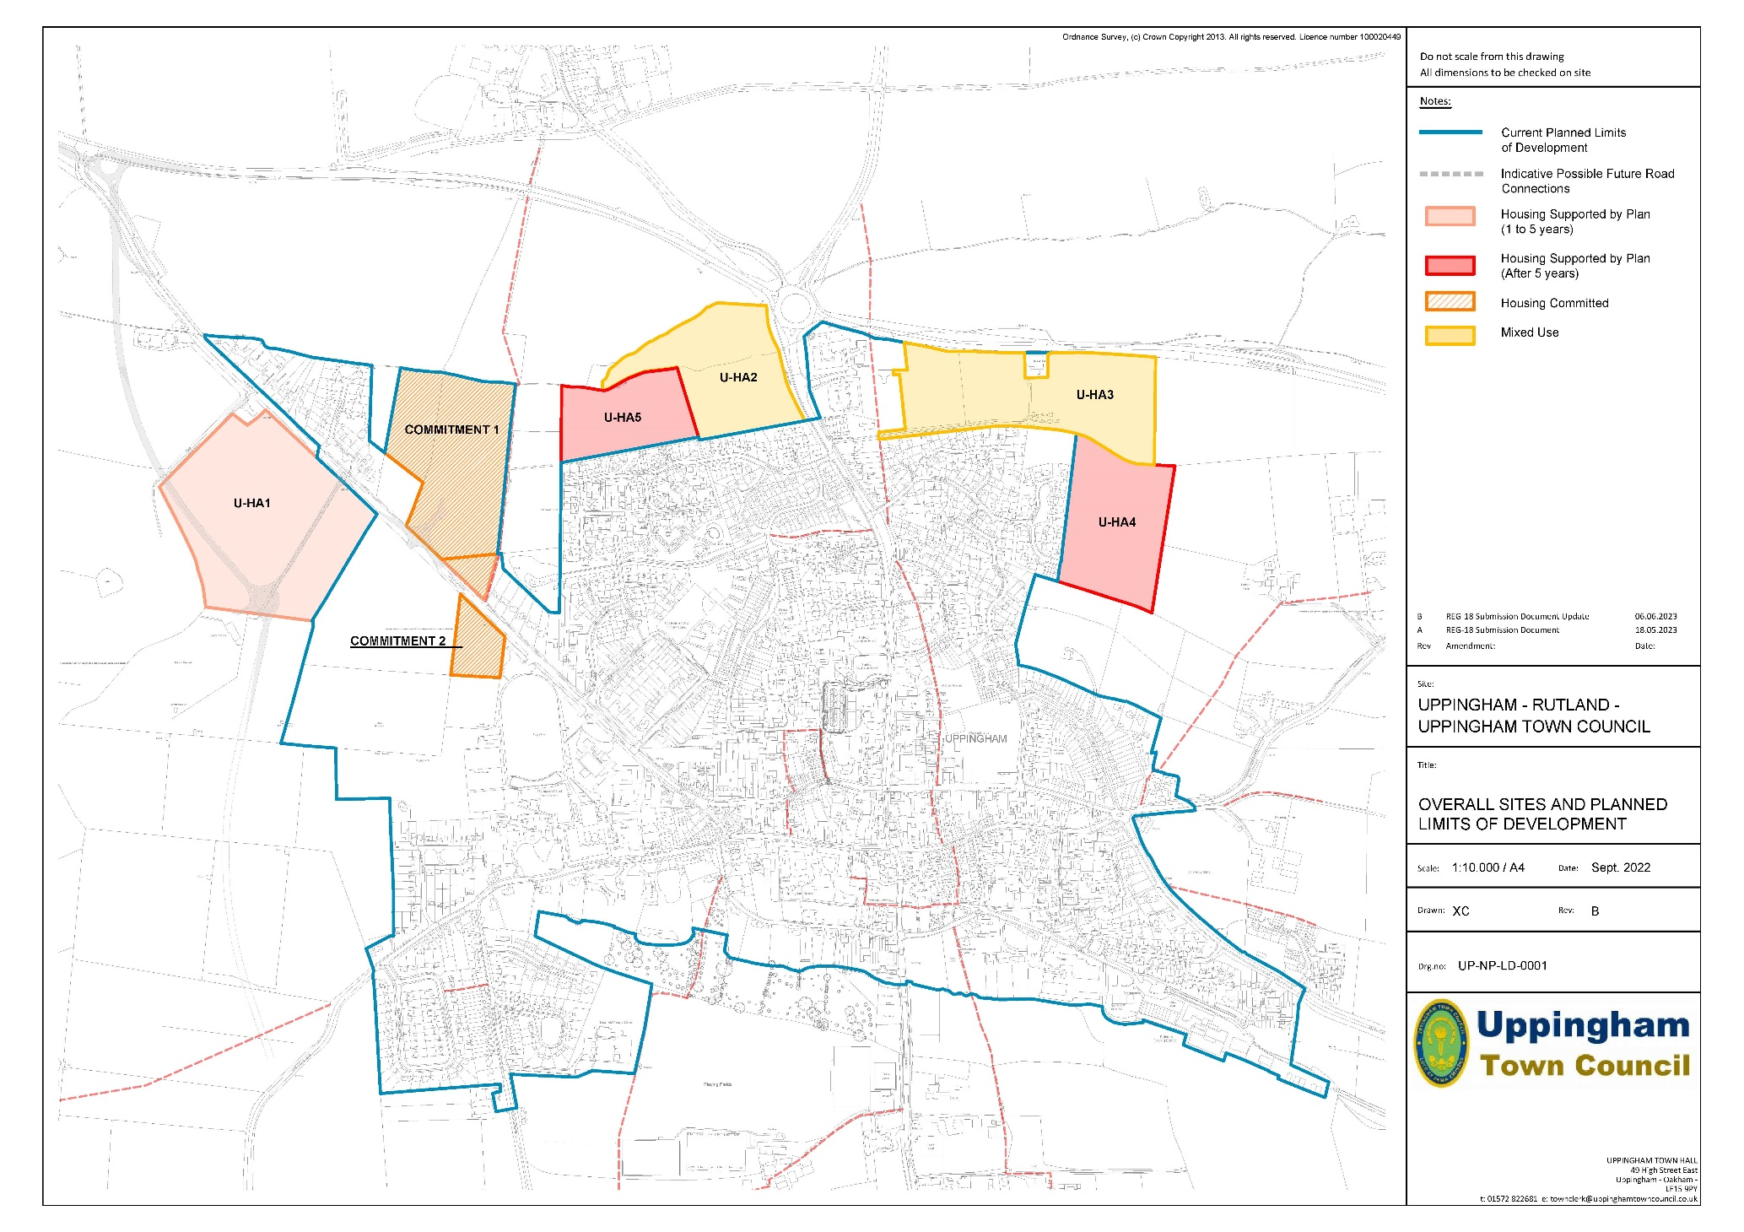

Individual site allocations and requirements
1. Site Allocation: Land in front of Cricket Club, off Leicester Road (Policy U-HA1)
Rationale
This land is just north-west of recent residential development off Leicester Road/Southwell Way and is opposite an older housing area off Leicester Road/Shepherd’s Way. It is an appropriate location for development to meet the indicative dwelling requirement. It is on a bus route and within walking and cycling distance of the town centre, also enabling access to the A47, without adding significantly to traffic though the town. The design and housing mix criteria will ensure that character is respected, and that local housing needs and aspirations can be met. Account has also been taken of the Landscape Sensitivity and Capacity Study (2017 for RCC).
The net developable area has been agreed with the developer/landowner, taking account of access and open space requirements and the potential of future road connections. Open space provision reflects RCC policy, matching overall needs and also takes into account the character and location of the site. The retention of access to the cricket club will enable the continued use of this important community/recreation facility. The retention of open land between the proposed site and the recently completed Southwell Way development would enable the future provision of a potential new road connection between Leicester Road and Stockerston Road.
RCC has stated that that a full Transport Assessment will be required to assess the impact on the surrounding road network, identify the type of junction necessary on Leicester Road and any mitigation for any unacceptable impact (both capacity & safety) beyond the access.
A map of the proposed allocation follows the policy. (NB The potential layout for a potential future road connection is shown is for illustrative purposes only).
Policy U-HA1 Site allocation for land off Leicester Road (in front of Cricket Club)
The capacity of this 8.37 Ha (5.02 Ha developable) site is for up to 110 dwellings. The development should:
(a) Provide a range of housing sizes, including single storey dwellings; (b) Provide at least 30% affordable homes, working with local providers; (c) Adopt high quality design, materials, open space and landscaping; (d) Include a separate access to the cricket club from Leicester Road; (e) Retain potential for a future road connection from Leicester Road to Stockerston Road; (f) Include access, based on a Full Transport Assessment, to be agreed with RCC.

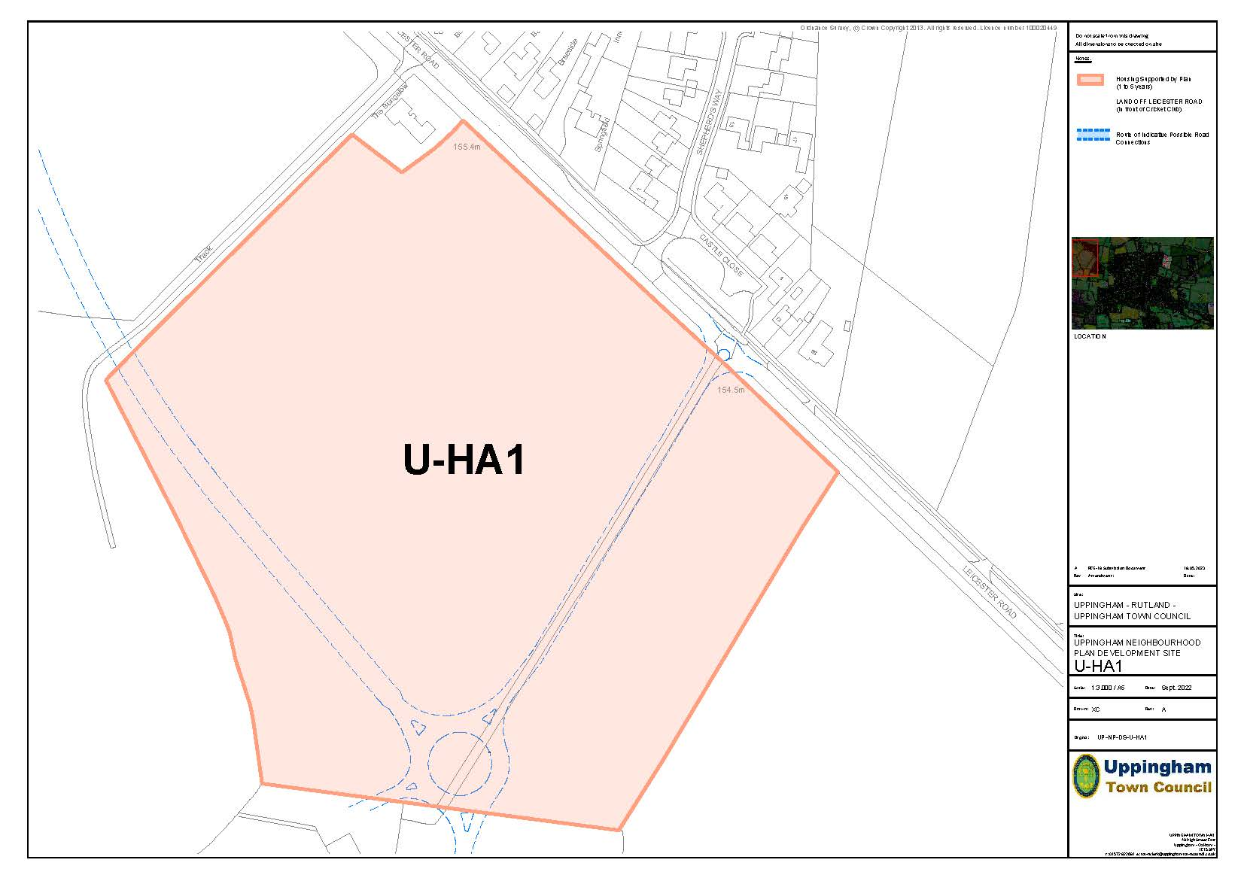

2. Site Allocation: land off Ayston Road (Policy U-HA2)
Rationale
This land adjoins existing residential development off Ayston Road/Firs Avenue. It is an appropriate location for development to meet the indicative dwelling requirement. It is on a bus route and within walking and cycling distance of the town centre, also enabling access to the A47, without adding significantly to traffic though the town. RCC Highways have indicated that the site can only be accessed by a single access, given its frontage, however its location and type must be given very careful consideration, with detailed design. They state that an access between the arms of Ayston Road roundabout and Northgate would not be acceptable due to the constricted length between the two. Access may be possible opposite Northgate, but the design must ensure vehicles are not backed-up up to and on to the A47. A Full Transport Assessment will be required.
The design and housing mix criteria will ensure that character is respected, and that local housing needs and aspirations as expressed in community consultation and in the Local Housing Needs Assessment can be met. The potential to include bungalows on this site was included in the March/May 2021 community consultation leaflet on possible housing sites.
In addition to enabling new housing, in accordance with the NPPF, the northern part of the landholding is allocated for commercial/retail use (see Policy BE 2). This is not to enable the housing, but recognizes the position of the site which creates potential for a high-quality mixed development. It is acknowledged, however, that the design and form of development must respect the attractive landscape of this location, taking account of the Landscape Sensitivity and Capacity Study (2017 for RCC). These considerations limit the extent of land on the site, especially the northern section, that is suitable for built development.
A map of the proposed allocation follows the policy (overleaf).

Policy U-HA2 Site Allocation for land off Ayston Road
The capacity of this 4.19Ha (3.04Ha developable) site is for up to 40 dwellings. The development should provide:
(a) A mix of housing to include 50% of dwellings as 2/3-bed bungalows, semi-detached and detached market dwellings catering for first time buyers, families, and older persons; (b) Provide at least 30% affordable homes, working with local providers;
(c) Public open space, with a new local play area, in accordance with RCC standards; (d) High quality design, materials reflective of surrounding built form and which are local to the area; (e) Enhanced tree planting and landscaping along the northern boundary of the site and retention of existing vegetation, specifically around the boundary of the site; (f) A single vehicular access point off Ayston Road, the details of which must be agreed with RCC through the submission of a Full Transport Assessment. Vehicular and pedestrian access to Site U-HA5 (Land off Goldcrest & Firs Avenue) should also be considered; (g) A new retail store on land to the north of the site.

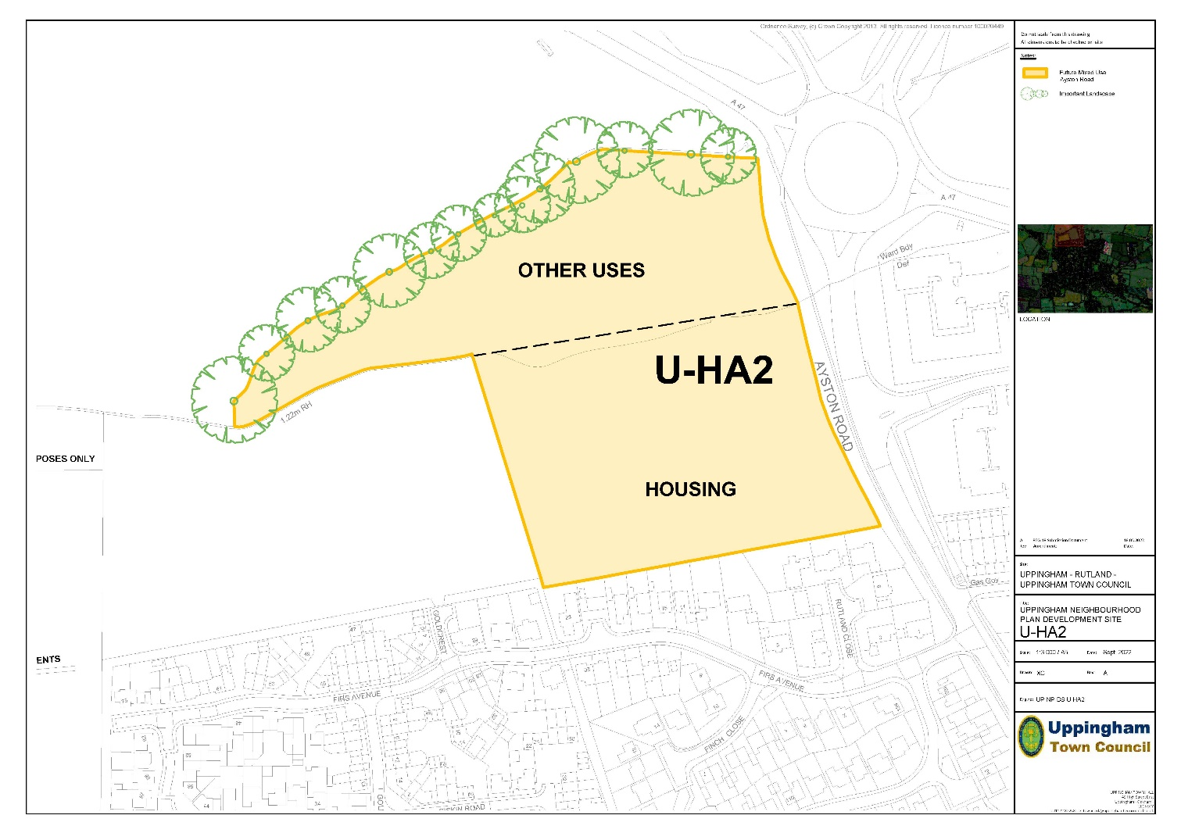

4. Site Allocation: Land at Uppingham Gate (Policy U-HA3)
Rationale
The area proposed for residential development is in the mid/south section of the overall site, adjoining existing residential development off Twitchbed Lane, Orchard Close and Hawthorn Drive. It will extend to the east of Twitchbed Lane, behind the car park for the proposed food retail store, which is to be accessed from the A47. It is an appropriate location for development to meet the indicative dwelling requirement. It is on a bus route and within walking and cycling distance of the town centre, also enabling access to the A47, without putting extra traffic through the town. The design and housing mix criteria will ensure that character is respected and that local housing needs/aspirations as expressed in community consultation can be met. The potential for bungalows on the site was included in the March/May 2021 community consultation leaflet on possible housing sites.
In addition to the standard housing on the site, there may be potential for a nursing home or extra care facility, reflecting the aging population of Uppingham and the need for specialist accommodation.
Other elements of the proposed mixed-use development are set out in Policy 14 (Business and Employment). A master plan will be required to show in detail how the site is to be developed. RCC Highways have commented that a Transport Assessment will be required (including the other sites off Ayston Road), to determine the overall impact of developments on the junction of Northgate with Ayston Road and the surrounding road network. There is likely to be a need to upgrade the junction of Northgate and Ayston Road.
A map of the proposed allocation follows the policy (overleaf).

Policy U-HA3 Site allocation for land at Uppingham Gate (part of mixed-use development). The 3.3 a. site has capacity for up to 60 dwellings.
(a) The mix of house types should comprise 35 houses and 25 bungalows; (b) A masterplan will be required setting out in detail how the housing element of the site is to be developed and how this links to other components of the mixed-use development; (c) The site must be developed in such a way that it will enable unfettered vehicular and pedestrian access to be provided to the future site 2 (Policy U-HA4 – Land off The Beeches/Hazel Close); (d) Access arrangements must be agreed with RCC through the submission of a Full Transport Assessment; (e) Within the housing component, at least 30% affordable homes should be provided, working with local providers.

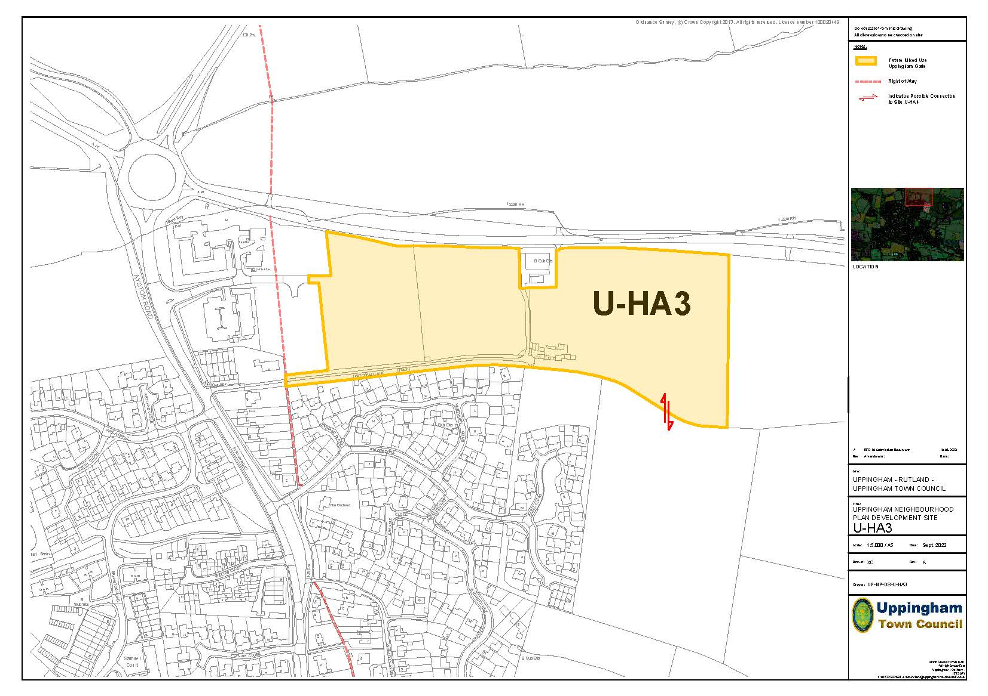

Longer term sites, allocated subject to access requirements (Policies U-HA4 and U-HA5)
The sites proposed in policies U-HA1 to U-HA3, will enable up to 210 new dwellings to be built, exceeding the minimum indicative dwelling requirement provided by Rutland County Council (taking into account known commitments). The two further development sites detailed below may be developed during the plan period, but only after progress fulfilling the stated access requirements. This will result in 120 additional dwellings, but it is intended that this will contribute to longer term strategic needs, for both Uppingham and, in wider terms, Rutland, for new housing. In addition to meeting housing needs, in accordance with the NPPF, this will also enable investment in beneficial infrastructure for the town.
Rationale - Land East of The Beeches (U-HA4)
This land is seen as having potential for longer term development in association with Uppingham Gate (U-HA3) immediately to the north once that development has been completed. Although RCC highways has suggested that The Beeches could be a secondary access, community opinion is clearly that the site should be served from Uppingham Gate with pedestrian and cycle access only from the existing housing area.
Site Allocation: Land East of The Beeches (Policy U-HA4)
Policy U-HA4 Site allocation for land to the East of The Beeches.
This site may be developed for up to 60 dwellings, but development should not commence until after access is resolved from the Uppingham Gate site (Site Allocation U-HA3). When development does occur, it should include at least 30% affordable homes, working with local providers.
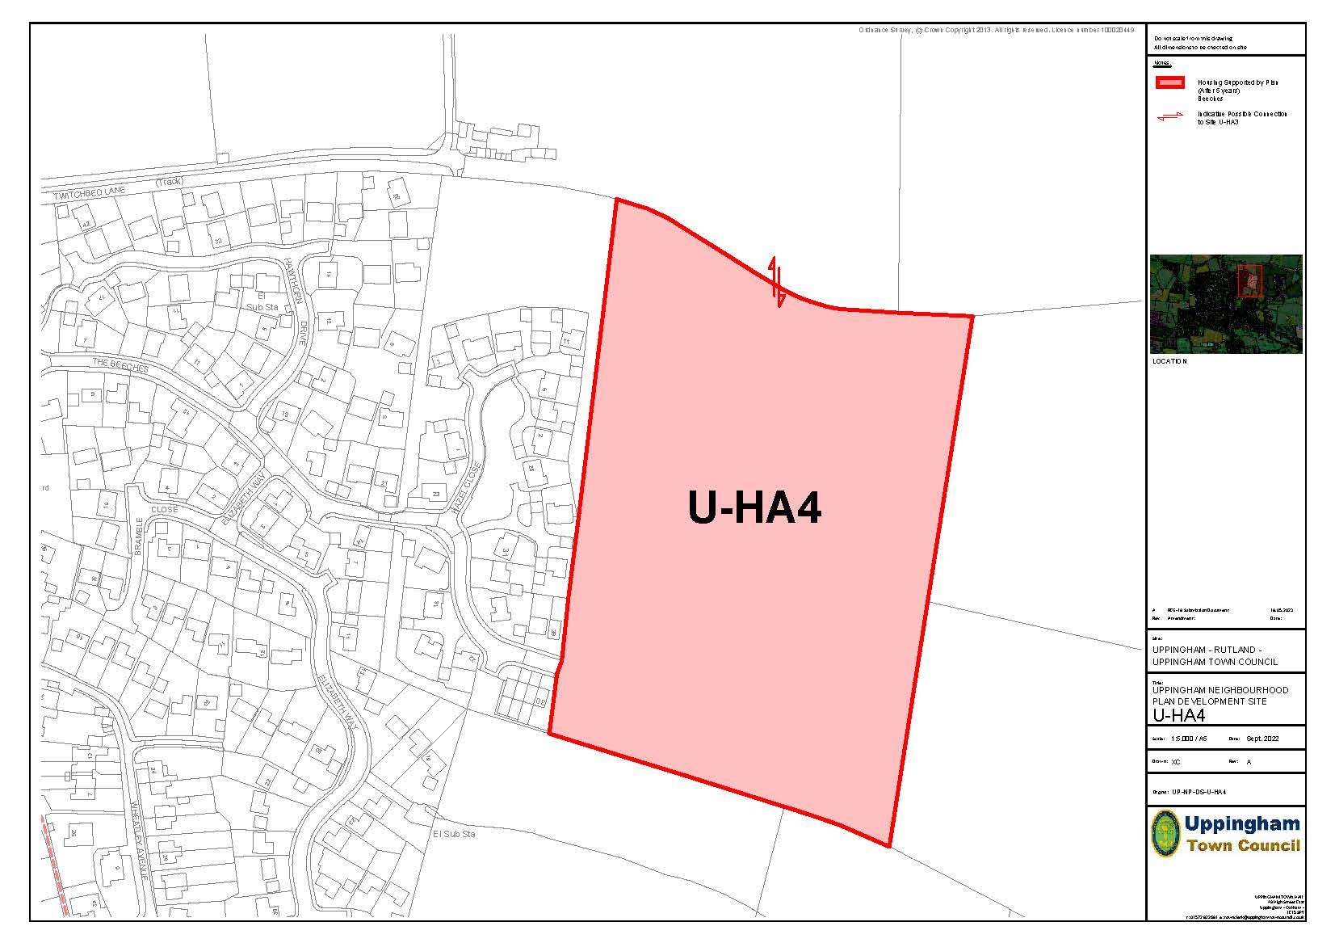
Rationale - Land off Goldcrest and Firs Avenue (U-HA5)
This land is seen as having potential for longer term development in association with land off Ayston Road (U-HA2) immediately to the east once that development has been completed. Although RCC Highways have suggested that vehicular access may be feasible from the existing estate road network, community consultation has shown that the site should be served primarily from a new access through U-HA2, with only pedestrian and cycle access from the existing housing.
6. Land off Goldcrest and Firs Avenue (U-HA5)
Policy U-HA5 Site allocation for land off Goldcrest/Firs Avenue
This site may be developed for up to 60 dwellings, but it must have a new vehicular access which is primarily not through Firs Avenue, before any construction can be started. When development does occur, it should include at least 30% affordable homes, working with local providers.
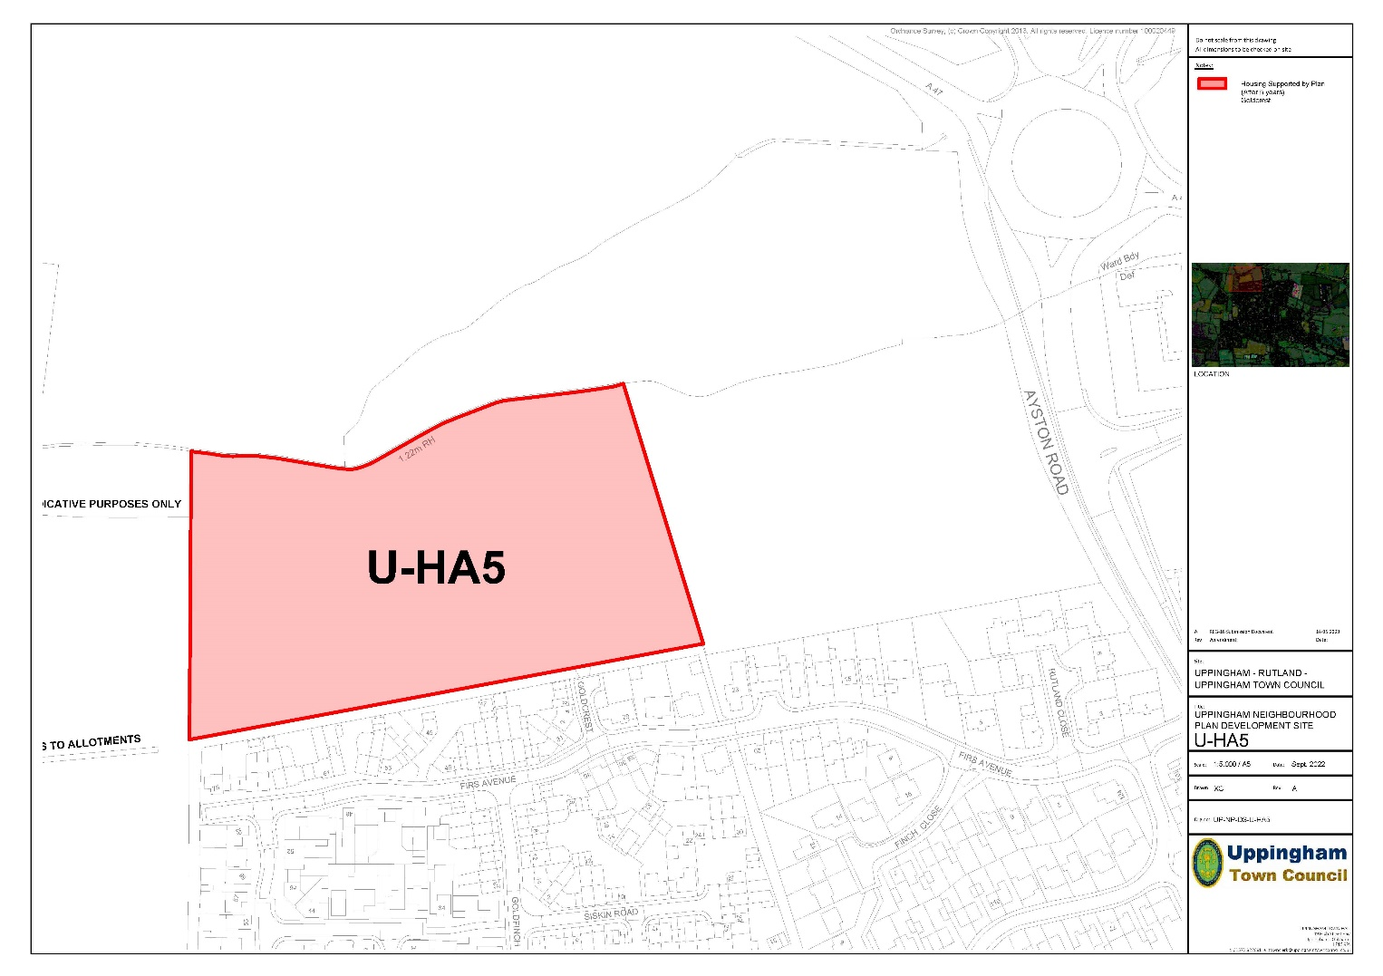
Other Housing Policies
1. Affordable Housing (Policy OH1)
Rationale
An adequate supply of housing which is affordable in relation to local incomes is an essential part of creating sustainable communities and helps to support a thriving local economy and to promote social inclusion. Rutland suffers particular problems of affordable housing, having some of the highest average house prices in the country and a high proportion of large houses. The main method where planning can help is by requiring developers to provide or contribute towards affordable housing as part of developments and by allowing small developments solely for affordable housing as an exception to normal planning policies.
In accordance with the NPPF, this policy (which is derived from the withdrawn Local Plan) is intended to meet the need for market and affordable housing in Uppingham. Although as a larger settlement, Uppingham has a wider role to play within Rutland, the specific needs of the town are also informed by the 2021 (CPRE) local affordable housing survey. Other than in prescribed circumstances, it is expected that affordable housing will be delivered on site. Affordable housing is defined in the NPPF as housing for sale or rent for those whose needs are not met by the market (including providing a subsidised route to ownership and/or is for essential local workers). The NPPF defines the following groups which meet this: • Affordable housing for rent; • Supporting entry to the market by first time buyers. (e.g. the Government requirement for that 25% of affordable homes on sites of 10 or more dwellings to be First Homes; • Discounted market sales housing; • Other affordable routes to home ownership.
The Town Council considers that, if possible, local management arrangements should be applied to any affordable or social housing that is provided. This will enable local needs and aspiration to be addressed to best effect and provide an opportunity for the sustainable long-term retention of properties to meet local needs.
Policy OH1: Affordable housing
Residential developments of 10 or more dwellings will be required to make provision, on site, for 30% of the scheme’s total capacity as affordable housing. Developments of between 6 to 9 dwellings may make contributions in the form of off-site contributions in line with the National Planning Practice Guidance. Affordable housing must:
(a) be of a combination of sizes and tenures to meet proven local and affordability housing need, including the number of bedrooms, property type and floor space;
(b) where affordable home ownership is included, ensure the properties meet a range of relevant local demand and local affordability;
(c) be equivalent in standard and siting to typical open market properties of the same floorspace/number of bedrooms/general type;
(d) be well integrated with open market housing through layout, siting, design and style; (e) be located on sites with reasonable access to town facilities. Development proposals which seek to underdevelop or split sites in a way that reduces the affordable housing contribution and/or promote off-site provision will not be supported.

2. Local needs and flexible homes (Policy OH2)
Rationale
The population structure of Uppingham means that, alongside the provision of houses for families (attracted by high quality schools and a generally high quality of life), there is a need for housing to meet the needs of older people, for example with reference to the RCC 2019 Strategic Housing Market Assessment and work in Uppingham. There is also a need to recognise increased working from home (self-employment and the changed, post-pandemic, workforce). The need for a range of house types and sizes within developments was included in the March/May 2021 community consultation leaflet on possible housing sites.
The price of new housing is a challenge for many first-time buyers, which is increasingly manifested by younger people who are not in established relationships buying properties on a shared basis. Whilst the Government First Homes requirement is pertinent and strategic policies require 1-bed dwellings, such units are not flexible. Households change and adaptation is required to meet the needs of both first-time occupiers and older people who need care. Boths groups often form single person households. Overall, and this is supported by consultation outcomes and local needs assessments, it is felt that wherever possible, new dwellings should not be too small such that they cannot be used flexibly by households of all types to meet changing needs and requirements. In general, this means that 1-bed units will normally be focused at social/affordable housing and specialist accommodation for older people. The number/proportion of such dwellings will be determined according to strategic policies and County/local needs and market assessments. It is anticipated that this will result in the housing mix set out in Table A, but provision on sites will be considered on merit, referring to factors such as location, landscape, access and adaptability.
Table A Indicative housing mix for new dwellings in Uppingham
Category | 1 bed | 2 bed | 3 bed | 4/5 bed
Open market housing | Up to 5% | 30 to 35% | 40 to 45% | 20%
Social/affordable housing | 20% | 35% | 35% | 10%
Elderly person housing | 60% | 40%

Policy OH2: Meeting local needs and providing flexibility.
New housing development on sites for 10 or more dwellings should include a range of house types and sizes to reflect the population, structure, existing housing stock and identified housing needs, in accordance with Table A (above). Homes suitable for young families and older people would be welcomed. However, smaller properties must include flexible spaces to enable adaptation: - as families grow and more space is needed; - to enable people to work from home; and - to enable carers and relatives to support elderly people.
New housing proposals must also take account of meeting identified needs for a growing ageing population by providing appropriate accommodation, including extra care and other forms of supported housing.

3. Opportunities for self-build (Policy OH3)
Rationale
The government’s intention is that there should be a significant increase in self-build and custom housebuilding. RCC research for the new Local Plan shows that there is a continued shortfall in self-build plots. This policy, which is based on the past RCC approach, supports the development of individual plots and small sites for self and custom build homes.
In deciding the location and scale of serviced plots on larger development sites, regard will need to be given to the practicalities, attractiveness and deliverability of the self-build plots. There should be regard to the market development and the impact that self-build can have on health and safety compliance during site construction. Regard will also need to be given to the impact of development where occupants have already moved in.
Policy OH3: Self-build and custom housebuilding
Proposals for self-build and custom build housing, to be occupied as homes by those individuals who have commissioned or built them, will be supported where they are in conformity with all other relevant local and national policies and there is proven demand.

4 Smaller scale infill development (Policy OH4)
Rationale
This approach is supported by the NPPF (Ch. 12 – Achieving Well Designed Places). Small-scale infill development on sites within the developed footprint provides an opportunity for sensitive development to help address housing needs and aspirations and this policy will ensure that the necessary design standards are met. It is intended that this policy will be applied alongside Policy SP5 of the Rutland Site Allocations and Policies DPD.
In built up areas, gardens are no longer considered to be previously developed land which means that there is no longer a presumption in favour of their development. The National Planning Policy Framework indicates that local planning authorities should consider the case for setting out policies to resist inappropriate development of residential gardens, for example where development would cause harm to the local area. Similarly, early work on the new Rutland Local Plan highlights the need for the planned limits of development to be taken into account, that the principles of good design should be met and the amenity of the wider environment to be protected.
Although it is a larger town, the principle of infill development comprising 9 or less dwellings, as applied to local service centres in Policy CS4 of the adopted Core Strategy, is considered to be appropriate within the Planned Limits of Development of Uppingham. These are defined on Inset Map 55 in the adopted Site Allocations & Policies DPD. https://www.rutland.gov.uk/my-services/planning-and-building-control/planning/the-local-plan/the-adopted-local-plan/ It is acknowledged, however, that site allocations in the current NP and this review document are not contained within these limits. In the longer term, the new Local Plan will confirm the Planned Limits of Development for Uppingham, incorporating site allocations in the Neighbourhood Plan.
Acceptable infill schemes will contribute to overall dwelling numbers as “Windfall Sites.” However, the extent of the Conservation Area, the needs of Uppingham School and other heritage/landscape related constraints, are likely to limit future windfall opportunities.
The existing Neighbourhood Plan includes a future housing allocation on a small triangular site off Leicester Road. Investigation has shown that this site is suitable for housing but the shape, access requirements and the public footpath (next to No.60) mean that only around 9 units can be accommodated. Given that the Neighbourhood Plan is limiting new allocations to larger plots, any proposals can, therefore, be considered under the infill policy and an allocation is not needed.
Policy OH4 Infill housing
Proposals for new housing on infill sites (10 dwellings or less) will be supported where they satisfy the following locally based criteria, where applicable to the location:
(a) Are appropriate to the surroundings, taking into account the character of parts of Uppingham with established dwellings set in large plots, the Conservation Area, listed buildings, archaeology, open spaces and Local Green Spaces;
(b) Are not located outside the Planned Limits of Development in the current, or future Local Plans;
(c) Would have no unacceptable impact on the residential amenity of nearby dwellings;
(d) Would not prejudice the operation of nearby commercial or industrial premises.

5. The design of new housing (Policy OH5)
Rationale
This approach is also supported by the references to design in the NPPF (Ch. 12 – Achieving Well Designed Places). In addition, guidance states that proposals should consider scale, both the overall size and mass of individual buildings and spaces in relation to their surroundings. It adds that decisions on building size and mass, and the scale of open spaces around/between them, will influence the character, functioning and efficiency of an area. It is also important that sustainable development features, including EV charging points are included in developments.
This policy provides important local details relevant to the distinct character of Uppingham. It will be applied alongside the RCC Supplementary Planning Document (November 2021- Design Guidelines for Rutland) https://www.rutland.gov.uk/my-services/planning-and-building-control/planning/the-local-plan/supplementary-planning-documents-spd/
There are many attractive villages in Rutland with a character based on vernacular architecture and materials, but Uppingham is a significant larger settlement in its own right. The traditional vernacular elements are present in the town, but the individual character of the built environment is further defined by topography, the role of larger institutions such as Uppingham School and the historic market, and administrative functions of the town.
Policy OH5: Design and access standards
Proposals for new housing developments proposals will be expected to:
(a) Make a positive contribution to the local distinctiveness and character of Uppingham. Proposals should reinforce local identity and not have an adverse impact on the street scene and the landscape/townscape character of the area, taking account of valued landscape, townscape and heritage characteristics, including views;
(b) Be of an appropriate scale, density and massing, using materials reflecting the area;
(c) Provide sufficient private amenity space, suitable to the type and scale of development;
(d) Retain and incorporate important on-site features, such as trees and hedgerows and incorporate, where possible, nature conservation and biodiversity enhancements;
(e) Demonstrate compliance with the Manual for Streets guidance and relevant Rutland County Council highways standards and guidance;
(f) Perform positively against national sustainability standards; (g) Ensure that streets and spaces are attractive, safe, easy to use and navigate and that they encourage people to walk and cycle, including connectivity to Town Centre to encourage integration, utility and recreation opportunities;
(h) Ensure that parking is well integrated and does not dominate the street scene;
(i) Ensure safe and easy access for emergency vehicles;
(j) Include ducting or other appropriate measures to enable (current and future) householder choice on IT services.
As part of its consultative role on planning applications and in support of the Neighbourhood Plan, the Town Council will require an individual design review on any development of 25 dwellings or more or any single building of more than 1000 sq. m. Such reviews should be carried out by an appropriately qualified independent body and conducted within the design review guidelines of this plan at the applicant’s expense.

Protecting the character and heritage of the town
1. Central Conservation Area (Policy C&H1)
Rationale
The growth of Uppingham from an agricultural settlement to a market town of over 4500 people, together with its rise as a place of manufacturing and trading help define its unique character and heritage. Many of its more substantial properties were erected in the 18th century creating its Georgian look. The ironstone from which many of them are built was quarried locally. The town’s marketplace and high street, with their attractive mix of retail and leisure outlets, lie at the heart of the conservation area. Their economic and social contribution to the town’s way of life are vital to the sustainability of Uppingham. It is a unique town with a very distinctive form and a long, rich physical and cultural heritage. There is, therefore, a need for specific local protection, given that the Local Plan is becoming out of date and there is a concern that the existing protection for heritage assets could diminish if the new Local Plan is delayed. This and the other heritage/environment policies reflect the advice contained in “Planning for the Environment at the Neighbourhood Level” (Historic England, Natural England, Environment Agency and Forestry Commission).

Policy C&H1: Central Conservation Area
Development proposals within or adjoining the Central Conservation Area will only be supported where:
(a) They comply with the County Council’s conservation and heritage policies, including those for listed buildings;
(b) Construction materials and finishes complement the surrounding area and the character and heritage of the immediate environment;
(c) If appropriate to the building/location, modern replacement/new build materials should also visually complement the immediate environment;
(d) In the case of commercial property alterations and frontages, they complement the heritage of the immediate environment. Wall mounted signage should be used.
(e) In the case of enhancement of the street furniture, signage and street lighting, it is of a heritage appearance but also has regard for energy conservation and public safety.
Any infrastructure improvements to the Central Conservation Area should complement the distinctive heritage/character and be as unobtrusive as possible. Such developments should not hinder their community use for events.

2. Other heritage assets, including important open spaces and frontages (Policy C&H2)
Rationale
The majority of the designated heritage assets are within the Central Conservation Area, but there are several listed buildings outside it. In addition, the adopted 2014 Site Allocations and Policies Development Plan identified Important Open Spaces and Frontages. Some of these larger spaces are covered by the Open Spaces policy in the Neighbourhood Plan, but other smaller areas are not and are regarded as heritage assets and are covered by this policy. Again there is, therefore, a need for specific local protection, given that the Local Plan is becoming out of date and there is a concern that the existing protection for heritage assets could diminish if the new Local Plan is delayed.
There is also archaeological interest in the town and the wider plan area. The NPPF (Para. 189 states “…Where a site on which development is proposed includes, or has the potential to include, heritage assets with archaeological interest, local planning authorities should require developers to submit an appropriate desk-based assessment and, where necessary, a field evaluation”. Details of the archaeology of the Neighbourhood Plan area can be found in Leicestershire and Rutland Historic Environment Record see: https://www.leicestershire.gov.uk/leisure-and-community/history-and-heritage/historic-environment-record
Policy C&H2: Other designated heritage assets, including Listed Buildings, Important Open Spaces & Frontages, and archaeological sites.
(1) Proposals affecting Designated Heritage Assets will only be supported where they satisfy the requirements of the Rutland Core Strategy Policy CS22 and the Rutland Site Allocations & Policies DPD Policy SP20.
(2) Development will only be supported where it does not have an adverse impact on an Important Open Space and/or Important Frontage as shown on the Policies Map of the Rutland Site Allocations & Policies DPD and the Uppingham Neighbourhood Plan.
(3) Proposals affecting archaeological sites and areas of archaeological potential, or their settings, should demonstrate that they:
(a) have taken into account the impact on above and below ground archaeological deposits, as recorded by Historic England and Rutland/Leicestershire County Councils; (b) identify mitigation strategies to ensure that evidence which could contribute to the understanding of human activity and past environments is not lost; and (c) include an appropriate desk-based assessment or, if necessary, a field evaluation.
Measures should be taken to minimise impacts of development upon the historic landscape character of the area.

The town centre and other retail development
1. Protecting the retail core of the town centre (Policy TC1)
Rationale
Uppingham has a vibrant town centre and is an important shopping hub for residents of local villages. Small independent traders predominate and the quality of life for those living in Uppingham is enhanced by the presence of the butchers, a hardware shop, baker, a clothes shop, post office, newsagent, food, takeaways, flower shop, cafes, licensed premises, the garage and food stores. The town is a quality visitor destination with excellent hotels, pubs and restaurants, art/antique galleries, book/gift shops and Uppingham School.
For the original Neighbourhood Plan and in connection with this review, respondents have made it clear that the Council should use the Neighbourhood Plan to sustain and support the trading efforts of local businesses while encouraging greater diversity in the town’s offer. Some towns have spoiled their centres by permitting inappropriate development or not encouraging an appropriate mix of quality businesses.
It is acknowledged that the Use Classes Order and Permitted Development Rights provide opportunities for property owners and businesses to adapt premises without the need for planning applications. However, outside these freedoms, where planning permission is needed for development, it is important to preserve the Uppingham shopping experience as one of ‘quality’. Therefore, the Neighbourhood Plan includes a primary frontage policy based on the existing Plan and including extensions on High Street West and Queen Street. Based on local concerns, the intention is to protect the unique character of the town centre and the critical contribution that it makes to the visitor economy for the town and County. It is in accordance with para 86 (b) of the NPPF.
Policy TC1: Primary Retail Frontages
Class E (commercial, business and service) and F2 (local community) uses will be supported within the Primary Shopping Area. Proposals for other uses in the identified primary shopping frontages will only be permitted where it is demonstrated that the proposal:
(a) will not result in an adverse cluster of other uses in the primary shopping area;
(b) will retain a ‘shop-like’ appearance with an active frontage;
(c) will not harm the predominantly retail character of the primary shopping areas; and
(d) will provide a direct service to the public with opening hours similar to shops. The primary shopping frontages comprise those shown on the map below with extensions on High Street West (Nos. 1,3,7,9,11 & 13) and Queen Street (Nos 3 & 5).
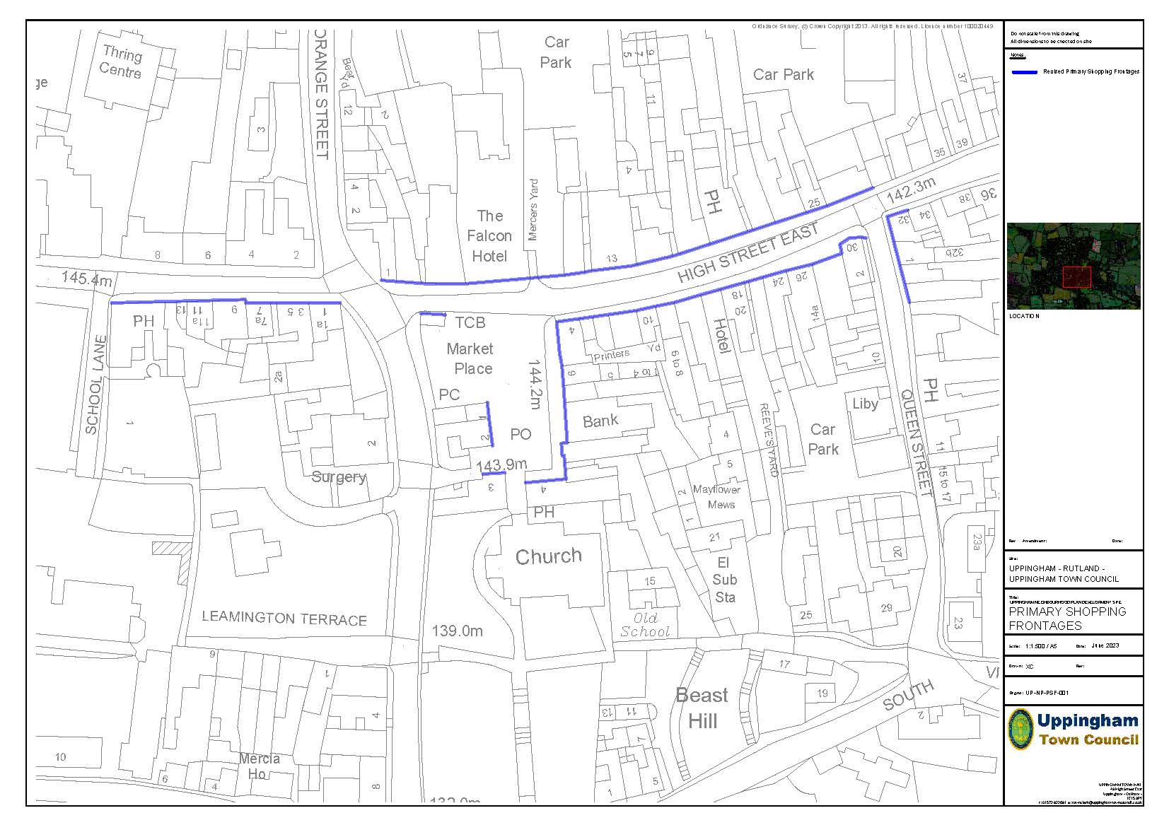

2. The role of the Market Place (Policy TC2)
Rationale
The Market Place is an important focus for the town and provides an attraction for visitors. Several surrounding buildings are covered by other formal planning policies, but this specific policy covers the historic and unique role of the Market Place, at the heart of the town.
In addition to planning control, where it is applicable, co-operation and partnership working will be needed to achieve necessary improvement. Complementing the protection offered by policies in this Neighbourhood Plan, the Town Council will work with the County Council and property owners to maximise the community use and appreciation of the Market Place, at the same time as respecting its unique heritage value.
Policy TC2: Protecting and enhancing the role of Uppingham Market Place
Development proposals to enhance the appearance, functioning and role of Uppingham Market Place will be supported, provided that they do not have an adverse effect on heritage assets, parking provision and traffic/pedestrian safety. Developments which would adversely affect the heritage and character of Market Place and its critical role at the heart of the community, will be resisted.
3. Enabling innovation and investment in the town centre (Policy TC3)
Rationale
In accordance with Section 7 of the NPPF (Ensuring the vitality of town centres), the Town Council and local businesses agree that continued investment is necessary to maintain the vitality and viability of the town centre. An important component of this is to encourage and enable new businesses to be opened, but the cost and requirements of floorspace is a constraint on this. The policy below supports innovation, giving emerging businesses a foothold in the high street. It is necessary to cross refer the policy to others, including heritage requirements, but the emphasis will be on enabling rather than frustrating development ambitions.
Policy TC3: Enabling innovation and investment in the town centre
Proposals to create dedicated town centre premises, either through conversion or new build, to accommodate new businesses will be supported, provided that other Neighbourhood Plan policies can be satisfied. This will include upper floors, where, when appropriate, residential uses will be encouraged.
4. Other retail development (Policy TC4)
Rationale
Uppingham is the second largest settlement in Rutland. It is strategically located at the A6003/A47junction which is heavily used by commuters and others. The 2011 population was 4745. Based on the 2020 estimate of 5000 population, the recent 2021 census is likely to show a further increase and the population could grow by up to 1000 as a result of new development over the plan period. Residents have to travel to Oakham, Corby and Stamford for larger convenience stores, which is not sustainable. The existing food convenience stores in the town centre are useful, but their capacity to meet growing need without creating unacceptable pressure on parking, traffic flows and air quality is limited.
At present, it is considered that land at Uppingham Gate and/or at Ayston Road, as part of mixed-use developments, may be appropriate locations for new food/convenience stores. Account must also be taken of the 2017 (RCC) Landscape Sensitivity & Capacity Study.
Policy OR1: Preferred locations for larger convenience stores
The provision of additional food/convenience stores, of an appropriate scale to meet the growing needs of Uppingham will be supported as part of a mixed-use development on sites U-HA2 (Ayston Road) and/or U-HA3 (Uppingham Gate) provided that landscape considerations are taken into account and that proposed dwelling numbers are achieved.

Related Community Proposals
Community Proposal TC1 – Investment in and support for Uppingham Town Centre
The Town Council will seek external funding opportunities to support investment in the town centre for premises, public spaces, infrastructure, events and marketing.
Explanation. Although Neighbourhood Plan policies must focus on land use which falls under planning control, the proposal concerns a wider town centre strategy, supported by evidence of public support and business involvement. This can provide a good platform to bid for government and other funding programmes. Where appropriate, the Town Council will also seek County Council S106 funding and CIL funds for town centre projects, or alternative funding if appropriate.
Community Proposal TC2 – Additional control of town centre advertisements and signs.
The Town Council will request the County Council to consider the designation of a Special Area of Control. This would enable additional control over advertisements and signs in the Town Centre, in particular the Conservation Area and its setting. It will also consider the potential for an informal advertisement and signage design guide supported by a local code.
Explanation. There is concern over advertisements and signage, including that which is temporary in connection with the letting or sale of properties. Much of this is covered by but this Community Proposal is included whereby the Town Council will engage the County Council in discussion about the potential for additional controls through a Special Area of Control in accordance with the Government Guidance on Advertisements, see: https://www.gov.uk/guidance/advertisements#Area-of-Special-Control It is recognised, however, that this cannot be achieved through a formal planning policy in the Neighbourhood Plan.
Town centre car parking, which also relates to needs generated by Uppingham School, tourism and leisure facilities, is considered in the Transport and Active Travel policy section.
Business and employment
1. Uppingham Gate business and related uses (Policy BE1)
Rationale
The principal development site offering new employment opportunities and business start-up possibilities is at Uppingham Gate on the northern boundary of the town (Reference Policy U-HA3). It has good heavy vehicle access from the north. This plan extends the opportunities at Uppingham Gate and an enhancement of the site’s viability, by supporting mixed use to deliver funding for infrastructure development, providing priority is given to job creation. The Classes referred to in the policy reflect the Use Classes Order (April 2021). The site area coincides with that of Policy U-HA3 for mixed use (residential and commercial).
Policy BE1: Employment Land and Mixed Use – Uppingham Gate
Land at Uppingham Gate is proposed for Class B2, B8 and/or E(gi), (gii) and (giii) uses, including small start-up units. Other employment generating uses and uses meeting local housing aspirations/needs will also be supported provided that:
(a) They address the local market, complementing rather than competing with facilities in Rutland and Corby, reducing the need for travel out of Uppingham to access services;
(b) The design is of a high standard, including aesthetics, layout and energy efficiency, with reference to the paragraph 130 of the NPPF;
(c) Landscaping is incorporated within the development, including the A47 frontage, the East and South boundaries, building upon existing hedges, trees, verges and ditches;
(d) Appropriate infrastructure is provided, including IT and electric vehicle charging points; (e) It includes access provision for pedestrians and cyclists.
The other uses which may be acceptable include: (1) A food supermarket of an appropriate size and design.
(2) Specialist accommodation for older people e.g. a nursing home or extra care facility. (3) Entertainment, leisure and recreation facilities.
Any development on the eastern (currently undeveloped) section of the site, or beyond, must include a new junction with the A47 which meets Highway Authority requirements. Access roads within the development must be designed to be capable of being extended to enable possible future development of land to the south and east.
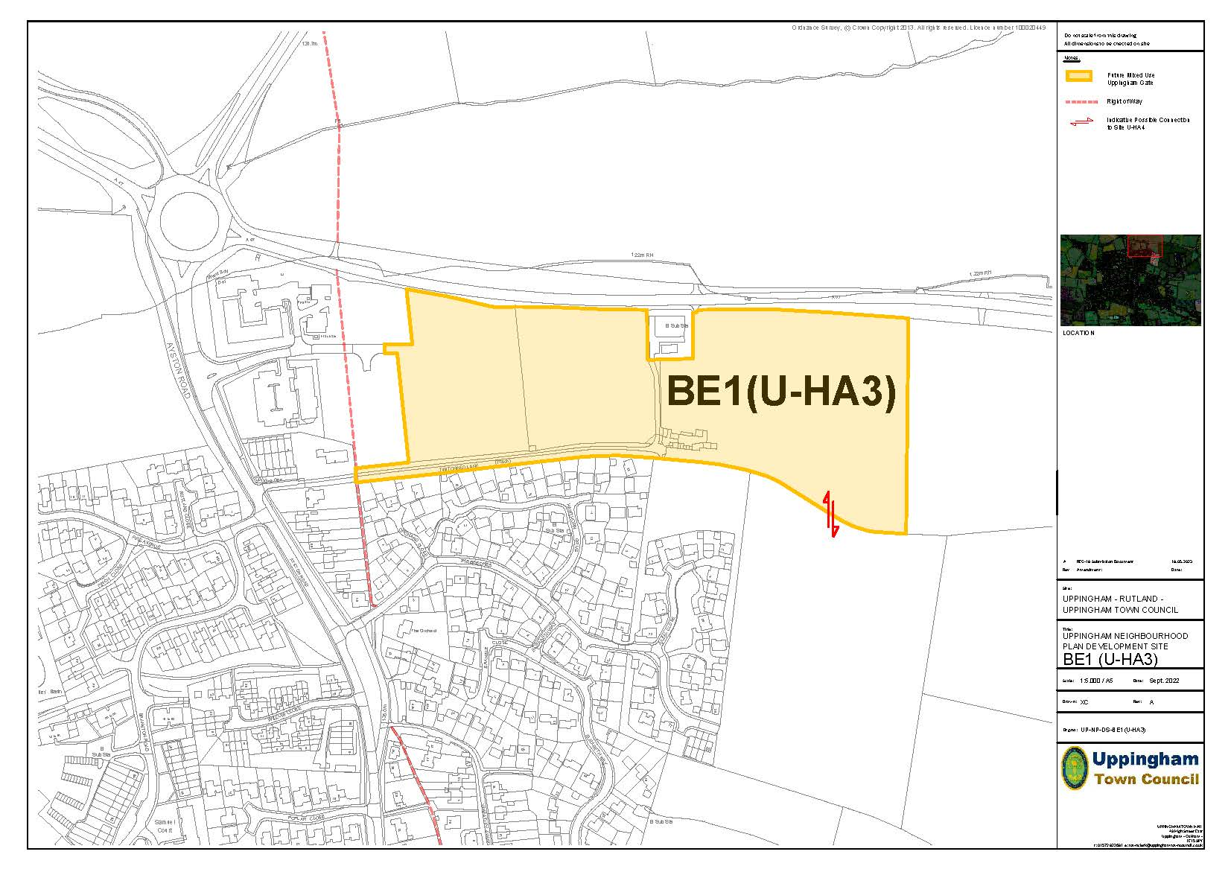

2. Land at junction of A47 and Ayston Road
Land off Ayston Road (Policy BE2)
Rationale
The site area comprises the northern section of Policy U-HA2 (residential development with potential for mixed uses) and could accommodate the local need for improved convenience shopping and/or other appropriate uses. Overall, commercial development of an appropriate scale, might include convenience shopping, food and drink outlets, a hotel or offices. The sketch plan shows the approximate area of land for development.
In accordance with the RCC Landscape Sensitivity and Capacity Study (2017), it is important that the landscape quality of the site is addressed through careful layout and sensitive design to minimise any adverse impact. In addition, this use could be made compatible with proposed new housing on the southern part of the site through access arrangements, design, layout, landscaping and screening.
Policy BE2: Mixed Use/Retail development at the junction of the A47 and Ayston Road
Approximately 1.67 Ha of land is proposed for mixed use development, subject to:
(a) Access arrangement, preferably a single shared road, to be agreed with RCC based on a Full Transport Assessment;
(b) A high standard of design with a landmark building and associated landscaping to create an attractive entry point to Uppingham from the north;
(c) The creation of a satisfactory functional relationship with the proposed new housing to the south.

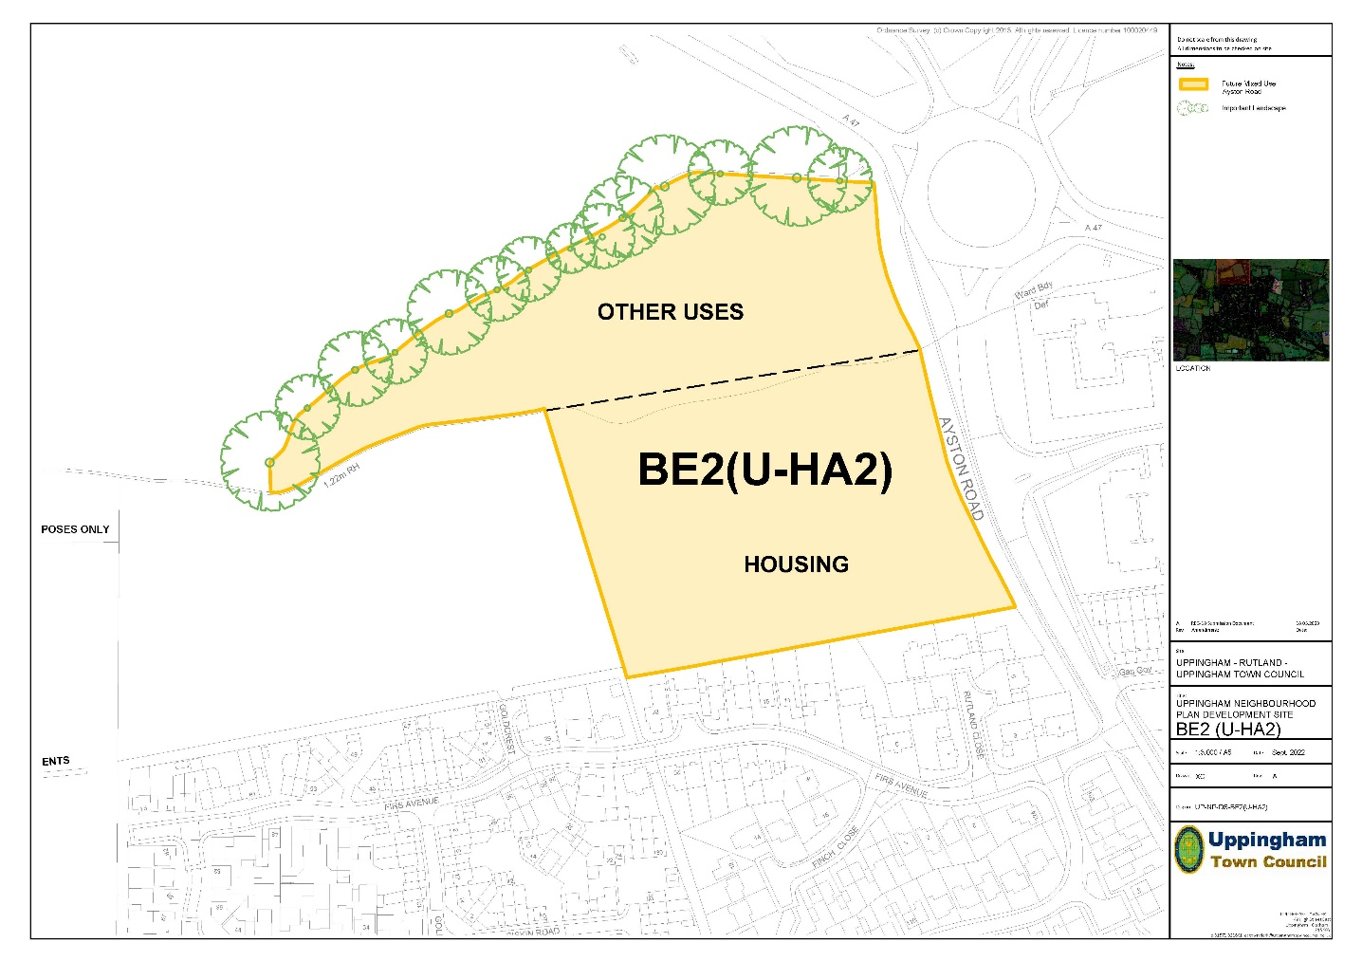

3. Station Road Industrial Estate (Policy BE3)
Rationale
Uppingham is a manufacturing town with heritage buildings and a character that attracts visitors from far and wide. Manufacturing uses are currently predominately located to the south of the town on Station Road. Employer discussions and subsequent public consultation have revealed that highway conditions, public safety, lighting, drainage and signage are concerns but private investment in many of the present buildings is noted, as is the stated desire of many employers to stay on Station Road.
The main spatial issues include whether a new access into the site can be created, and the highway upgraded to the Highway Authority adoptable standard. A research study of the potential to create a new Economic and Skills Development Zone founded on the estate will be commissioned in support of this policy.
In addition to enabling appropriate development through this formal planning policy, the Town Council will support efforts to secure the following improvements.
- Public adoption of the highway, with upgrading the road surface.
- Modernise and increase quantity of street lighting.
- Surface water drainage improvements. - A commercial public electric vehicle charging station, subject to appropriate access. - Introduction of a pressure pad/sensor warning light system at the London Road junction.
- Improved signage on London Road and at the entrance to Station Road.
- Fibre to the premise Broadband connections. - Improved access at the entrance to Station Road.
- Better traffic management and improved parking.

Policy BE3: Station Road Industrial Estate
Development will be supported provided that it supports the continued use of land and premises at Station Road for Class B2, B8 and E(gi), (gii) and/or (giii) uses.
Development proposals should not prejudice or prevent the potential for a new future point of access or egress from the eastern section of the industrial estate.

4. Welland Vale Business Zone (Policy BE4)
Rationale
Welland Vale, a long-established Garden Centre, with a café, play area, antique furniture centre and other small businesses is located outside the town, but has good access and parking and a stop for the Uppingham Hopper. There is scope for further development in what has become a distinct rural business location. However, new development must be appropriate to a rural location, and it should complement the current offer of the town.

Policy BE4: The Welland Vale Business Zone
Proposals for commercial and business development will be supported provided that: (a) The footprint of the garden centre/related uses is not extended into open countryside;
(b) Access and parking arrangements satisfy the requirements of the highway authority;
(c) The activity does not create noise, smells or pollution;
(d) The design of any new or converted buildings is appropriate to a rural setting.

5. IT and Communications (Policy BE5)
Rationale
Efficient, accessible and affordable communications are essential to a successful and sustainable rural economy. They are needed to enable existing and new businesses to thrive and to support working from home. It is also important to education, home care, social interaction and tourism. The previous NP noted that new technology will be a vital part of Uppingham’s future, with the ability to attract new employers and promote economic growth dependent upon the community embracing next generation technology. This need continues and an aging population will need access to tele-healthcare. Community services will often be offered on-line. Hotels, galleries, shops and schools will need the very best IT infrastructure the town can secure.
Investment in information technology and communications infrastructure is vital to sustainable development. However, as an attractive market town, it is important that infrastructure development does not detract from the charms of Uppingham and infrastructure provision should, wherever possible, observe this principle. The town is currently poorly served by mobile signals and has no 5G. The policy is intended to enable infrastructure investment as the town develops. The opportunity should continue to be taken to build in capacity and resilience at the time of construction, of both new houses and other buildings by incorporating ducts to enable occupier choice of broadband and other service infrastructure. As with the existing Neighbourhood Plan, it is also required that new housing developments should make a financial contribution to infrastructure. The County Council’s Digital Rutland project offers broadband speeds up to 80Mbs and Digital Uppingham Fibre Project offers a 1Gb ‘fibre to the premise’ service. The policy is in accordance with the NPPF (Chapter 10 - Supporting high quality communications).

Policy BE5: Information technology and communications
(1) All residential and employment schemes on sites allocated in this Plan will be expected to incorporate provision for fibre cables to the premises, information technology and communications infrastructure at current or future standards and to allow for future investment and improvement. The needs and preferences of property owners and/or occupier should be taken into account. (2) Other development proposals, including infill residential sites, retail, commercial and employment premises should make the maximum possible provision for owner determined fibre to the premise information technology and communications infrastructure, taking account of location, the land/premises involved and the scale of the development.
6. The visitor economy (Policy BE6)
Rationale
Rutland has a long established and important tourism economy, including Oakham, stone-built villages, attractive countryside, Rutland Water and Eyebrook reservoir. Tourism attracts 1.7 million visitors a year, generating over £113 million, supporting 1,600 jobs.
Uppingham makes a unique and significant contribution to tourism in Rutland and the East Midlands. Heritage buildings, quality shops, pubs and restaurants and Uppingham School combine to create an important local tourist destination for day visitors and overnight stays. This role is recognised on the Discover Rutland website: https://www.discover-rutland.co.uk/uppingham/ which acknowledges that visitors can: “Enjoy shopping amongst honey-coloured buildings, steeped in history, in a distinctly charming English market town.” In more detail, the thriving café society, renowned heritage and tree trails and the artisan/craft base of the town centre, attract visitors. Tourism based on Uppingham School, with international pupils and a Summer School, plus the benefit of an active French town twinning arrangement add to the attraction of the town. In addition, there are specialist visitor activities, based on things as diverse as high value motorcycles and bookshops.
The policy encourages continued sustainable growth in the visitor economy and supports developments where these will benefit the town and provide a quality experience to visitors and enrich the character of the local area.
Policy BE6: Proposed tourism development
Proposals which support the visitor economy in Uppingham, which are in accordance with other relevant Neighbourhood Plan policies, will be supported where they:
(a) make provision appropriate in use and character to the town and its rural setting; or
(b) support or enhance existing tourist and visitor facilities; or
(c) support the retention and enhancement of existing overnight accommodation and the provision of new overnight accommodation; or
(d) provide new tourism provision and initiatives which would also benefit local communities and support the local economy.
Sustainable rural tourism development of an appropriate scale and use which utilises the conversion of existing buildings and well-designed new buildings in the countryside will also be supported where it is located adjacent to, or closely related to, the town.

Community Proposal BE1– Investment in and support for Station Road Industrial Estate
The Plan supports a bid to the Local Enterprise Partnership (LEP) and any relevant government programmes for development funding and business support to maximise the economic potential of Station Road Industrial Estate and address current sustainable development issues related to traffic and energy efficiency.
Explanation. It is important, alongside any planning measures which can be taken, that a pro-active partnership-based approach is taken to highlight the infrastructure needs of the Station Road Industrial Estate. This community proposal sets out the intention of the Town Council to support funding bids and requests for investment by relevant agencies.
Community Proposal BE2 - Tourism
The Town Council will work with its partners to help promote Uppingham as a unique visitor experience, with quality at its heart and will take the lead in establishing a centralised information point.
Explanation. As a destination for visitors, Uppingham has much to offer, but no full-time tourist office. Some tourism literature is held by the major hotels, the library and restaurants. The town is promoted by means of a range of successful websites but there is a need to ensure effective linkages between them. In the absence of a full-time tourist office, much could be gained from a centralised information point, supported by trained volunteers. The town’s community mount a wide range of initiatives and events to increase footfall and attract more visitors. However, it is the town’s reputation for being a ‘quality’ destination that has most significance for any marketing initiative. The town’s approach to promoting tourism must recognise its unique character and heritage.

Transport and active travel
1. Reducing town centre traffic (Policy TR1)
Rationale
At present, the lived experience of residents, local businesses and visitors is that the town centre suffers from high volumes of traffic, including HGVs. While the A47 routes West/East bound traffic to the North of the town, the A6003 and B664 intersect in the heart of the town centre. The A6003 linking Oakham/Rutland Water to Corby is especially busy, partly due to the growing population of Corby and its extensive industrial and logistics sites. This creates safety problems for pedestrians and cyclists (including school pupils), causes congestion and air quality issues and has an adverse effect on historic buildings. In terms of the proposed site allocations in this neighbourhood plan, it has been concluded that, as acknowledged by RCC and considered in the UTC Arup Study, much of the traffic in Uppingham is generated elsewhere. Consequently adding 360 to 513 new homes over a 20-year period is unlikely to be significant when compared to general traffic growth. However, the situation is finely balanced, and it is important that the traffic implications of any further speculative development proposals, are given serious consideration.
As demonstrated in earlier studies for RCC and a recent study by Arup and Partners commissioned by the Town Council, there is potential for development around the edges of the town to include road connections which give alternatives to some of this traffic. In particular, there is potential for a new relief road, if funding could be found. The Town Council recognises that it may not be possible for these connections to be provided in the form of a single by-pass scheme but consider that a pragmatic approach which links improved connectivity to planned development is a legitimate objective for the Neighbourhood Plan.
As part of this, the potential to improve connectivity has been one of the criteria involved in the selection of the preferred locations for new housing. However, in addition to infrastructure provision associated with new housing, the Town Council wishes to protect opportunities for longer term connections and will also seek external funding in support of new connections.
In addition to these positive measures, the need for an accurate assessment of traffic generated by development is recognised as an essential part of the planning process. This policy should be read in conjunction with site specific requirements for new housing sites and mixed used development, including food retailing at Uppingham Gate.
Policy TR1: Providing the scope for new/improved road connections.
Development proposals around the edge of Uppingham will be supported where they can satisfy other relevant Neighbourhood Plan policies and where they can contribute to new or improved road connections.
Development proposals will not be supported where they prejudice the potential for new or improved road connections.

Proposals which would generate significant additional traffic and/or which would generate additional HGV traffic will require a Transport Assessment or Statement.

2. Active Travel (Policy TR2)
Rationale
Active travel concerns walking and cycling. It is acknowledged that transport is the responsibility of the highway authority (RCC) and that a policy context is provided mainly in the Local Plan and Local Transport Plan, but partnership working with the Town Council will be important to address local issues. For development other than residential extensions and changes of use in individual units, it is hoped to support an increase in safer walking and cycling, including access to public transport. This will support sustainable development and support the social, health and well-being of the community. It is recognised that the nature of development in the town centre is such that individual schemes are unlikely to enable substantial measures, but there is the potential for an incremental approach. In addition, the Town Council will look for partnership opportunities with, and investment from, the County Council and other agencies to address the known problems in the town centre.

Policy TR2: Providing safer walking and cycling and public transport.
Residential and commercial development proposals on new sites and through the conversion of existing buildings will be supported only where they incorporate measures to increase the provision of safe walking and cycling routes around the town and better public transport. The following needs should be addressed:
(a) Access to schools, shops, community facilities and open spaces;
(b) Access to employment sites;
(c) Convenient access to bus stops and public transport;
(d) Connections to public rights of way;
(e) Integration of the new housing areas with the town and its facilities.
Development should, where possible, facilitate the provision of safer road crossings and better traffic management to improve the environment for pedestrians and cyclists.
3. Town centre car parking (Policy TR3)
Rationale
Notwithstanding the benefits that will arise from more active travel options, car access for local people, visitors and businesses is a critical element in the viability and economic health of the town centre. At present there is insufficient town centre parking at peak times and the fragmented nature of provision leads to some congestion.
The Plan supports the current Town Council efforts to improve the situation. Having successfully campaigned for more parking at the top of Seaton Road, it is hoped this can be extended. Signage to car parks in the town has generated criticism which is addressed in the signage section of the Plan. Resident parking is an issue in some streets. New housing should link communal parking spaces to individual properties where appropriate.
A survey of town centre parking undertaken in October/November 2021 resulted in the finding that, whilst there is adequate parking within the town for local and visitor traffic, it is not always where it is needed and inadequately signposted, which leads to problems at peak times. Details are available in the evidence document.
It is again recognised that the nature of development in the town centre is such that individual schemes are unlikely to enable substantial new or improved parking, but there is the potential for a cumulative approach to be taken. In addition, the Town Council will look for partnership opportunities with, and investment from, the County Council and other agencies, to address the known parking problems in the town centre. This should include the potential to reconfigure existing on and off-street parking.
Policy TR3: Town centre car parking
Development proposals will be supported where they incorporate improvements to the access, signage and usability of town centre car parking, including the provision of electric vehicle charging points.
4. Public transport and coaches (Policy TR4)
Rationale
As noted in the current Plan, the oval shaped roundabout at the top of Seaton Road continues to cause problems for buses and long commercial vehicles trying to turn around it. It should be replaced by a low-profile roundabout of a different shape.
Consideration should be given to bus movement on North Street East. The current situation can be dangerous for vehicles exiting the Co-op car park and visibility is impaired by waiting traffic at bus stops and parked vehicles. This needs to be improved as a matter of urgency. Coaches regularly bring visitors to the town and service the schools but provision for coach parking is poor.
Policy TR4: Improved facilities for public transport and coaches
Highway and transport improvement schemes that address problems will be supported at the following locations: (1) The roundabout at the top of Seaton Road; (2) The present bus interchange and access to it. (3) Coach parking in an appropriate location which is accessible by foot to the town centre.

Community Proposal TR1 (improved management of town centre car parking).
The Town Council, working with businesses and the County Council, will agree an action plan to address known parking problems in the town centre.
Explanation. It has been noted that the car parking survey resulted in the finding that there is adequate parking within the town for regular local and visitor traffic but that it is not always where it is needed and not adequately signposted. Details of the survey are available in the evidence document. A series of factors were identified that need to be considered.
- There is little or no indication to the visitor as to where parking is available.
- The town has an ageing population which needs close access to the high street and its businesses. Some parking is too far away from the town centre.
- A number of on-street parking areas do not have marked bays which frequently works against maximum use.
- A large number of disabled spaces are unused at present.
- Servicing and unloading cause congestion.

Community facilities and services
1. Existing community facilities (Policy CF1)
Rationale
To provide the social, recreational and cultural facilities and services the community needs, the NPPF (Para. 83d) states that planning policies and decisions should enable: “the retention and development of accessible local services and community facilities, such as local shops, meeting places, sports venues, open space, cultural buildings, public houses and places of worship.” In criterion (a) explicit community support would include the views of the Town Councils and users of the facility in question. Applicants may also wish to undertake consultation with the local community to demonstrate support for a proposal. Local Plan policies also state that local facilities are important to the sustainability of towns and that proposals that would result in the loss of existing facilities will be resisted.
This, locally focused, Neighbourhood Plan policy updates the protective approach of the Local Plan, noting that is becoming out of date. The policy requires that applicants must demonstrate that consideration has been given to re-using premises for an alternative community business or facility and that effort has been made to try to secure such a re-use. The impact that closure may have on the area and its community must be measured, with regard to public use and support for both the existing and proposed use. Where a loss of a community facility is promoted on market-based grounds, the Town Council will consider seeking Asset of Community Value designation.
In the previous Neighbourhood Plan, it was noted that, because Uppingham is not the county town, some investment in new community services or buildings has been lacking. However, the town has a vibrant community sector with many of the community services that are accessible in the town being provided by local voluntary groups in a variety of premises. The town does not have its own youth centre but does have excellent school-based facilities and independent sports clubs.
Policy CF1: Community facilities & local services
The Plan identifies the following community facilities and local services: - Library
- Town Hall - Community Uppingham Football Club - Uppingham Bowls Club - Uppingham Cricket Club - Uppingham Library - Uppingham Scout Hall - Uppingham Church of St Peter and St Paul (C of E) - Uppingham Methodist Church
The improvement and extension of these buildings and the creation of new facilities will be supported, subject to compliance with other Neighbourhood Plan policies.
The community facilities in Uppingham will be protected. Where planning consent is required, the loss of such facilities will not be supported unless:
(a) alternative provision of equivalent or better-quality facilities (with community support evidenced by pre-application consultation and/or local surveys) is made; or
(b) it is evident that there is no reasonable prospect of the facility being retained; or
(c) it is evident that the service or facility is no longer economically viable; or
(d) there is no demonstrable evidence of local use of that service or facility.
2. Needs arising from new development (Policy CF2)
Rationale
The principle of new housing is accepted, but the development of new dwellings will result in a population increase over the life of the Plan. It is reasonable, therefore, that the development should have appropriate safeguards to ensure a good quality of life, health and welfare, according to the diverse needs of existing and future residents.
Increased provision of community facilities is essential to ensure that new development can be successfully integrated into the town physically, socially and economically. As noted in the NPPF (Sections 8: Healthy and Safe Communities, 12: Well-Designed places & 14: Climate Change), investment in community infrastructure is necessary to ensure that communities undergoing growth and change remain sustainable, cohesive and healthy. It is acknowledged that funding must comply with Community Infrastructure Levy regulations.
Policy CF2: Investment in new and improved community facilities and services
Proposals for new and improved community facilities will be supported on sites which are accessible to the local community, where the requirements of other applicable Neighbourhood Plan policies can be met.
This applies to provision associated with new housing and other development, other investment in new sites/facilities and existing locations.
Direct investment in infrastructure and/or development related funding must be provided as part of new housing development (of 10 dwellings or over) to ensure that community facilities and services (including health and education) are able to meet the needs of a growing population.
Community Proposal CP 1 - Getting the best out of community facilities.
The Town Council will seek investment from and partnership working with the County Council, external funders, community organisations and schools to maximise the effective use of existing buildings and facilities. There is also an intention to improve facilities to benefit users and achieve better environmental/energy efficiency standards.
Explanation. Thriving local communities need places to meet for group activities and entertainment, larger community events and celebrations, and to hold public meetings and elections. Existing community halls are valued by residents, but consideration needs to be given as to their future as the town expands. To complement the protection offered by policies in this NP, the Town Council will work with the relevant stakeholders and other groups to secure the future of the community facilities and to discuss ways in which their value to the community can be built upon. This will include exploring a range of collaborative funding initiatives.

Open Spaces and Environment
1. Protect and enhance existing open spaces (Policy OS1)
Rationale
Open spaces are critical to the quality of life enjoyed by residents and contribute to the character of Uppingham. As such, they may be protected in line with Paragraphs 92(c) and 97(a, b & c) of the NPPF. Where development is proposed that affects playing fields and recreation areas, the Sport England guidance should be followed and, if necessary, advice sought from that organisation, which is a statutory consultee. In addition, the Town Council will support proposals to enhance and improve the open spaces in the town, both in terms of facilities and habitat creation/management, as and when opportunities emerge.
Under this policy open spaces include public open space (parks and recreation grounds), school playing fields, sports grounds, cemeteries, churchyards/burial grounds. Sports grounds, which are well known and readily identifiable on OS or online maps, are not mapped separately but are covered by the policy. The two allotments sites in the town are the subject of a separate Local Green Spaces Policy (OS3).
Tod’s Piece is the principal central open space in the town and is a Field in Trust. The Trust Deed defines it as a playing field for the purpose of outdoor games, sports and pastimes.
Larger open spaces associated with housing areas are shown but there are also many other incidental open spaces small (and consequently difficult to map accurately) within the housing estates in the town (including private and rented housing). These fulfil a multiple role, providing breathing space for residents, improving the landscape and creating valuable habitats and are also covered by the policy.
The policy reflects, but adds local detail to, CS23 in the Core Strategy. It is important that the protection of these open spaces extends beyond the time that the Core Strategy has legal status. They are essential to the character of the town and to the quality of life of the existing and future residents of Uppingham.
Policy OS1: Protect and enhance existing open spaces.
The Plan protects existing sports/recreation grounds and designates the areas of land listed below as open spaces which will be protected. OS1 Tod’s Piece OS2 Hog Hill
OS3 Beast Hill OS4 London Road Cemeteries (South View and The Lawn) OS5 Leicester Road Cemetery
OS6 Ayston Road Green and connecting footpath OS7 Land off Linnet Court and Lime Tree Avenue OS8 Land off Ash Close and Seaton Road
OS9 Land within and South/East of The Elms (recently completed housing)
(a) Development proposals which enhance or improve existing sites will be supported.
(b) Development proposals which would reduce the quality or quantity of these facilities will only be supported if existing facilities are replaced at a better quality or quantity and in a sustainable location.
The policy also covers incidental and amenity open spaces within housing areas which, although smaller, are all nonetheless important to the community.
This policy will also apply to open spaces created within the proposed new housing sites .
The Open Spaces identified by the policy are shown on the three maps below.
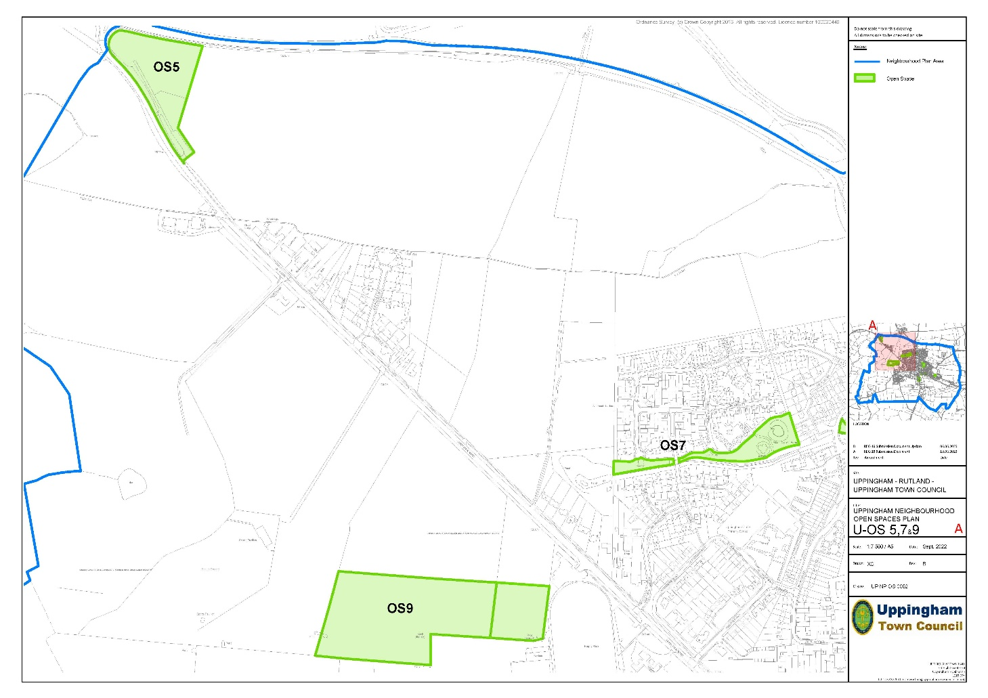
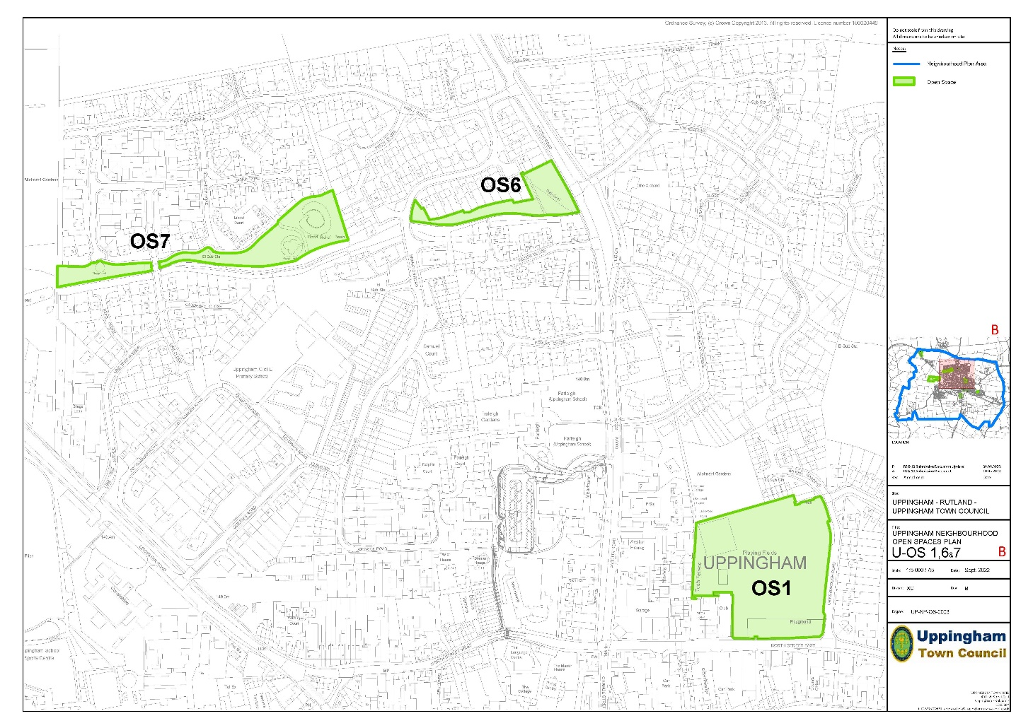
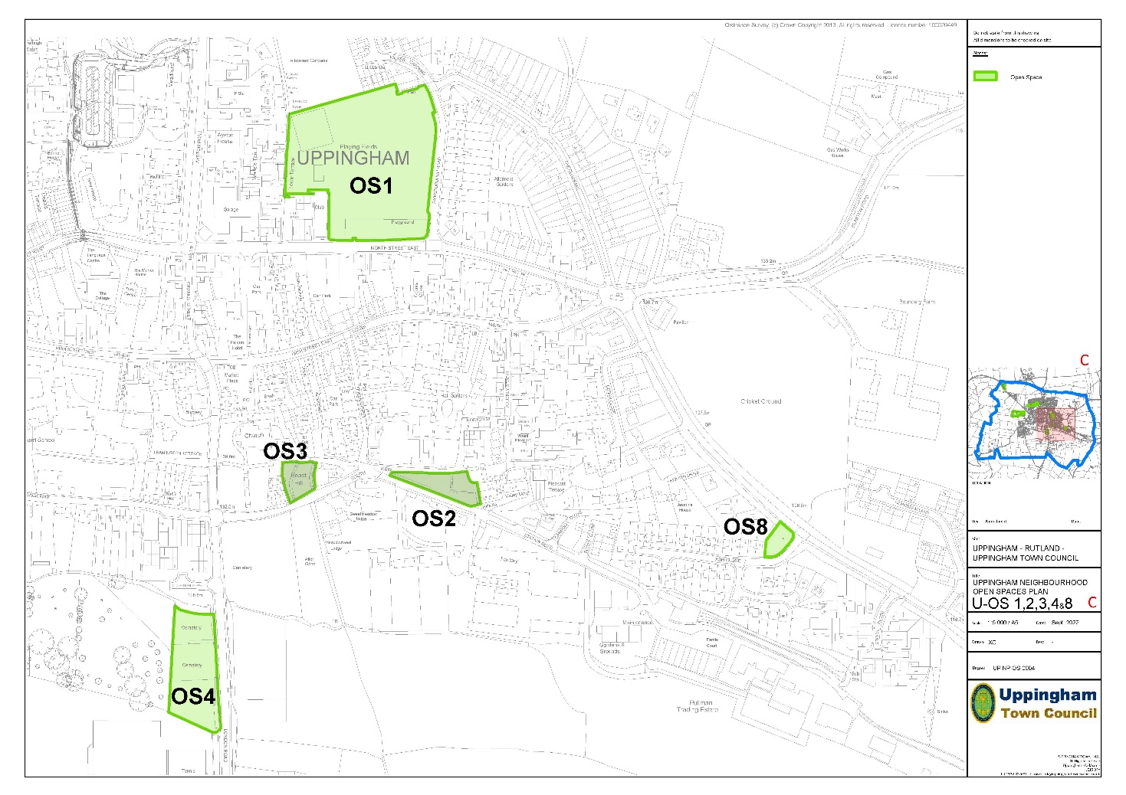

2. Open spaces and new development (Policy OS2)
Rationale
The development of new housing sites will create a need for new open spaces and require the provision of such open spaces. Whilst incidental open space and landscaping should be provided as part of good design in new housing schemes, there is also a need for investment in the larger spaces/facilities which serve the whole community. As with other physical and community infrastructure, it is important that open spaces are provided to ensure that existing infrastructure is not over-stretched as a result of the potential scale and pace of new development over the plan period. The nature, scale and location of new open spaces need to be considered carefully from an early stage in the planning process. It is acknowledged that the existing Local Plan provides a reasonable basis for open space provision in new development, but that document is becoming out of date. Given new housing sites will arise through the review of the NP, it is considered important that a locally based policy, reflecting needs in Uppingham, is put in place. However, as far as the strategic policy SP22 is concerned, it is acknowledged that a revised policy will emerge through a new Local Plan.
With regard to the final clause(c) of the policy it is important that long-term ownership and maintenance arrangements are put in place, including initial and ongoing financial contributions related to the development. The discussions on this should involve the developer, the Town Council, Fields in Trust and the County Council. The Town Council will wish to ensure that unreasonable financial burdens associated with open space provision and management are not placed upon it. The Town Council already owns and manages open spaces and wishes to expand this, but it is important that this activity is sustainable from a financial viewpoint.
Policy OS2: Open space provision within new housing developments
(a) Larger scale new housing development (10+ dwellings) should include the provision of:
(i) Green spaces to meet the recreation needs arising from the development and for the benefit of wildlife;
(ii) Green corridors to help bring the countryside into the built environment;
(iii) Tree planting and other landscaping, using native species to enhance the appearance.
Provision of larger open spaces should be made within or adjoining the development unless it is not practical or viable to do so and agreement has been reached on that point with the Town and County Councils. In such circumstances, land and/or a commuted sum should be made available to those authorities to enable appropriate provision to be made.
All incidental or amenity open space provision must be within the new development.
(b) The level of provision should be in accordance with the standards operated by Rutland County Council, set out in the adopted Site Allocations & Policies DPD Policy SP22.
(c) Arrangements must be put in place for the long-term maintenance of any open spaces created or enlarged/improved.
3. Proposed Local Green Spaces (Allotments)

Rationale - Proposed Local Green Spaces
In the (Regulation 14) Draft Plan protection was afforded to public open spaces, including allotments by Policy OS1. However, consultation on the Draft Plan showed a clear community desire for particular protection for the two allotment sites in the town and it was suggested that Local Green Space (LGS) designation should be considered. Government guidance notes that LGS designation is a matter “...for local discretion...” and includes allotments as the type of spaces for which LGS designation may be appropriate, provided that the designation criteria can be met. The NPPF (Paras. 99 -101) allows the designation of Local Green Spaces in Neighbourhood Plans subject to three criteria, in that the land must be:
a) in reasonably close proximity to the community it serves;
b) demonstrably special to a local community, holding a particular local significance, e.g. because of beauty, historic significance, recreational value, tranquillity or rich wildlife;
c) local in character and is not an extensive tract of land.”

The Tod’s Piece (LGS1) and Leicester Road (LGS2) allotment sites are shown on the map on page 58 of this Submission version of the Neighbourhood Plan. The table below summarises how the two sites meet the LGS designation criteria.

Location/Site | Not Extensive (NPPF) | Proximity to community (NPPF) | Qualities (NPPF) | Other Factors
Tod’s Piece | Local (0.5Ha) | Within town | Recreation, Tranquillity, Wildlife | Public access on footpath alongside west side of site.
Leicester Road | Local (2.1Ha) | Within town | Recreation, Tranquillity, Wildlife. | Public access on footpath alongside west side of site.
Therefore, the two allotments sites fulfil the criteria and an explicitly restrictive policy approach towards development is reasonable. The Town Council wishes to be clear that only allotment uses and any development ancillary (e.g. access, water supply, sheds, green houses) to that principal use will be acceptable on these sites.
Policy OS3: Proposed Local Green Spaces
The Neighbourhood Plan designates the following sites as Local Green Spaces: LGS 1 - Tod’s Piece Allotments, and LGS 2 - Leicester Road Allotments
Proposals for development on the Local Green Spaces other than that associated with the use as allotments will not be supported.

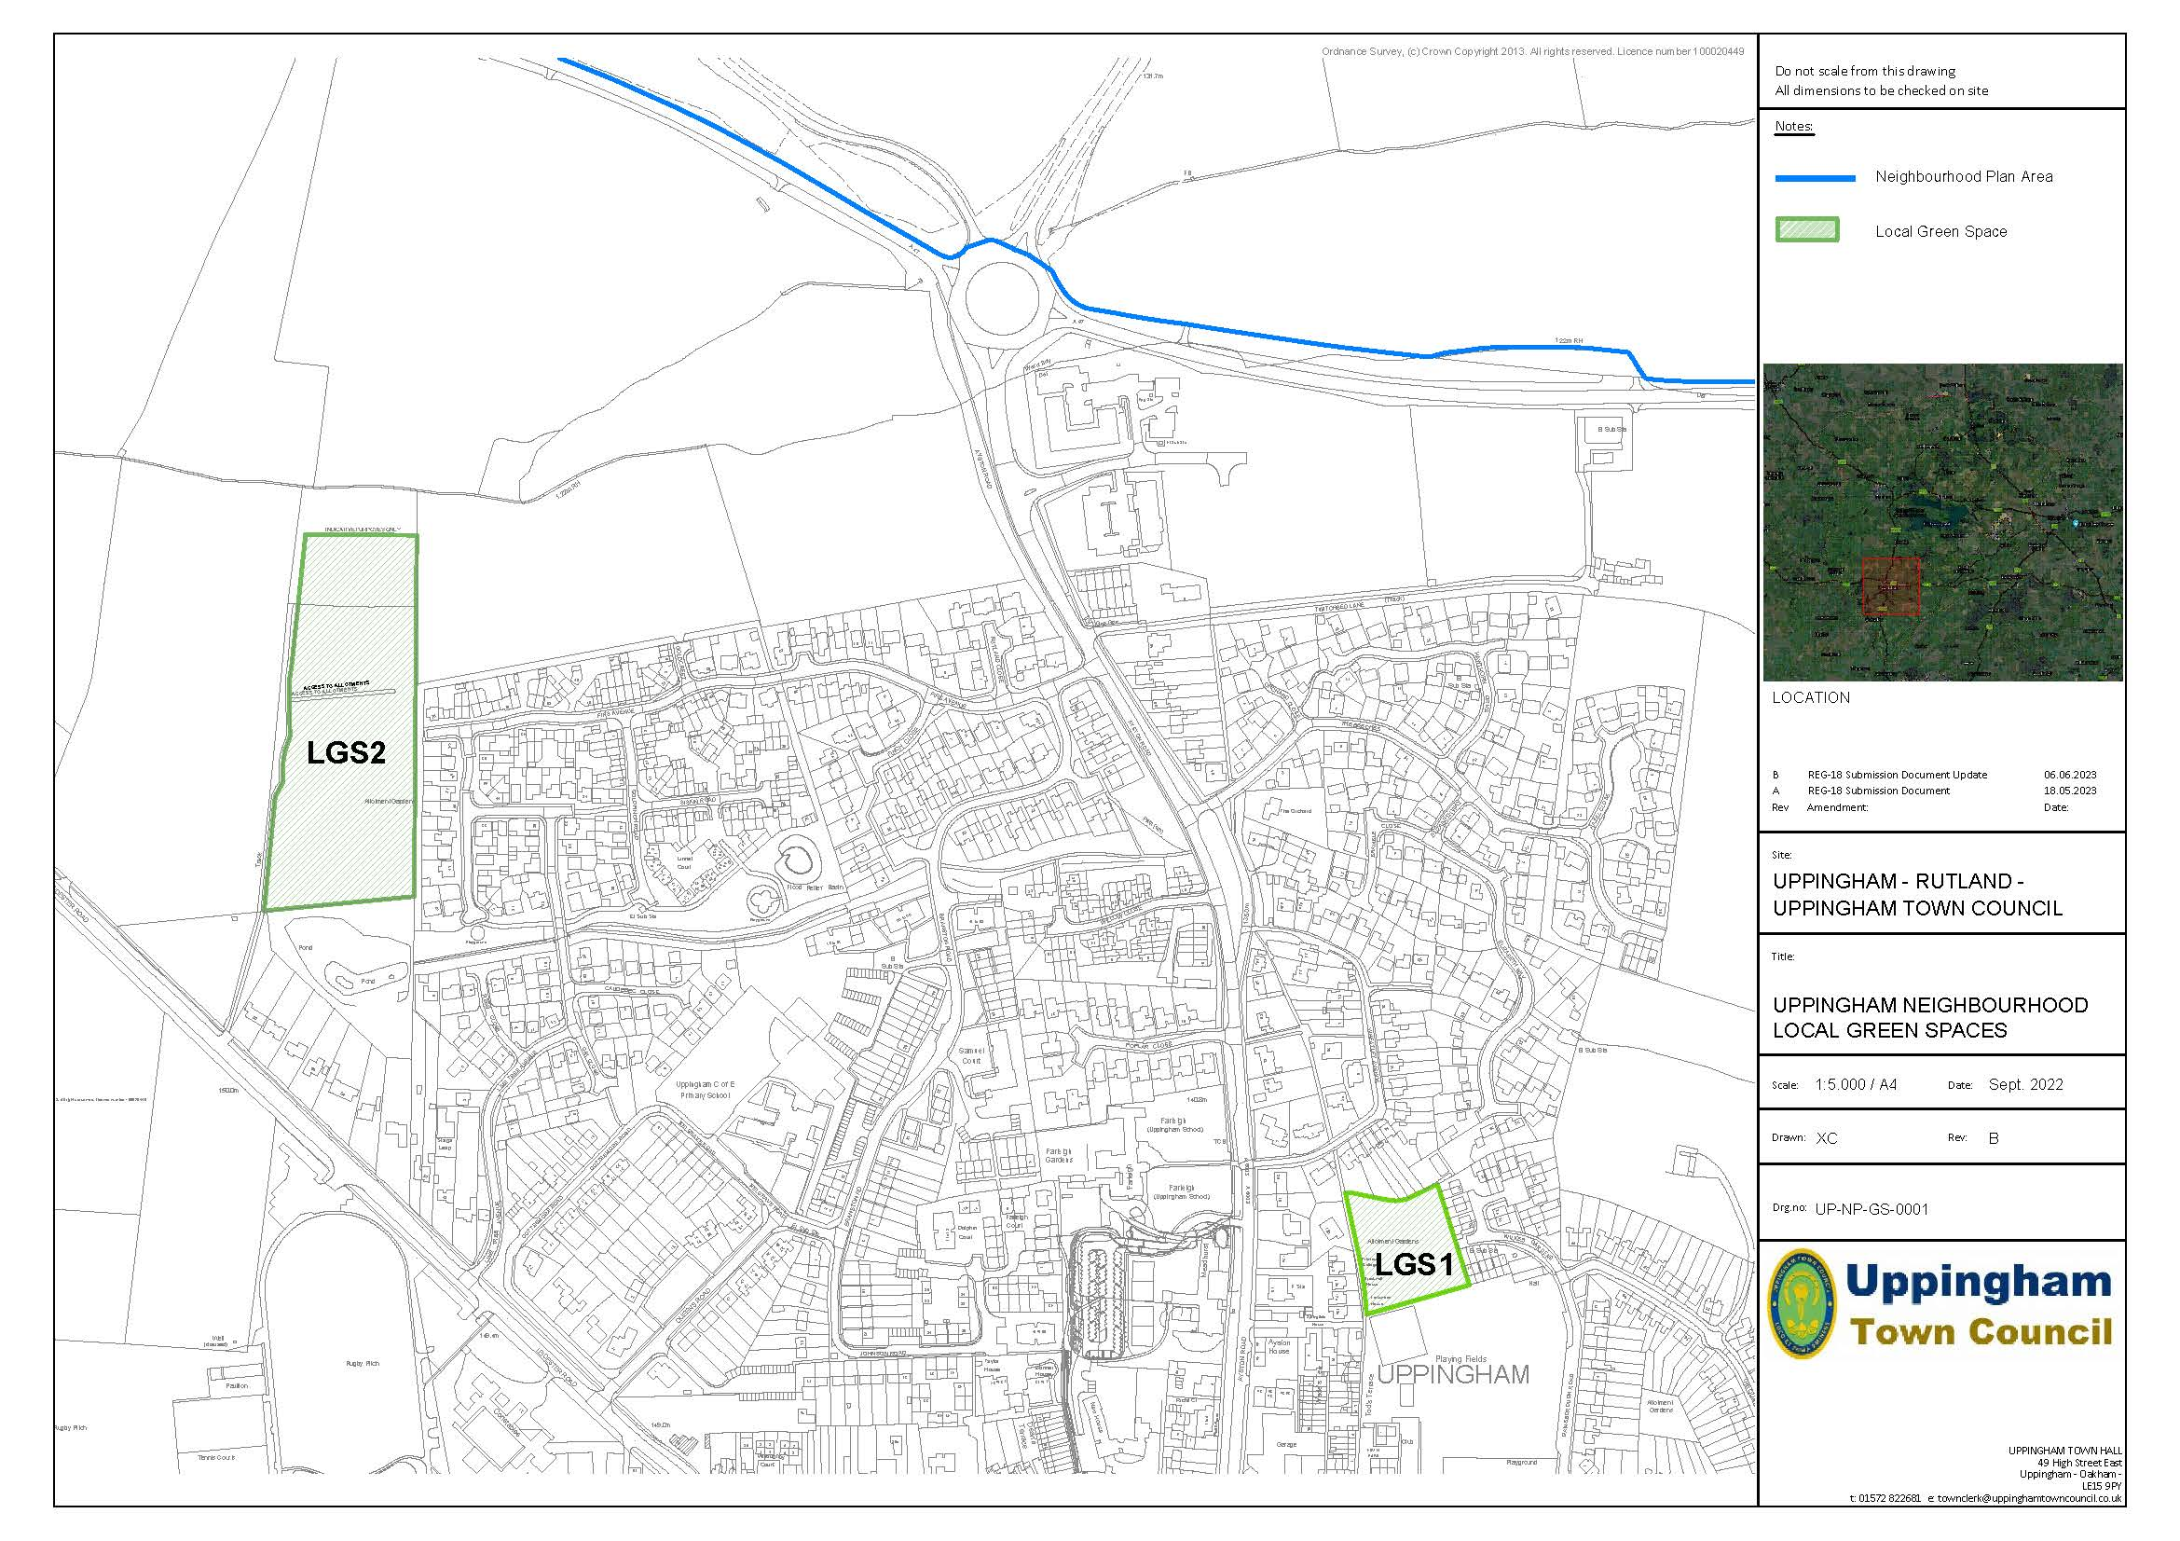

Implementation, Monitoring and Review
This section outlines the approach to the implementation, monitoring and review of the new Uppingham Neighbourhood Plan, including:
- working in partnership.
- monitoring/review.
- funding mechanisms; and
- priority projects.
Partnership working
The approach will be that new development, which is in other ways appropriate and acceptable with reference to the Neighbourhood Plan, should be supported by the timely delivery of the infrastructure, services and facilities necessary to provide a vital and viable community, with the highest possible quality of life for residents.
Uppingham Town Council is committed to Localism and locally informed influence over planning decisions, building upon an excellent track record in engaging in planning decisions. They will work:
- reactively through consultation; and
- proactively through promoting the policies of this plan and by delivering related projects for the local community.
It is recognised that partnership working is needed for the potential of the plan to be realised. In particular, landowners and developers will be encouraged to continue to engage with residents, the council and the town’s community partners at the earliest possible stages in development, including pre-application enquiries, progress discussions and potential infrastructure levy contributions required by the planning authority.
Monitoring and review
The adopted Neighbourhood Plan will be monitored by Uppingham Town Council with appropriate support from the Local Planning Authority (RCC).
The policies in this Plan will be implemented by Rutland County Council as part of their development management process. However, Uppingham Town Council will be actively involved in engaging developers/investors, using the Neighbourhood Plan to frame representations on planning applications and, where appropriate, as part of the pre-application process.
In terms of review, this second version of the Uppingham Neighbourhood Plan provides a clear basis for decision-making at present, but circumstances inevitably change. Flexibility may be needed as new challenges and opportunities emerge and it is intended to review the Plan periodically (e.g., every 5 years), in line with the Neighbourhood Planning Act (2017). A future review could be based on the following elements, to be considered in periodic monitoring reports:
    - public and private sector investment in the town, where securing the right type and nature of investment through adaptations and new development will be crucial.
    - the statutory planning process, and, in particular, how the Plan is used to determine local planning applications.
    - the state of public services (and community assets), together with other measures to support local services for the vitality and viability of the parishes.
    - engagement in the preparation of the future versions of the RCC Local Plan.
It is expected that the County Council will support the monitoring of the Neighbourhood Plan by providing dedicated data for the plan area.
The views of RCC, as the Local Planning Authority, will be sought on these matters.
Monitoring reports might conclude that a partial or comprehensive review of the Neighbourhood Plan is necessary at any time and accordingly trigger that process.
The report, prepared by the Town Council, will also include a listing of all planning applications in the Neighbourhood Plan area and the decisions made on them together with a schedule of approved development for new housing, from conversions and single plots to larger sites. A narrative section will describe the extent to which the Neighbourhood Plan has been successful in influencing planning and development decisions. The outcome of, and consistency with, pre-application discussions will also be considered.


In addition, the progress on achieving the community aspirations, including partnership, project work and funding, will be considered. Amongst others, developers and landowners are likely to be an important partner.
In accordance with the regulations, the Neighbourhood Plan has been prepared to be in general conformity with the current (RCC) Local Plan. However, UTC will pay particular attention to the Local Plan review, currently in its early stages.
Funding
UTC will direct funding from Community Infrastructure Levy (CIL) receipts towards Neighbourhood Plan-related projects and other local priorities which are identified, as set out in a three-year action programme which will be reviewed annually. Under current arrangements, a Parish Council with a “Made” Neighbourhood Plan in place can receive 25% of the CIL generated by development.
UTC will engage with RCC on the production of the county wide (CIL related) Infrastructure Development Plan (IDP) to ensure that wider CIL priorities reflect the needs of Uppingham.
Direct investment and/or other financial contributions will also be sought from developers, service providers and utilities to address other needs and opportunities arising from proposed development.
In addition, UTC will seek to influence budget decisions by RCC, including on transport and other infrastructure investment, to ensure that needs in Uppingham are addressed.
Work will also be undertaken with other organisations on funding bids to help fulfil Neighbourhood Plan aspirations, including sources such as the National Lottery’s Heritage Fund and Community Fund, Central Government, and Local Enterprise Partnership programmes.

Local priority projects
The list of infrastructure projects below reflects local priorities. This should inform CIL investment, the negotiation of Section 106 agreements and priorities attached to relevant spending programmes and external funding bids, for the following areas:
- Education
- Community Housing
- Car Parking
- Tod’s Piece
- High Street Improvements
- Footpaths/Cycleway
- Town Hall/Community Hub
- Health Provision
- Disability Access
Consideration will also be given to projects from other plans, strategies and projects prepared by the Town Council or other partners which relate to local aspirations.
In terms of CIL and S106, it is recognised that the proposed planning changes initiated by Government may impact on the aspirations of the Town Council to achieve and direct investment related to development.

Acknowledgements
The Town Council would like to thank the following.
Xell Cases of Uppingham School, for her support in helping to produce the technical maps that have appeared in both the earlier consultation document and in this current version.
Rutland County Council for their invaluable support.
All members of NPAG both past and present over the years.
Town Clerks and their assistants.
Town Councillors for their many years of hard work.
The cooperative approach of developers and land agents.

Appendix 1 – List of (with links to) Evidence Documents
Consideration was originally given to a review of the Uppingham Neighbourhood Plan, shortly after it was “Made” in 2016, but uncertainty about the timing of the introduction of a new Local Plan and the impact of Covid-19 slowed progress. In 2018 and 2020 the Town Council undertook community surveys and commissioned external support in preparation for Neighbourhood Plan review and that work is part of the evidence base. Other documents have also been prepared in response to comments on the Draft Plan. Therefore the (final) Evidence Documents for the Uppingham Neighbourhood Plan are:
May 2018 and May 2020 (Commissioned from OPUN by UTC to inform the NP review).
- 2018 Paper 1: Census Data
- 2018 Paper 2: Local Housing Needs Assessment
- 2018 Paper 3: Local Business Aspirations
- 2018 Paper 5: Roads and Transport
- 2018 Overall Paper: Strategic policy context, sites and issues.
- 2020 Paper 1: Principles
- 2020 Paper 2: Neighbourhood plan policies and the emerging Rutland local plan
- 2020 Paper 3: The evidence base
- 2020 Paper 4: Planning Decisions and the Uppingham Neighbourhood Plan
- 2020 Paper 5: Housing site assessment criteria and local transport needs
- 2020 Paper 6: Traffic Context (Corby/Kettering and Rutland)
- 2020 Paper 7: Proposed approach to external consultation
Other reports
- 2021 Arup Uppingham bypass study (Commissioned by Uppingham Town Council)
- 2020 CPRE Uppingham Local Housing Needs Survey
- 2022 Housing Sites Assessment
- 2022 Housing Requirement; Past Development Rates
- 2022 Strategic Environmental & Habitat Regulations Assessments (by AECOM)
2023 (in response to consultation responses on the Draft Plan)
- BP1 Reg. 14 Housing numbers and requirements
- BP2 Uppingham 2021 Census update
- BP3 Housing Mix
- Housing Need Assessment 2023 (by Marrons Planning for landowner/developers)
All documents can be seen at: https://uppingham-neighbourhood-plan.com/consultation-documents/ along with the agendas and minutes of all the Neighbourhood Plan Advisory Group meetings, and community, business, landowner and developer consultation documents. These are also detailed in the Consultation Statement. Older consultation, on the existing Neighbourhood Plan, also remains relevant and can be viewed at: https://www.rutland.gov.uk/my-services/planning-and-building-control/planning/neighbourhood-planning/uppingham-neighbourhood-plan/ An RCC document “Capacity Study of Land to the N & W of Uppingham: Addendum Report, June 2017” has been taken into account in policies and the assessment of housing sites. See: https://www.rutland.gov.uk/my-services/planning-and-building-control/planning/the-local-plan/the-new-local-plan/local-plan-evidence-base/landscape/

