PRoposal for Internal works to Uppingham Town Hall

July 2023
Presented by Cllr. Mark Shaw
This Proposal has created in light of the urgency of works required at Uppingham Town Hall following a paper from Sharon Coe – Town Clerk and RFO
In additional to the Clerks paper there is a requirement for the replacement of the current heating systems as the current system is inefficient, old and costly to repair / maintain.
It is recommended that the Town Hall move to infrared heating for the office’s, toilets and kitchen areas. Main reasons being they are low maintenance, easy to control and reduces dependances on fossil fuels.
For more information see: https://www.warm4less.com/news/5-surprising-health-benefits-of-infrared-heating/
For future protection and in consideration of future energy requirements it is recommended the town hall be upgraded to 3-phase electricity as it currently has a domestic 100amp supply into the building. Should the town hall install a high-capacity vehicle charger in the future a 3-phase supply will be required.
The recommendations are as follows:
- Refurb kitchen to a similar layout with 5-ring induction hob and two electric ovens
- Refurb ‘Bar’ area to be open-plan with increased area for tables and chairs. This change of layout will increase flexibility of the area.
- Decorate kitchen and bar areas.
- New flooring to kitchen, toilets, and lobby areas.
- Install Infrared Heating to offices, toilets, kitchen and bar areas
- Upgrade electricity supply to 3-phase electricity.

Paper from Sharon Coe – Town Clerk and RFO
Town Hall CIL Funding

This paper has been written following a tour and inspection of the Town Hall with Town Clerk, Sharon Coe. The Town Hall is in a good to moderate state of repair with some minor works needing attention that can be managed through the annual maintenance budget.
It was agreed that there were 2 main areas that could benefit from CIL funding
- Kitchen
- Cellar
Kitchen
Kitchen cupboard doors are peeling drastically, cupboards are damp, visually off-putting, musty smell in the room. Without removing the cupboards, it is not possible to ascertain the condition of the walls and floor.
Estimate to fit new kitchen cupboards/repair/decorate walls and floor: £10k (£15k should problems be found).
Cellar
Plans to repair and refit the cellar have been ongoing for several years with plans for a Public Works Loan to finance the essential work. There is a need to repair some structural damage and a leaking ceiling. After the repair there are existing plans and quotes to refit the cellar. These refurbishment plans would create much needed storage space for hirers to keep equipment and provide additional storage for the Town Council.
The cellar refurbishment works have been previously approved by Full Council, resolution 364/18. A quotation has also been accepted, resolution 279/19.

Costs c£23k – could apply for part-payment by PWLB and part CIL?

Town Hall hirers were contacted for input and feedback re Town Hall Facilities and highlighted

- Toilets
- Disabled Access
Toilets

Hirers have described the toilets as “grubby”, “unwelcoming”, “not up-to-date” but the main complaint has been the lack of heating. A simple electric heater would suffice

Disabled Access

The council began a project re disabled access in 2016.
By 6/3/2019 the project had been approved by FC/F&GP Planning permission granted, quotes received, and architect’s drawings paid for plus exploratory groundworks. Grant submission to WREN and council contribution agreed.

Cost in 2019 was £32,800

All projects fulfil the requirement for CIL funding via increased usage of existing facilities.

Main Hall Suspended Ceiling
The suspended ceiling tiles are beginning to sag and require replacement. A full inspection of the suspended ceiling should be undertaken
Works Required
Kitchen
- Supply and fit new Kitchen Base & Wall Units as per design and white goods (inc Electric Hob and two ovens)
- Electrical Works
- Plumbing Works
- New Flooring to Kitchen Area
- Make good accordingly & redecorate
Bar Area
- Supply and fit new Kitchen Base & Wall Units as per design
- Electrical Works
- Plumbing Works
- New Flooring to Bar Area
- Make good accordingly & redecorate
Cellar
- Electrical Works
- New suspended floor
- New Suspended Ceiling
- Batten walls and line with moisture resistant boards
- Make good accordingly & redecorate
Communal hallway and toilets to front of Town Hall
- Replace flooring to all areas
Electrical Works
Install infrared heating to:
- Main Office
- Secondary Office (Police)
- Toilets
- Communal Hall
In addition to the above we will require the following:
- Electrical works as required for kitchen installation
- Electrical works as required for bar installation

3-Phase Electric Supply
Additional Electricity Supply Required for future use
- Installation of 3-phase electricity – Currently 100amp domestic supply

summary

Quotations Received for the various works:
Kitchen, Bar Area & Cellar

Marvin Building Services Limited [Toft]
Quotation: £17,215.33 + VAT (See Appendix A)

Palmers of Oakham Ltd [Egleton]
Quotation: £17,919.00 + VAT (See Appendix B)

Arete Contractors Ltd [Corby]
Quotation: £18,823.96 + VAT (See Appendix C)
Kitchen Supply Only
- Howdens Kitchen Limited [Corby]
Quotation: £8,355.43 + VAT (See Appendix D)
- Wren Kitchens
Rough Price £8,105.83 + VAT (See Appendix D (a) )
- Wickes Kitchens
Rough Price £8354.51 + VAT (See Appendix D (b) )

Flooring

Welland Flooring Ltd [Corby]
Quotation: £10,884.56 + VAT (See Appendix E)

Barefoot Flooring Ltd [Oakham]
Quotation: £4,520.54 + VAT (See Appendix F)
Electrical Works

Odom Electrical Limited
Quotation: £6,288.28 + VAT (See Appendix G)

3-Phase Electricity Supply

National Grid
Quotation: £6,656.00 + VAT (See Appendix H)

Final Cost and recommendations

Kitchen, Bar Area & Cellar Area
 | Marvin Building Services Limited [Toft] | £17,215.33
Kitchen Supply Only
 | Howdens Kitchen Limited [Corby] | £8,355.43
Flooring
 | Barefoot Flooring Ltd [Oakham] | £4,520.54
Electrical Works
 | Odom Electrical Limited | £6,288.28
3-Phase Electricity Supply
 | National Grid | £6,656.00
 | Total | £43,035.58

Project Contingency Fund
 | Contingency Fund – 10% | £4,303.55
 | Total Cost of Project | £47,339.13
 | VAT | £9,467.83
 | Total Cost of Project (inc. VAT) | £56,806.96

Appendix A
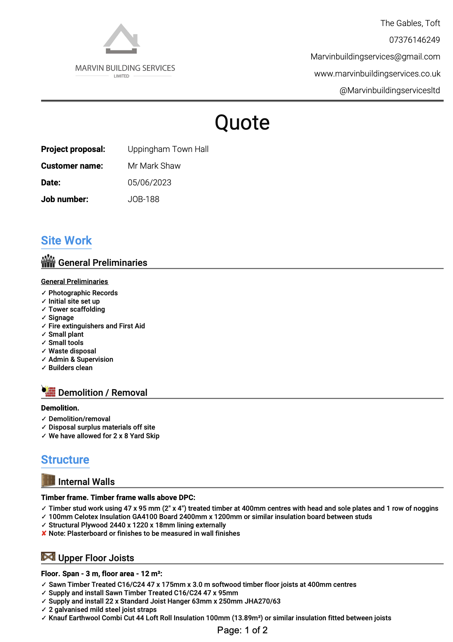
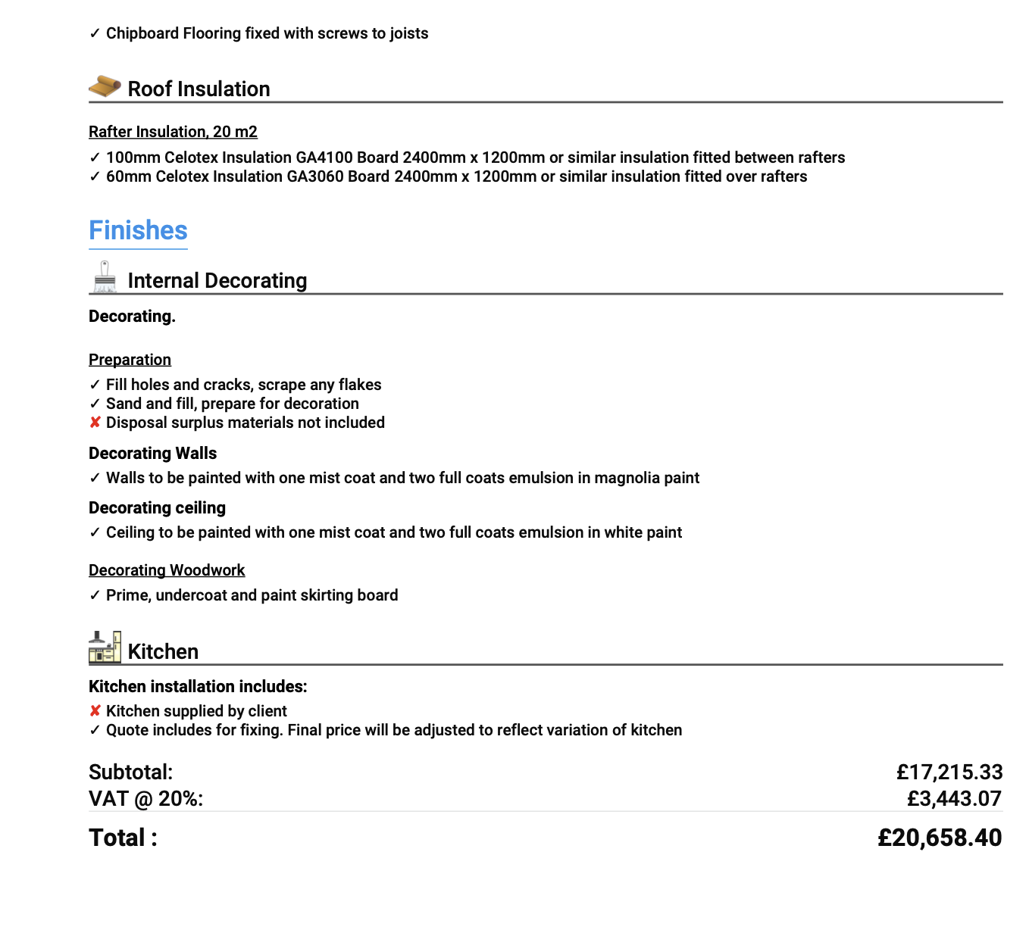

Appendix B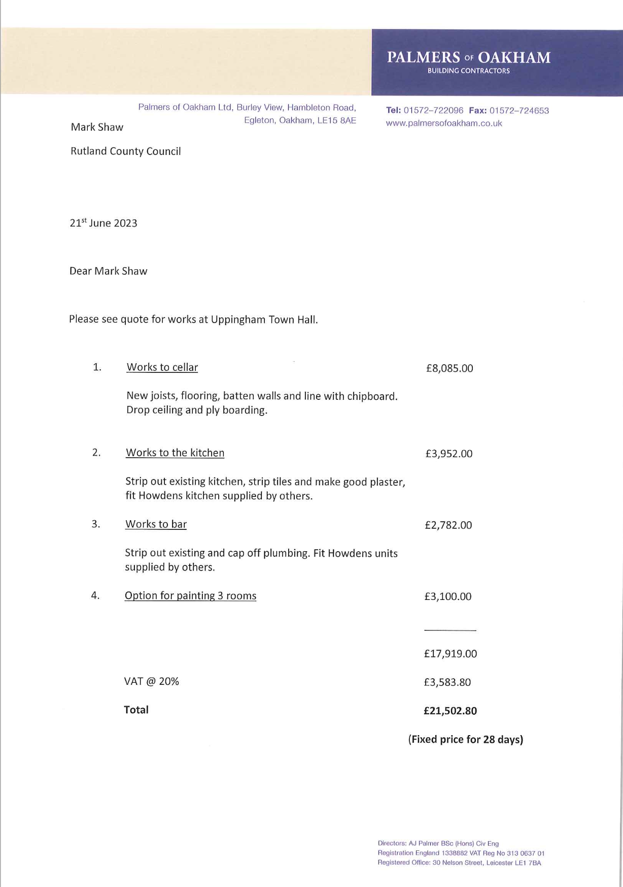

Appendix C 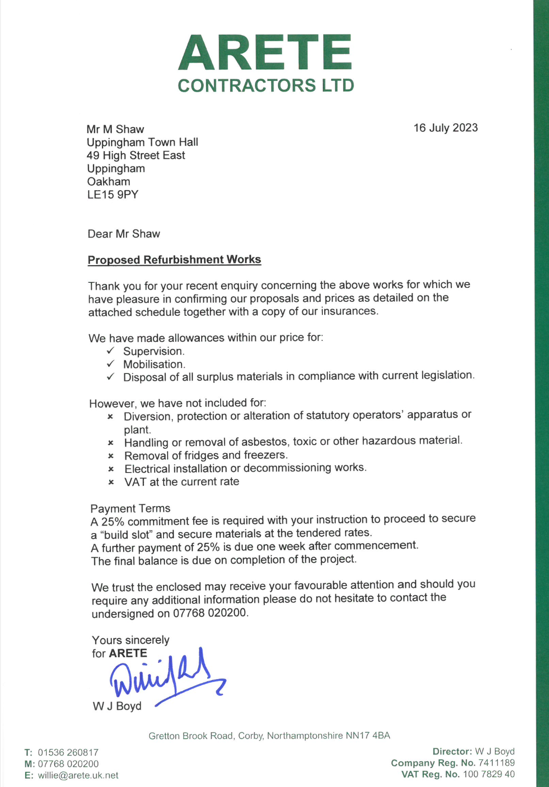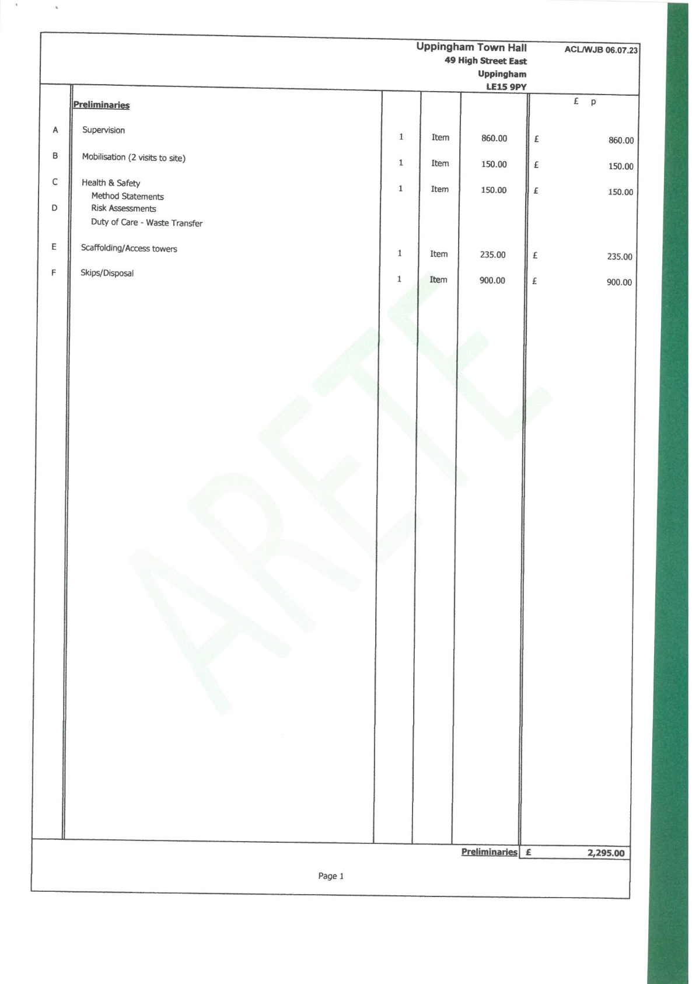

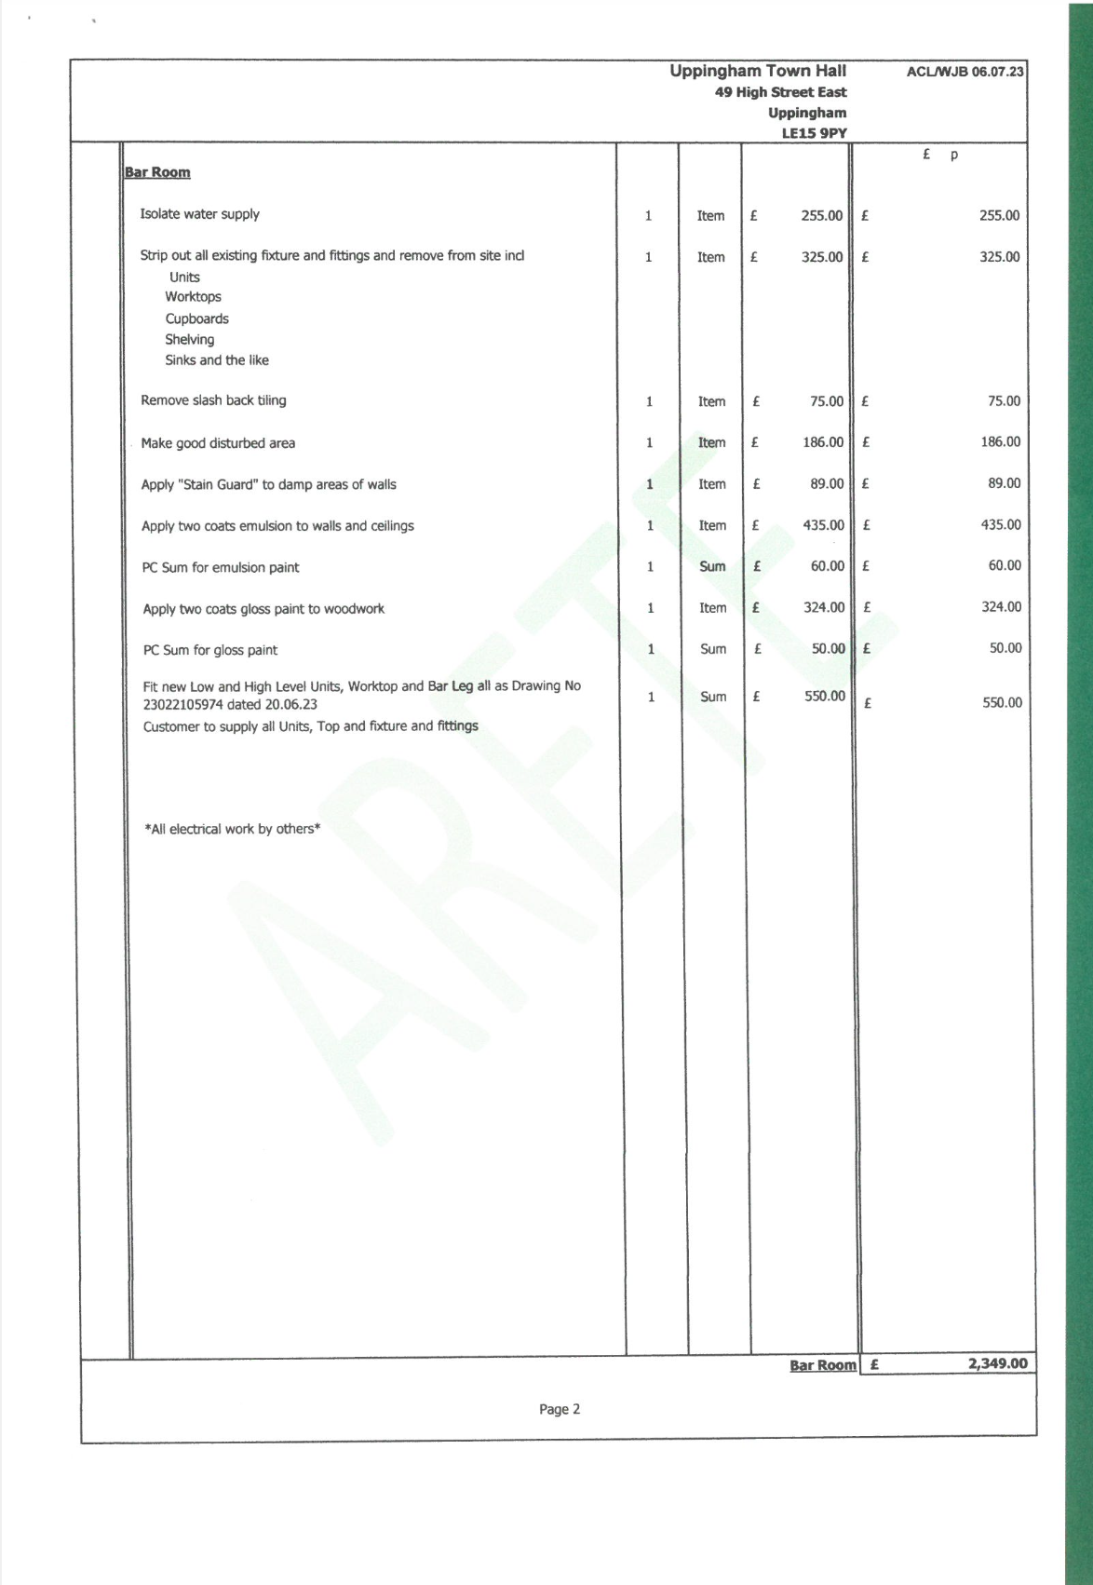

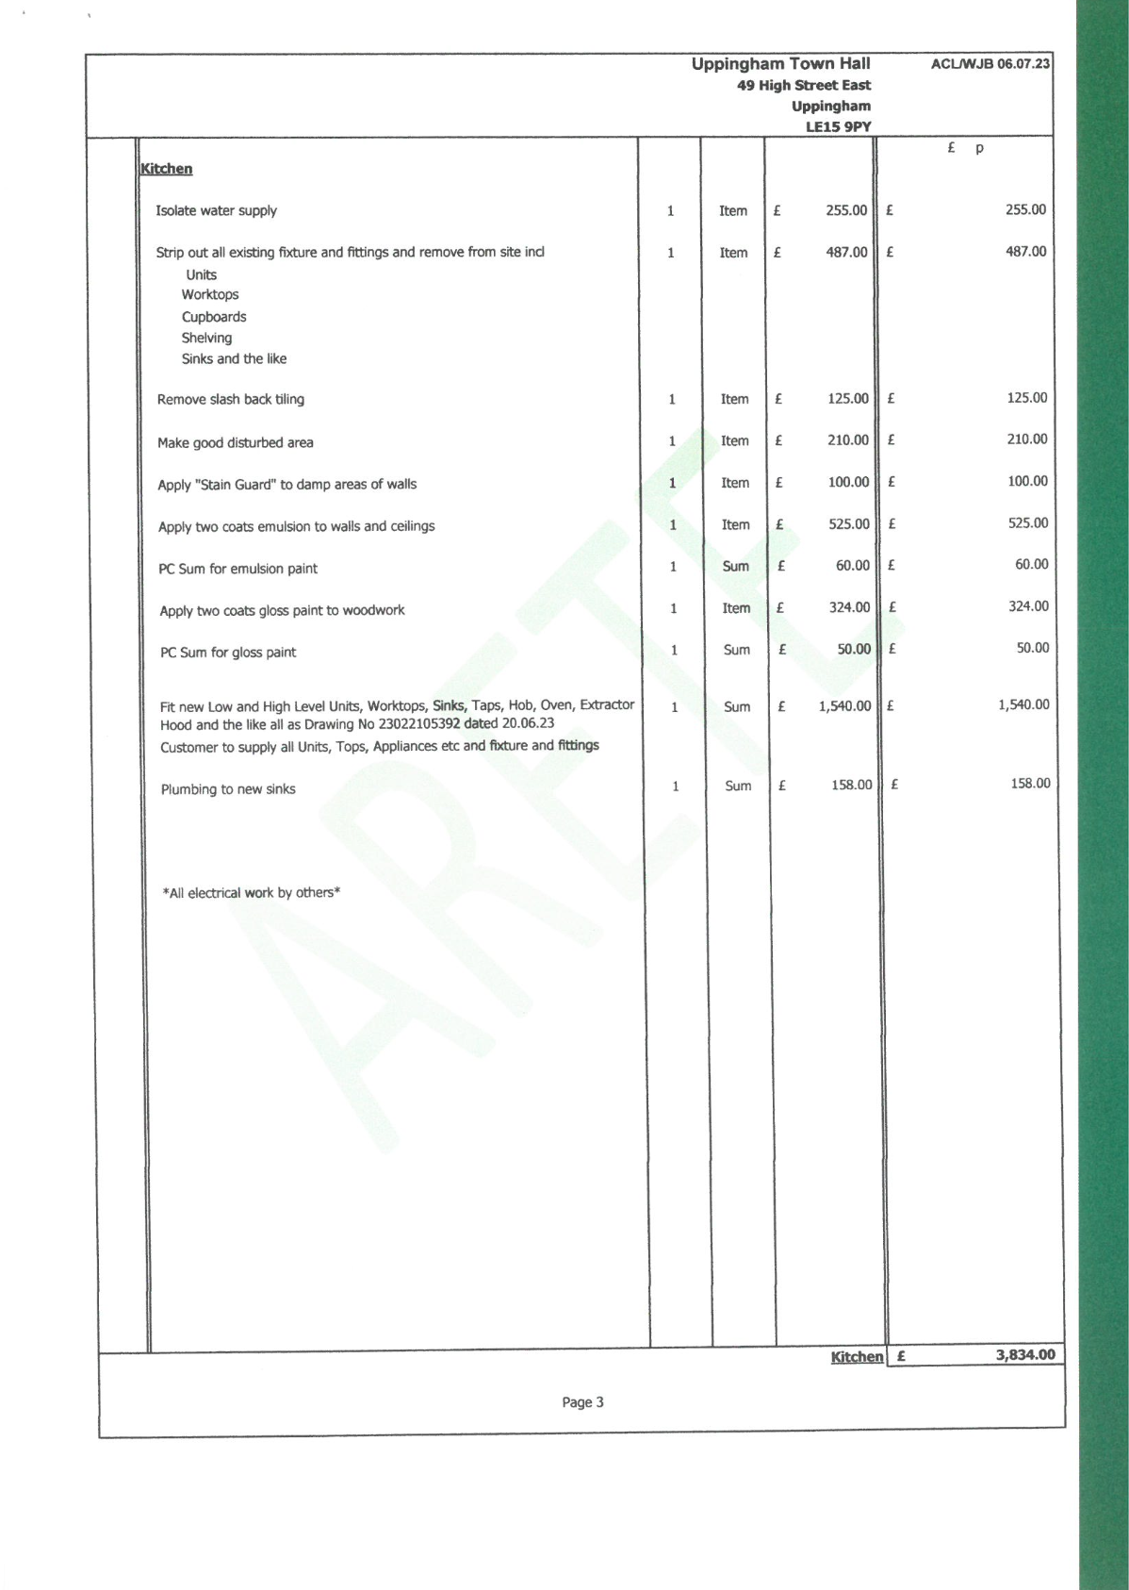

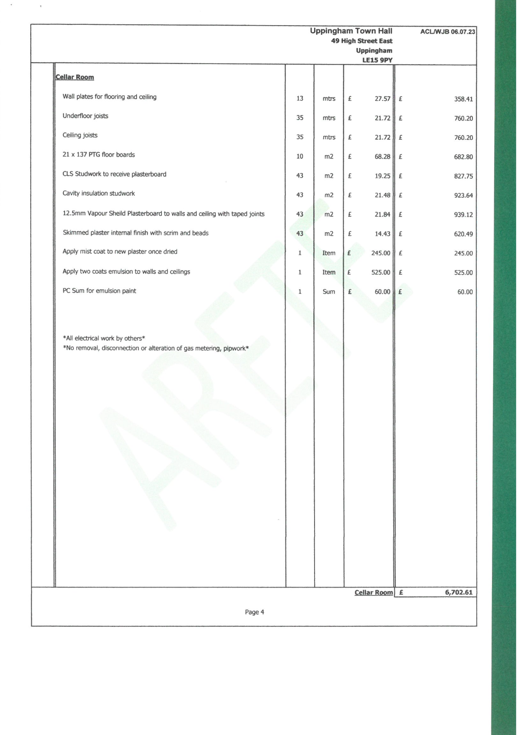

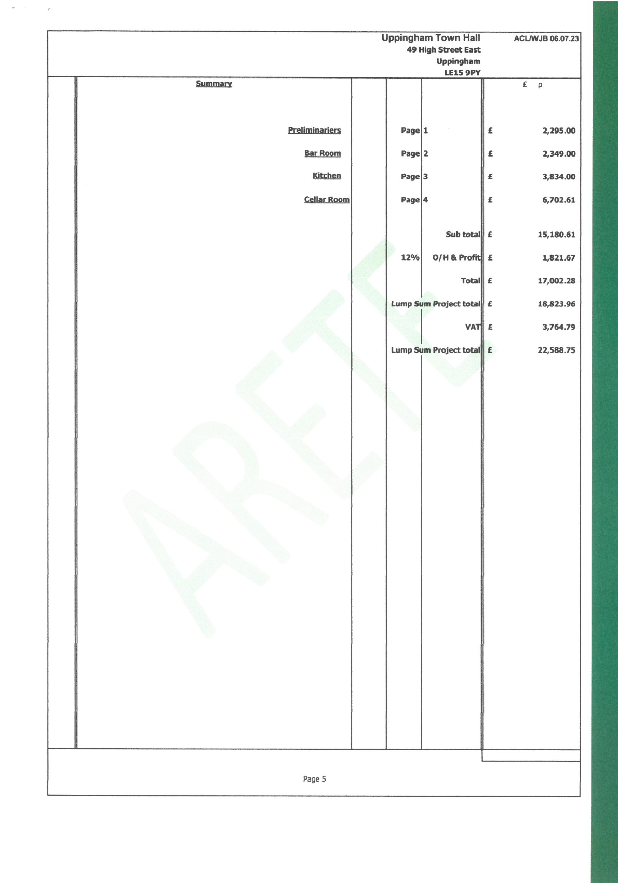

Appendix D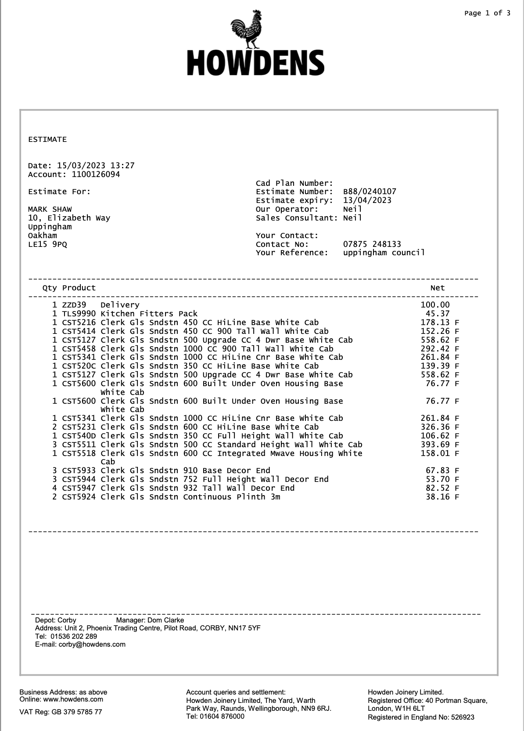

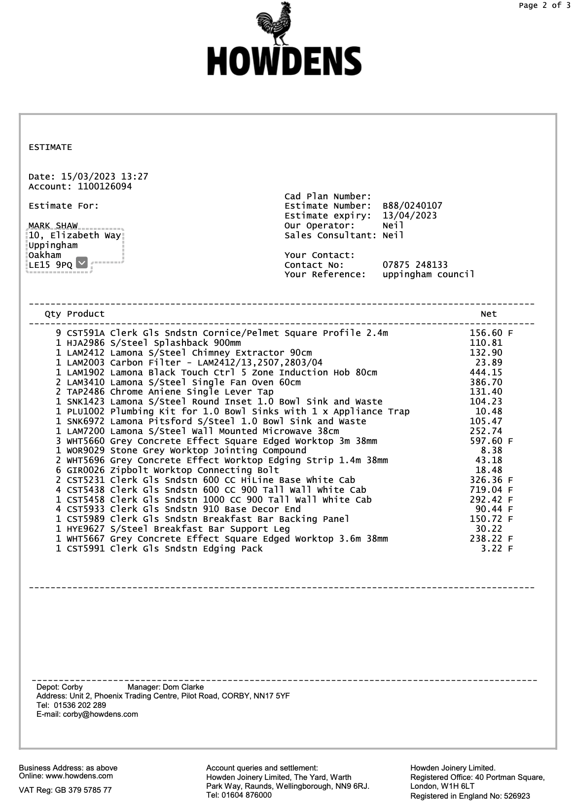

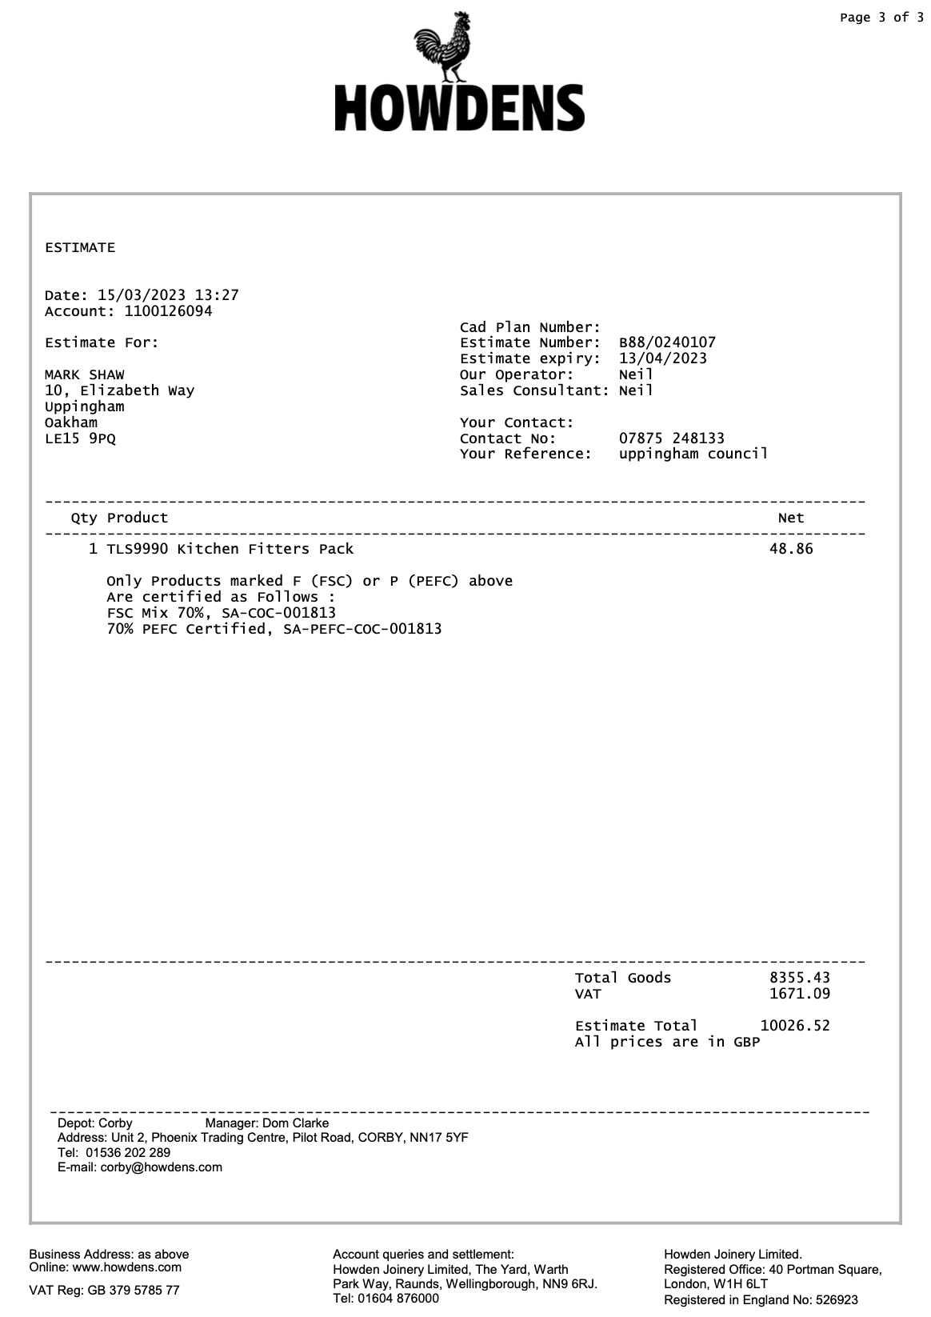

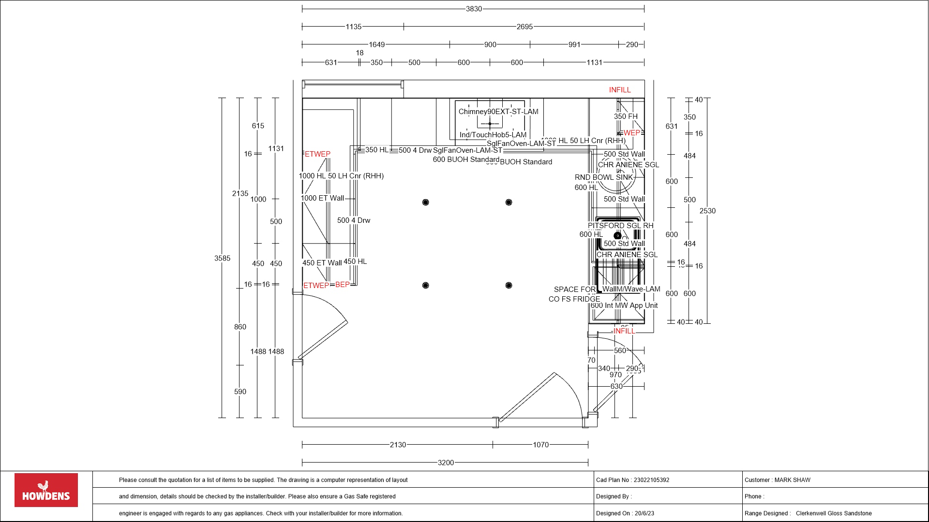
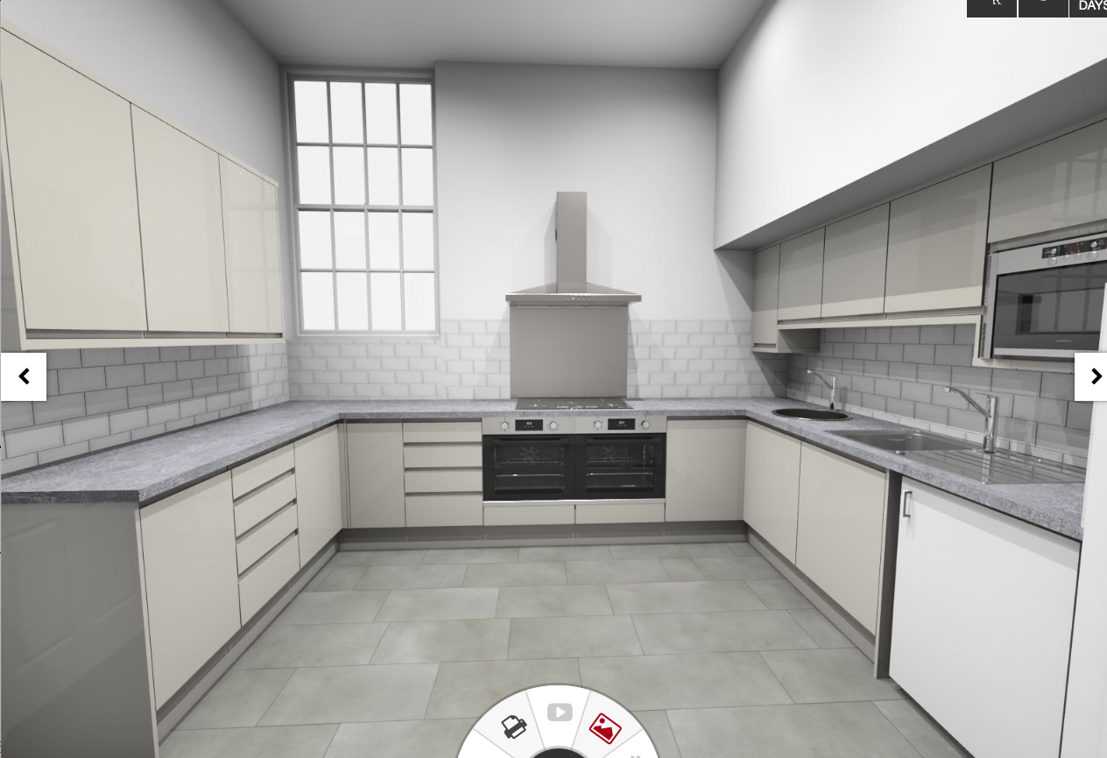

https://my-kitchen.howdens.com/plan/lgB8802482622Srf
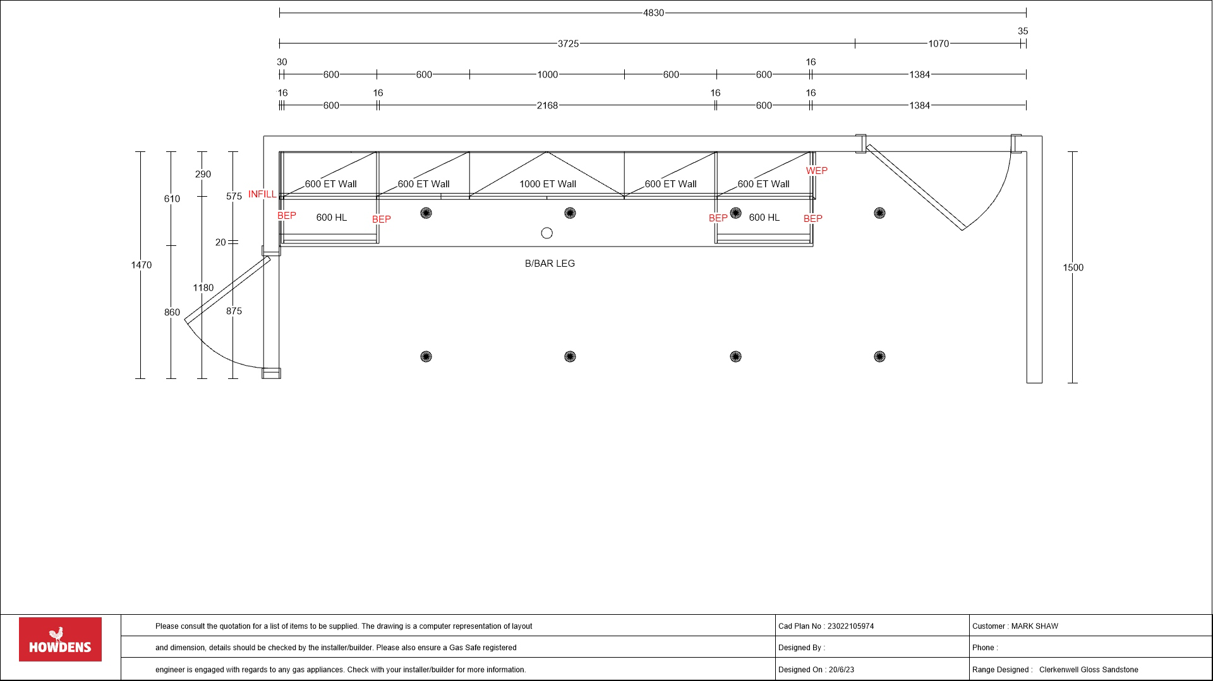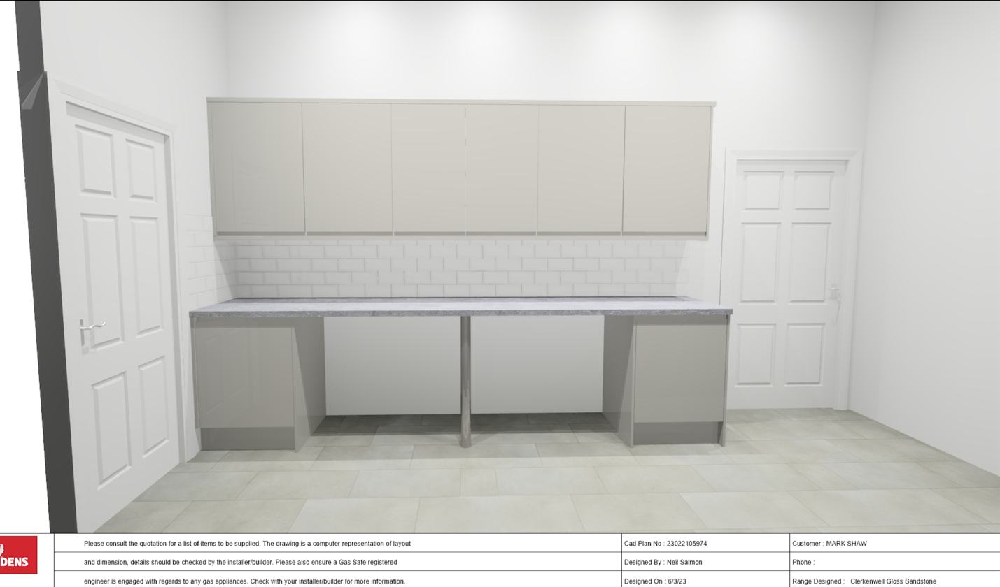

Appendix D (a)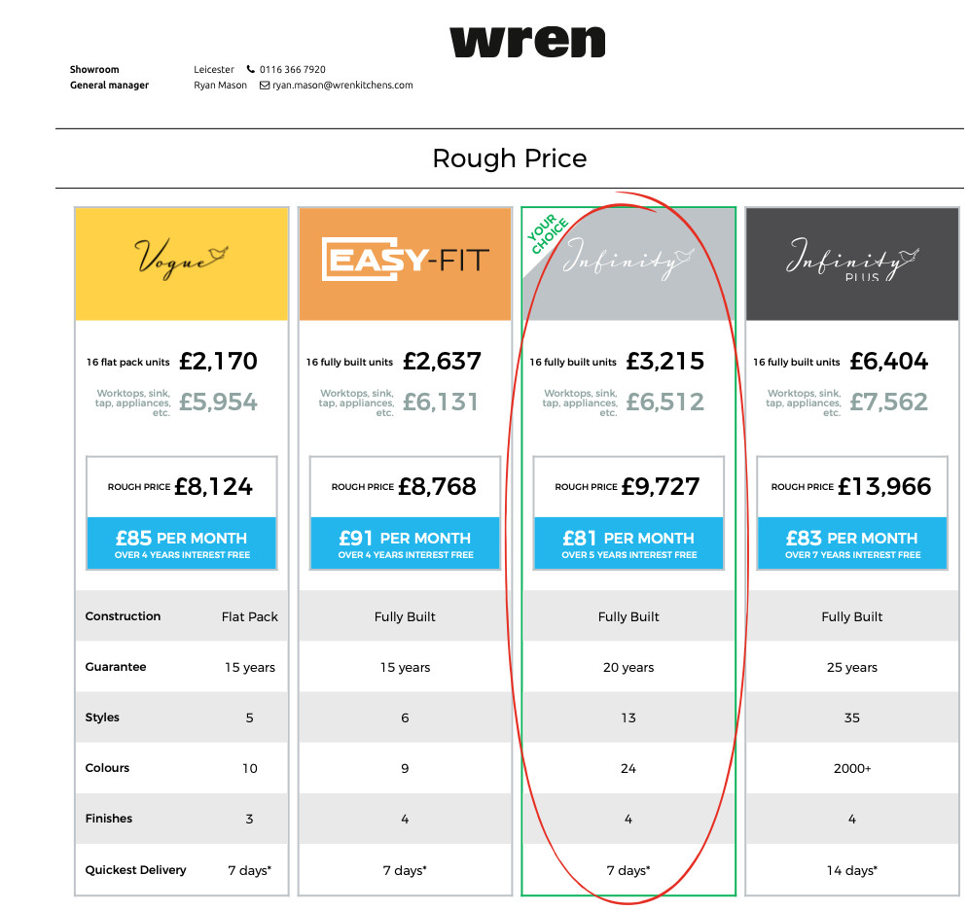

Appendix D (b)

Hi,

The total cost of both is £3,513.42

*Please note this does not include Worktop, 5 ring induction hob or extractor .

Kind Regards,

Caitlin Ramjeebhai
Kitchen And Bathroom Advisor
Wickes
Wigston

Using the cost of Worktop, 5 ring induction hob or extractor of £6512 from the rough Wren quote takes this price to:

£8,352.27 + VAT

Appendix E 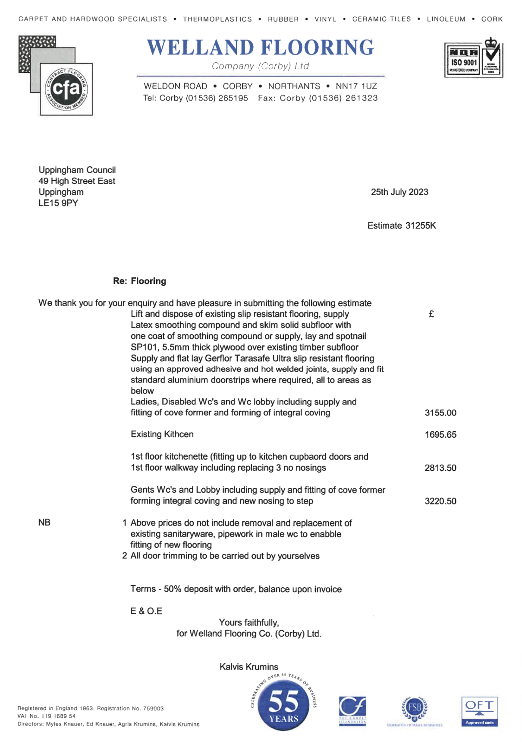
Appendix F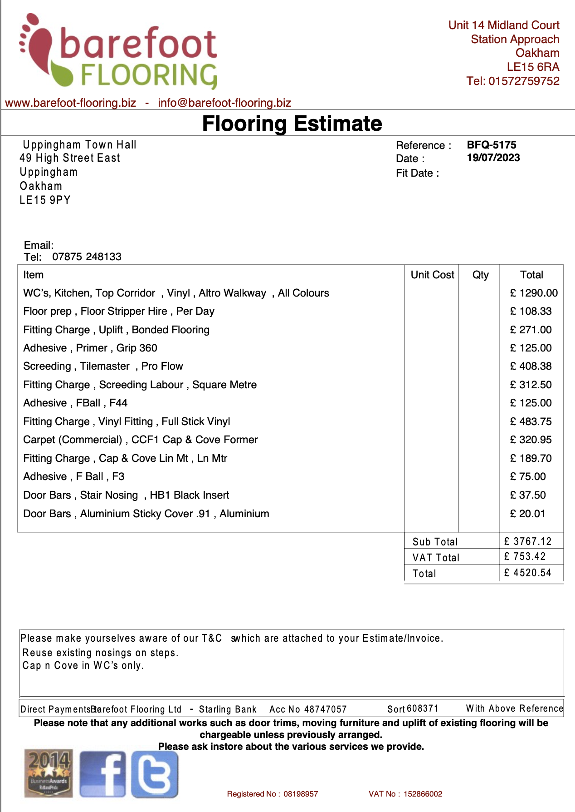

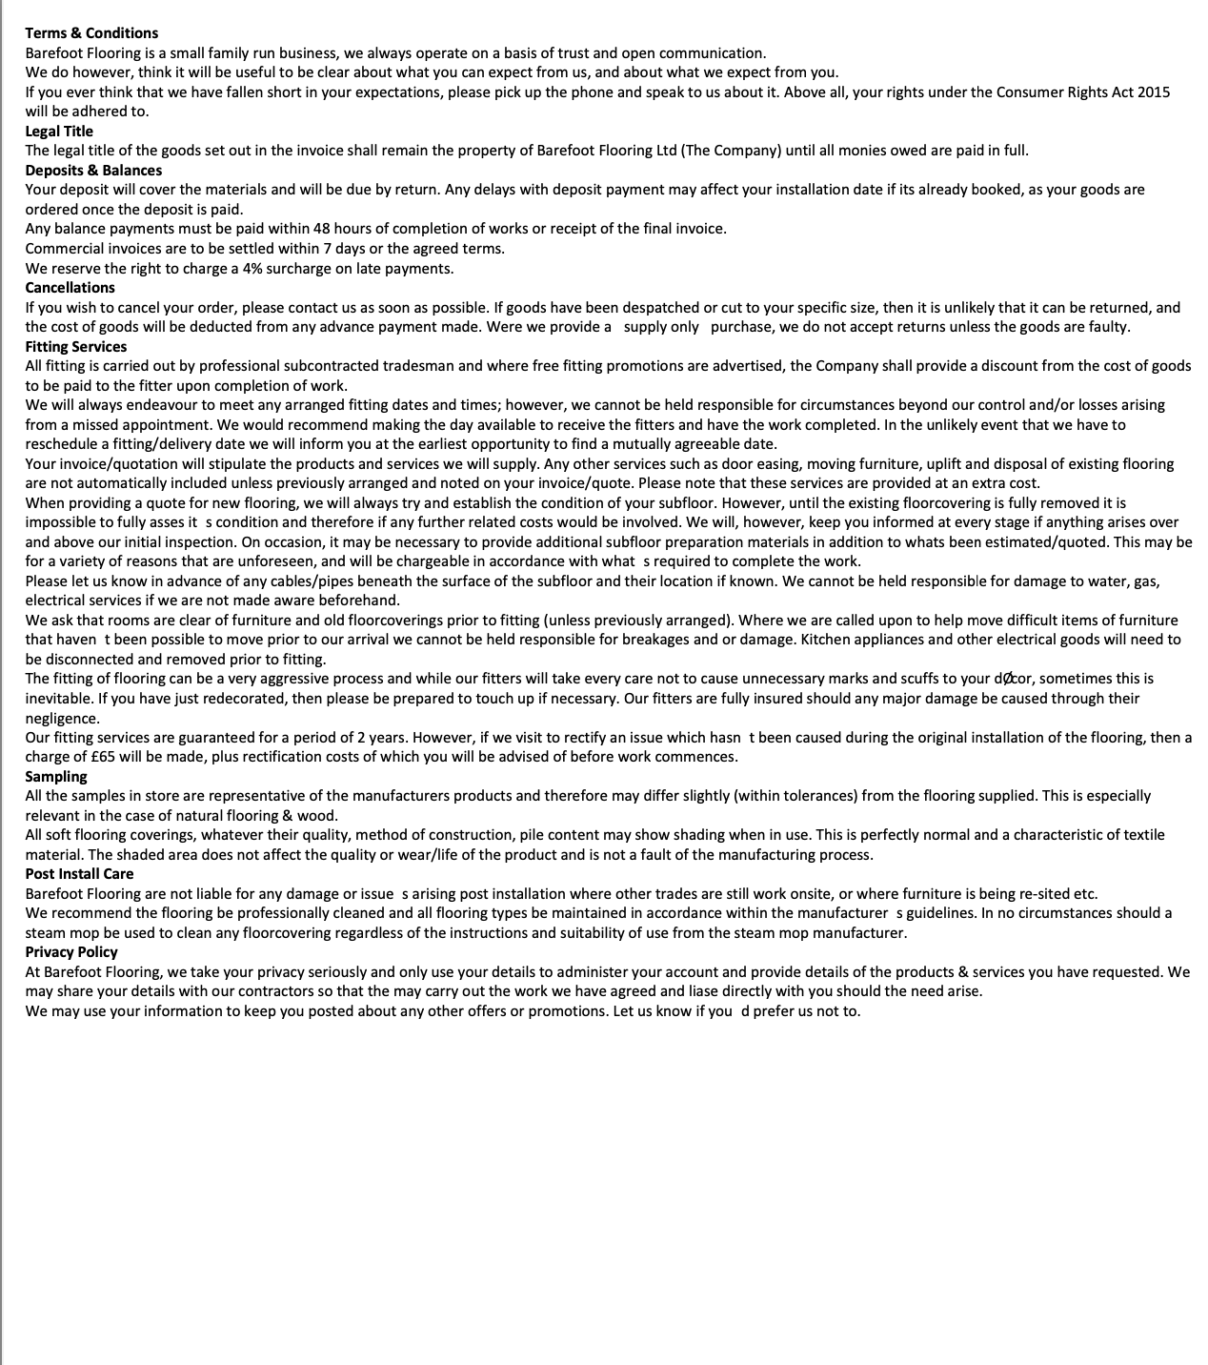

Appendix G 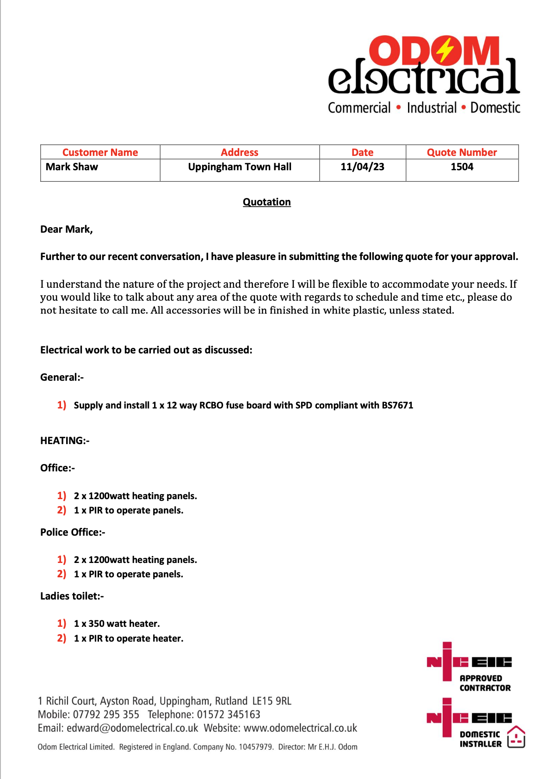

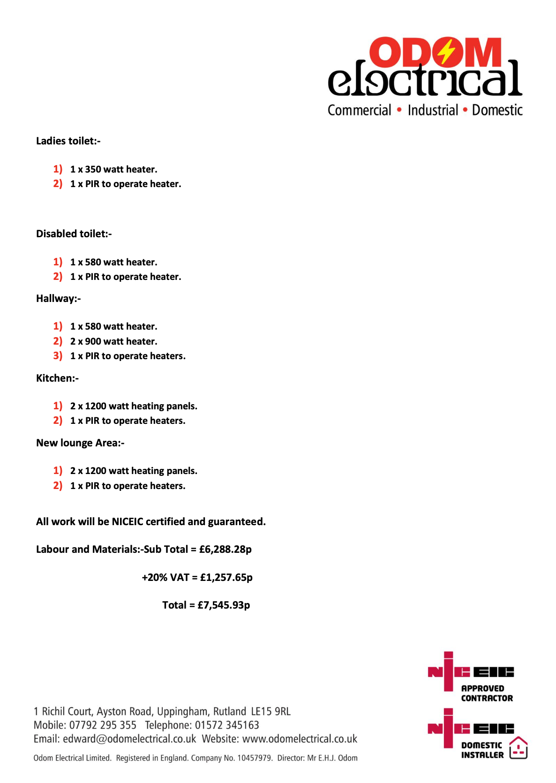

Appendix H 