**Uppingham Town Council**

**Constitution**

**How the Council is Constituted - Scheme of Delegation**

**Content**

1.1 Aim of this document

1.2. The Council and its Councillors

1.3 Councillors and their duties

1.4 The Council

1.5 The Town Mayor

1.6 The Town Clerk (Clerk to the Council)

1.7 The Council’s Standing & Advisory Committees

* Committee membership
* Meetings
* Quorum

1.8 Planning Committee

* Terms of reference

1.9 Environment, Infrastructure and Amenities Committee

* Terms of reference

1.10 Finance & General Purposes Committee

* Terms of reference

1.11 Staffing Committee

* Terms of reference

1.12 Neighbourhood Plan Sub Committee

* Terms of reference
  1. Council Performance Review Group
* Terms of reference

1.14 Complaints Panel

* Terms of reference

1.15 Appeals Panel

* Terms of reference

**1.1 Aim of this document:**

* + 1. This document is designed to give guidance and clarity to officers and members of the Council as well as the community it serves about how it is constituted. It should be easy to understand and follow and is reviewed annually to ensure it remains relevant.

This document shows how decisions are made and the procedures which are followed to ensure the Council operates in an efficient, transparent and accountable manner for the people of Uppingham.

1.1.2 **How the document is structured:**

It covers in detail the framework within which the Council will operate and how it will

conduct itself.

More detailed policies, procedures, protocols and codes of practice are provided separately

and on the Council’s website to further enhance the management and operation of the

Council.

1.1.3 **The Council is committed to:**

* Promoting equality;
* Providing effective leadership;
* Delivering efficient, effective and economical services;
* Conducting business transparently;
* Acting responsibly.

1.1.4 **Decision making:**

Uppingham Town Council will base its decision making on what is best for the town in the interests of the people of Uppingham.

**1.2 The Council and its Councillors:**

1.2.1 The Council is made up of 15 Councillors elected every four years.

1.2.2 All Councillors are democratically accountable to residents of Uppingham. The overriding duty of Councillors is to the whole community.

1.2.3 All Councillors are bound by the Council’s code of conduct to ensure high standards are maintained in the way they undertake their duties.

1.2.4 All Councillors meet together as the corporate body of the Council.

1.2.5 Meetings of the Council are open to the public, press and media. At these meetings Councillors deliberate and agree the Council’s overall policies and set an annual budget. The full Council is the statutory forum for debating issues concerning Uppingham, determining the Council’s finances and making strategic decisions.

1.2.6 Annually, the Council appoints a Town Mayor to chair the Council and be the public face of Uppingham. A Deputy Mayor is also appointed.

1.2.7 The Council is responsible for any changes to its Standing Orders.

**1.3 Councillors and their duties:**

1.3.1 Before taking up their duties, Councillors must sign a statutory declaration of acceptance of office on being elected to the Council and sign and complete their register of members’ interests.

1.3.2 **Councillors:**

• when sitting in full Council, collectively make the decisions of the Council;

• represent their community and bring its views into the Council’s decision-making process, i.e. be the advocate of, and for, their community;

• deal with individual casework and act as an advocate for the people of Uppingham in resolving particular concerns or grievances;

• respond to enquiries and representations fairly and impartially;

• be available to represent the Council on other bodies as well as serve on committees;

• maintain the highest standards of conduct and ethics in accordance with the Code of

Conduct.

1.3.3 **A Councillor’s key tasks:**

• Participate effectively as a member of the Council and any committee, or other body to which they have been appointed, acting at all times within the remit of these standing orders;

• promote the Council and the town it represents;

• promote partnership working with other bodies;

• serve on any review body the Council has constituted and to which they have been appointed;

• participate in the activities of an outside body to which they have been appointed by the

council, providing two-way communication between the organisations;

• report to the Council at the next available opportunity on the activities of any outside body to which he or she is appointed by the council;

• ensure that, when attending meetings with third parties at the resolution of full council or standing committee, a brief report of the meeting is submitted to the Clerk at the next available opportunity for circulation to members;

• participate, as appointed, in consultative processes with the community and with other organisations;

• develop and maintain a working knowledge of the Council and the role of the Town Clerk;

• contribute constructively to open government and transparent decision making;

• actively encourage local people to participate generally in local governance of the area;

• use any delegated power solely within the confines of the resolution giving those powers.

**1.4 The Council**

1.4.1 Only full Council can exercise the following functions:

• adopt and change standing orders;

• adopt corporate strategies and policies;

• approve and adopt the annual budget;

• set an annual precept;

• agree terms of reference for any committee;

• appoint to committees

• appoint representatives to outside bodies

• appoint a Town Clerk unless such power has been delegated to a group set up with the purpose of making such an appointment;

• promote byelaws;

• elect the Town Mayor;

• elect the Deputy Mayor;

• and all other matters, which by law, must be reserved to the Council.

1.4.2 There are three types of Council meeting:

• the annual council meeting; • ordinary meetings; • extraordinary meetings.

1.4.3 The Council and its committees meet throughout the year as determined at the Annual

Council Meeting.

1.4.4 **Scheme of Delegation.**

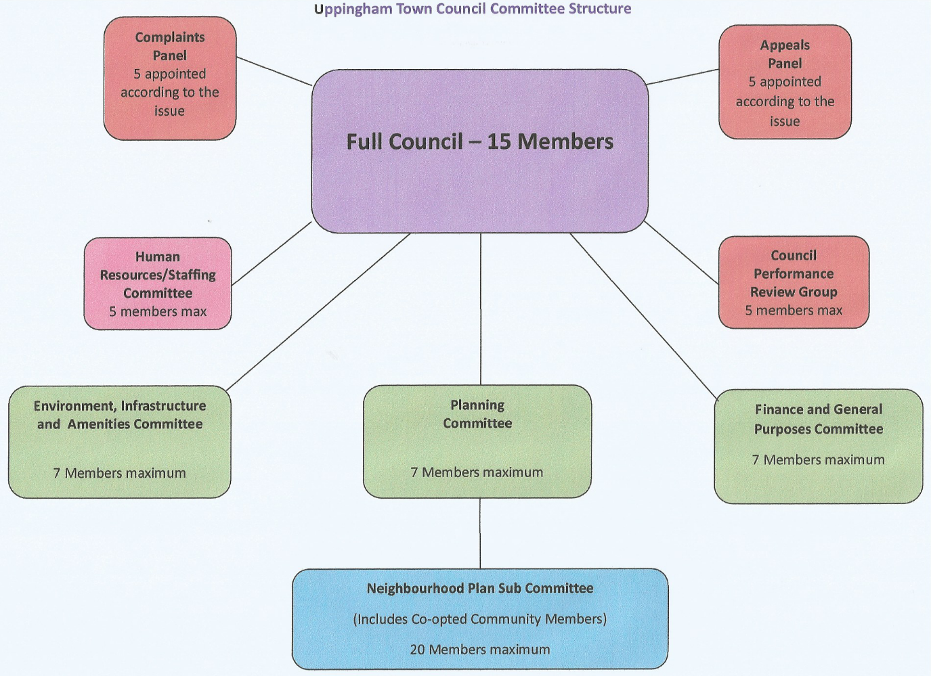

**Standing Committees:**

* Planning as appropriate to local Planning Authority timescales, or as and when required;
* Environment, Infrastructure and Amenities as and when required;
* Finance & General Purposes as and when required;
* Staffing as and when required.

**Sub Committees:**

* Neighbourhood Plan Sub Committee as and when required.

**Advisory Committees:**

* Council Performance Review Group as and when required
* Complaints Panel as and when required
* Appeals Panel as and when required

1.4.5 Quorum – a quorum shall consist of a minimum 5 members for meetings of the full council (being one third of the membership), and a minimum of three members for Standing Committees and advisory panels, committees and groups. For the Neighbourhood Plan Sub Committee the quorum shall be 7 of which at least three shall be council members.

**1.5 Town Mayor**

1.5.1 The Council has a Town Mayor, who is elected annually at the Annual Meeting. The main duty of the Mayor is to preside over meetings of the full Council.

1.5.2 The role of the Mayor is to undertake Uppingham Town Council’s civic and ceremonial duties in a dignified manner so as to uphold and enhance the status of the town and engender civic pride. The role has three main aims:

• As a symbol of authority;

• Act as ambassador for the town;

• An expression of Social Cohesion.

1.5.3 The Mayor is entitled to the right of precedence within the town and should be accorded the respect due to the office.

1.5.4 For the purposes of these standing orders the Town Mayor is the Chair of the Council and has the same rights and duties as a local council Chair.

1.5.5 The Council’s civic regalia shall be worn as appropriate and when not in use should be stored safely.

1.5.6 The Mayor sits on all standing committees ex-officio – in addition to specified members (shown at section 1.7.0 below)

1.5.7 In the absence of The Mayor, the Deputy Mayor will act in accordance with the points above in 1.5.0 to 1.5.6

**1.6 Town Clerk (Clerk to the Council)**

1.6.1 The Council has a Town Clerk to provide advice, implement decisions, and manage the day-to day running of the Council and the delivery of its services.

1.6.2 The Town Clerk is the Proper Officer of the Council delegated to discharge any functions of the Council provided for under statute (See also, Section 15 Standing Orders).

1.6.3 The Town Clerk is also the Responsible Financial Officer for discharging the Council’s responsibilities under section 151 of the Local Government Act 1972. The Town Clerk’s financial role is to ensure the proper administration of the Council’s finances (See also, Section 16 Standing Orders).

1.6.4 The Town Clerk is responsible for the day to day management of the Council’s staff.

1.6.5 Documents pertaining to legal procedures or proceedings of the Council shall be signed by the Town Clerk or other person(s) authorised by the Council.

**1.7 The Council’s Standing Committees, Sub Committees & Advisory Groups**

*Committee membership*

1.7.1 Each committee shall consist of a maximum number of members and these will be elected at the Annual Council Meeting or Committee where appropriate (apart from the Complaints Panel and the Appeals Panel where membership shall be established at an appropriate full Council meeting dependent upon the issue requiring deliberation):

• Planning – 7 members

• Environment, Infrastructure and Amenities – 7 members

• Finance & General Purposes – 7 members

• Staffing – 5 members

• Neighbourhood Plan Sub Committee – maximum 20 members (including Councillors and community/external representatives.

• Council Performance Review Group – 5 members

• Complaints Panel – 5 members

• Appeals Panel – 5 members

1.7.2 For the Complaints Panel and the Appeals Panel where the matter to be discussed involves a Councillor, they may not serve as a member of that group

1.7.3 At the Annual Council Meeting a Chair and Deputy Chair will be appointed for each committee/group (with the exception of the Complaints Panel and Appeals Panel where these appointments will be made as and when required).

*Meetings*

1.7.4 The Council will agree a year’s meeting dates for each committee at its annual meeting in May. It may ask committees to meet at additional times and committees may also determine to meet at other times.

1.7.5 Committees will normally meet between Council meetings.

**Terms of Reference for Standing & Advisory Committees**

**1.8 Planning Committee**

**1.8.1 Purpose of the Committee:**

The purpose of the Planning Committee is to debate issues in detail concerning planning policy and planning applications and to make observations to the Planning Authority in accordance with planning guidelines on behalf of the Council, which is a statutory consultee.

**1.8.2 Powers**:

The Committee has **delegated authority** to consider and comment on planning applications and make recommendations to Council about planning policy and highways matters.

**1.8.3 Frequency of meetings:**

The Committee shall meet as appropriate to local Planning Authority timescales, or as and when required.

**1.8.4 Specific brief to:**

• consider planning applications and make observations to the Planning Authority;

• convene a public meeting if it is felt that a planning application warrants such action and report findings to the Council and Planning Authority;

• appoint representatives or the Proper Officer to attend Planning Authority meetings and authorise them to speak on behalf of the Town Council;

• appoint representatives or the Proper Officer to attend Planning Enquiries and authorise

them to speak on behalf of the Town Council;

• consider and make recommendations to Council on planning policy, Neighbourhood Plan

and highway matters;

• ensure when requested to do so by the committee members or the proper officer that meetings with third parties have a clear and transparent agenda and recorded outputs are shared at the next available opportunity with committee and, when appropriate, full Council.

**1.8.5 Sub-committee**

The Neighbourhood Plan Sub-committee reports to the Planning Committee.

**1.9 Environment, Infrastructure and Amenities Committee**

**1.9.1 Purpose of the Committee:**

The purpose of the committee is to debate issues, determine decisions and when appropriate, make recommendations to Council in respect of issues within the remit of this Committee. It has **delegated authority** to spend within its allocated budget.

With a view to stengthening social cohesion to consider the functions and services provided by the Council in relation to:

* its environmental duties and goals
* the infrastructure and amenities for which the council is accountable including cemeteries, parks, gardens and open spaces, amenity areas, play areas and community facilities and toilets; and if required for budget and other relevant reasons to make recommendations to Council for any variations, improvements or alterations.

**1.9.2 Powers:**

To oversee the finance allocated to the Committee, for which it has **delegated powers** to make decisions and spend within the budget headings allocated to the Committee by the Council. Any virement applications must be referred to Finance & General Purposes Committee or to full Council.

**1.9.3 Frequency of meetings:**

As and when required.

**1.9.4 Specific brief to:**

• consider and recommend to Council any improvements variations, improvements or alterations to the Council’s infrastructure including leisure and recreation facilities;

• monitor and enact changes to the ground’s maintenance contract within existing budgetary constraints;

• review the use of the Council’s leisure and recreational facilities;

• to oversee progress on any leisure or recreational projects;

• consider projects and associated costs;

• liaise with any appropriate external bodies and agencies;

• oversee the Christmas Lights installation as well as heritage and cultural initiatives;

• annually inspect the Council’s leisure and recreation facilities;

• oversee the maintenance and development of the Town Hall, property and land;

• be the Council’s primary area of expertise for all environmental matters

• ensure when requested to do so by the committee members or the proper officer that meetings with third parties have a clear and transparent agenda and recorded outputs shared at the next available opportunity with committee and full Council.

**1.10 Finance & General Purposes Committee**

**1.10.1 Purpose of the Committee:**

The purpose of the Finance and General Purposes Committee is to oversee and implement the councils financial affairs and to debate relevant issues of Strategy and Policy in detail and to formulate recommendations to the Council.

The Committee’s strategic role will be to formulate strategies for the Council to consider adopting. Maintain oversight of Council approved long term plans. Draft for Council approval policies and procedures for the good governance of the Council.

**1.10.2 Powers:**

The Committee will also maintain oversight over the Council’s finances. It has **delegated authority** to spend within its allocated budget. This will include making decisions on budgeted finance and recommend to Council any proposals which are outside the approved budget and require either grant aiding or the use of financial reserves. Consider and recommend to full Council any virements proposed by other committees.

**1.10.2 Frequency of meetings:**

As and when required.

**1.10.3 Specific brief to:**

• formulate and consider draft strategic documents for Council approval;

• formulate and consider policies and procedures for Council approval;

• formulate and consider projects, their associated costs and funding sources;

• annually review financial regulations and recommend to Council any changes;

• oversee internal audit, consider any weaknesses identified and recommend

appropriate actions;

• use its delegated authority to spend within the budget allocated to the committee subject to the overall budget adopted by the Council;

• oversee the preparation of a medium-term financial plan;

• prepare draft budgets for the following financial year and recommend to Council

accordingly;

• maintain oversight of the income and expenditure against the current financial year’s

budget;

• approve applications for virement either from other committees or the Council’s

Responsible Financial Officer;

• formulate, consider and recommend to Council applications for expenditure from other committees which are outside their current budgets;

• ensure appropriate health and safety policies are in place to mitigate risk;

• provide oversight and manage the Council’s risk approach;

• ensure when requested to do so by the committee members or the proper officer that meetings with third parties have a clear and transparent agenda and recorded outputs shared at the next available opportunity with committee and full Council.

**1.11 Staffing Committee**

**1.11.1 Purpose of the Committee:**

The purpose of the committee is to debate issues and recommend to Council matters relating to employment and personnel.

**1.11.2 Powers:**

The committee has **no delegated powers** and all decisions and recommendations should be referred to Full Council at the next or most appropriate opportunity.

**1.11.3 Frequency of meetings:**

As and when required.

**1.11.4 Specific brief to:**

• oversee all matters relating to the employment of staff and making recommendations to

Council thereon;

• recommend to Council matters regarding conditions of employment;

• review, job descriptions, contracts, salary awards, clerk appraisals and staff allocations,

make recommendations to Council as appropriate;

• convene investigatory committees to examine disciplinary matters, reporting outcomes to

full Council;

• monitor Health & Safety regulations, policy and procedures;

• monitor and review the Council’s personnel policies and make recommendations to

Council;

• In consultation with and including the Town Clerk, advise Council on the continuous

professional development of all employees;

• recommend to Council any staff training requirements;

• ensure when requested to do so by the committee members or the Proper Officer that meetings with third parties have a clear and transparent agenda and recorded outputs shared at the next available opportunity with committee and full Council;

• require the maintainance by the Town Clerk of a staff handbook.

**1.12 Neighbourhood Plan Sub-committee**

**1.12.1 Purpose of the Sub-committee:**

The purpose of this subcommittee of the Planning Committee is to:

* Monitor the delivery of the current Neighbourhood Plan
* Monitor the relationship of the current Neighbourhood Plan with the Rutand Local Plan making recommendations to Planning Committee as appropriate
* Advise the Planning Committee and Full Council on the refreshing of the Neighbourhood Plan with the full involvement of the community and other interested parties.

**1.12.2 Powers:**

This is a subcommittee of Uppingham Town Council who are the governing body for the Uppingham Neighbourhood Plan. All decisions, recommendations and proposed expenditure should be referred to Planning Committee or where appropriate, full Council. Volunteer committee members drawn from the community will be required to declare relevant interests and observe the council’s code of conduct.

**1.12.3 Frequency of meetings:**

As and when required.

**1.12.4 Specific brief:**

• to report to the Planning committee and to follow the governance approach set out for the council by the Proper Officer;

• to consider and make recommendations to Council on future planning options for Uppingham;

• to engage as many of the community and key stakeholders as possible in the process, by encouraging participation and the submission of views and ideas

• to produce a plan that is compliant with current Neighbourhood Planning legislation and in general compliance with Rutland County Council’s Local Plan

• to consult with and use the expertise of professional planners where appropriate

• to assess existing evidence as well as gather fresh evidence about the needs and aspirations of the community;

• to keep Rutland County Council Planning Department informed of progress;

• to liaise as appropriate with neighbouring councils (parish, district and county);

• to liaise with central government about new initiatives potentially shaping future content and revisions of the plan;

• ensure when requested to do so by the sub committee members or the proper officer that meetings with third parties have a clear and transparent agenda and recorded outputs shared at the next available opportunity with planning committee and full Council.

**1.12.5**  In addition to appointed town councillors, members of the Sub Committee are drawn from the community with no more than two representatives from each recognised community forum outside of the Council.

Organisations are invited to confirm their nominated representatives and if desired, deputies with the Council. Those nominated should then (with assistance from the Town Council) complete and declare their pecuniary interests with the Monitoring Officer at Rutland County Council. To be able to vote at the Subcommittee, members will have to submit their registration before attending a meeting. Any deputies who have not undertaken a declaration will not be able to vote on matters conducted at the meetings.

Examples of community forums that may be invited to submit nominations for membership

include:

*Residents’ Associations*

*• Beeches Residents Association*

*• Limes, Firs & Spurs Residents Association*

*• The Elms Residents Association*

*Schools*

*• Uppingham School*

*• Uppingham Community College*

*• Leighfield Primary School*

*• Uppingham C of E*

*Churches Together*

*• St. Peter’s & St. Paul’s*

*• Uppingham Methodist Church*

*Youth Organisations*

*• Scouts / Cubs*

*• Brownies / Girl Guides*

*Others*

*• Uppingham First Ltd (which will include its sub groups)*

*• Uppingham Neighbourhood Forum*

*• Uppingham Business Forum*

*• Rutland County Council*

*• Sports Clubs*

In exceptional circumstances the Town Council may also authorise membership of the subcommittee by an individual who is not representing any group, where that individual is judged to have specific skills of value to the subcommittee.

**1.13 Council Performance Review Group**

**1.13.1 Purpose of the Advisory Group:**

The purpose of this group is to critically appraise progress (or otherwise) against the Council’s agreed overall strategic plans (including Visions, Aims and Objectives) and bring any variations to the attention of Full Council for appropriate action to be taken.

**1.13.2 Powers:**

The advisory group has **no delegated powers** and all decisions and recommendations should be referred to Full Council at the next or most appropriate opportunity.

**1.13.3 Frequency of meetings:**

The group should meet at least quarterly to review the Council’s performance but may meet more frequently as and when required.

**1.13.4 Specific brief to:**

• oversee all matters relating to the monitoring of Council’s performance against agreed targets and objectives

• identify where shortfalls in performance are to be seen

• make recommendations to full Council on how to address any shortfalls in performance

• propose appropriate levels of communication on the subject of Council performance

**1.14 Complaints Panel**

**1.14.1 Purpose of the Advisory Group:**

The purpose of this group is to act as an appropriate body to hear any complaints made within the boundaries of the Council’s published Complaints Procedure.

**1.14.2 Powers:**

The advisory group has **no delegated powers** and all decisions and recommendations should be referred to Full Council at the next or most appropriate opportunity.

**1.14.3 Frequency of meetings:**

As and when required.

**1.14.4 Specific brief to:**

• Be the primary group to consider all complaints made to the Council which are covered by the Council’s Complaints Policy

• identify the facts in each case referred to it

• make recommendations to full Council on how to address any such complaints

• make recommendations to full Council on any proposed improvements that could be made to the Council’s Complaints Procedure.

**1.15 Appeals Panel**

**1.15.1 Purpose of the Advisory Group:**

The purpose of this group is to act as an appropriate body to hear any appeals made within the boundaries of the Council’s published Complaints Procedure and Staff Procedures.

**1.15.2 Powers:**

The advisory group has **no delegated powers** and all decisions and recommendations should be referred to Full Council at the next or most appropriate opportunity.

**1.15.3 Frequency of meetings:**

As and when required.

**1.15.4 Specific brief to:**

• Be the primary group to consider all appeals made to the Council which are covered by the Council’s Complaints Policy

• Be the primary group to consider all appeals made to the Council which are covered by the Council’s Staffing Policies

• identify the facts in each case referred to it

• make recommendations to full Council on how to address any such appeals

• make recommendations to full Council on any proposed improvements that could be made to the Council’s Complaints Procedure or Staffing Procedures.

• NB Members of this panel must not also serve on the Complaints Panel (1.14).